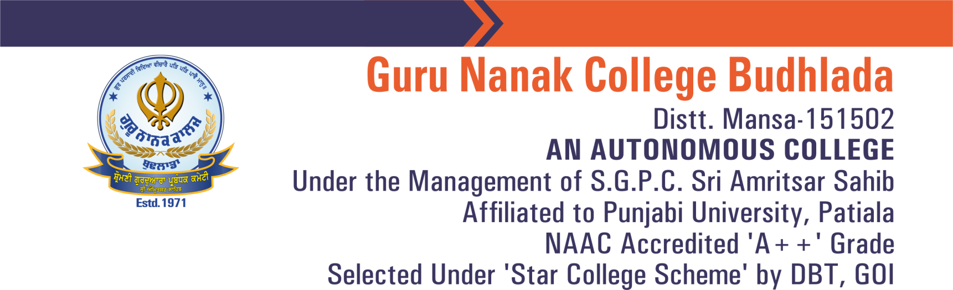

7.2 Glimpses of the Various Initiatives of the College under Best Practice: Promoting Heritage, Culture, Sports and Social Values among Students during the session 2024-25
Guru Nanak College Budhlada Bhangra Team make a Guinness World Record in a cultural event organised by Ministry of Culture (GOI).
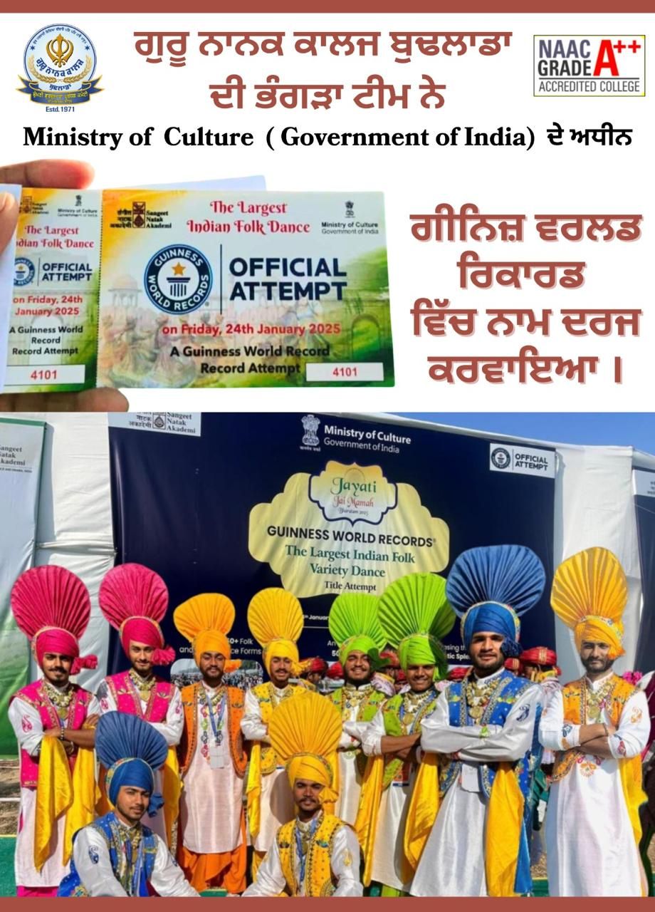
GNC became Zonal Youth and Folk Festival champion consecutively 10th time which was organised from 22 to 24 October 2024 at University College Bahadarpur. College students participate in different cultural, theatre, folk arts, folk dance items etc. The always focuses on the holistic development of students and ensures their maximum participation in activities.
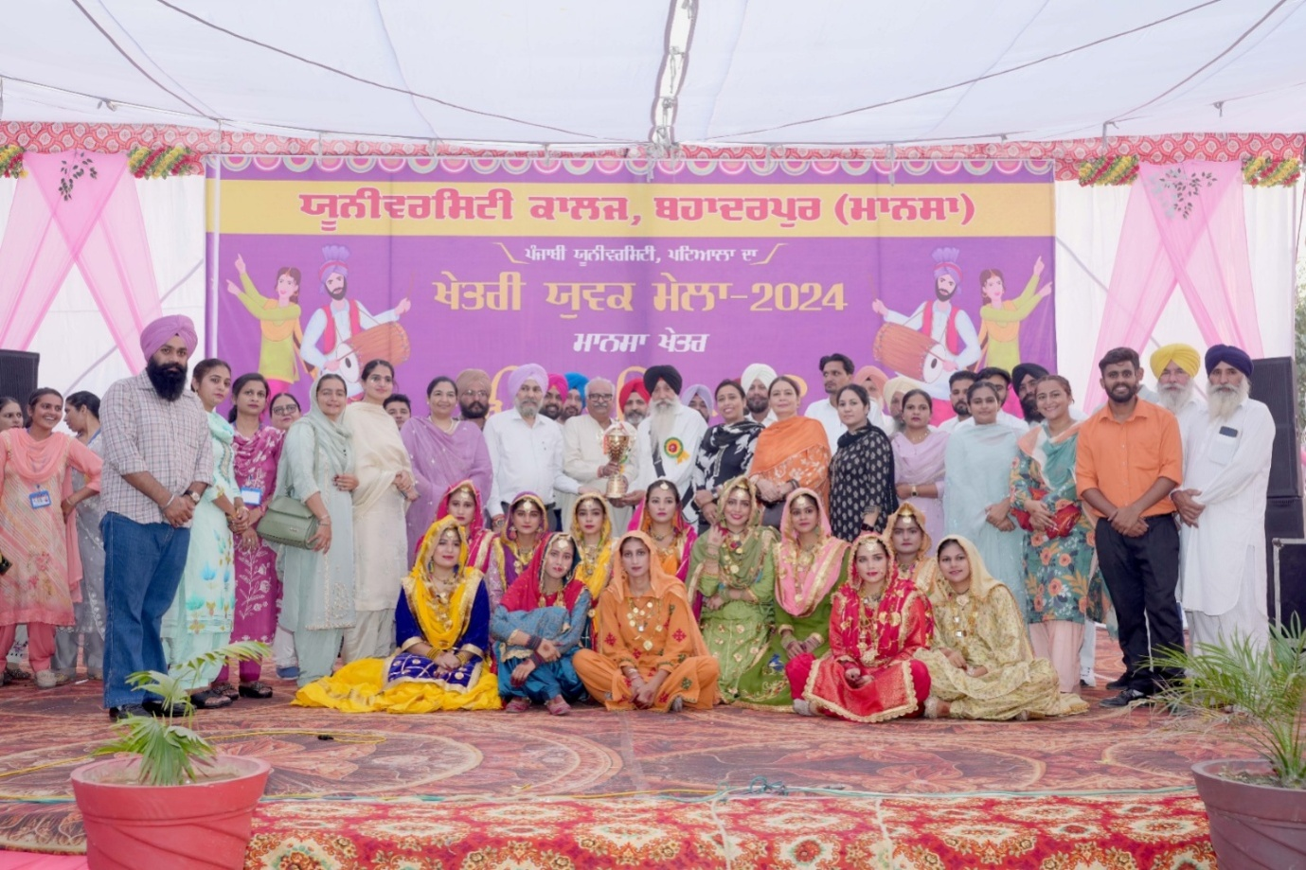
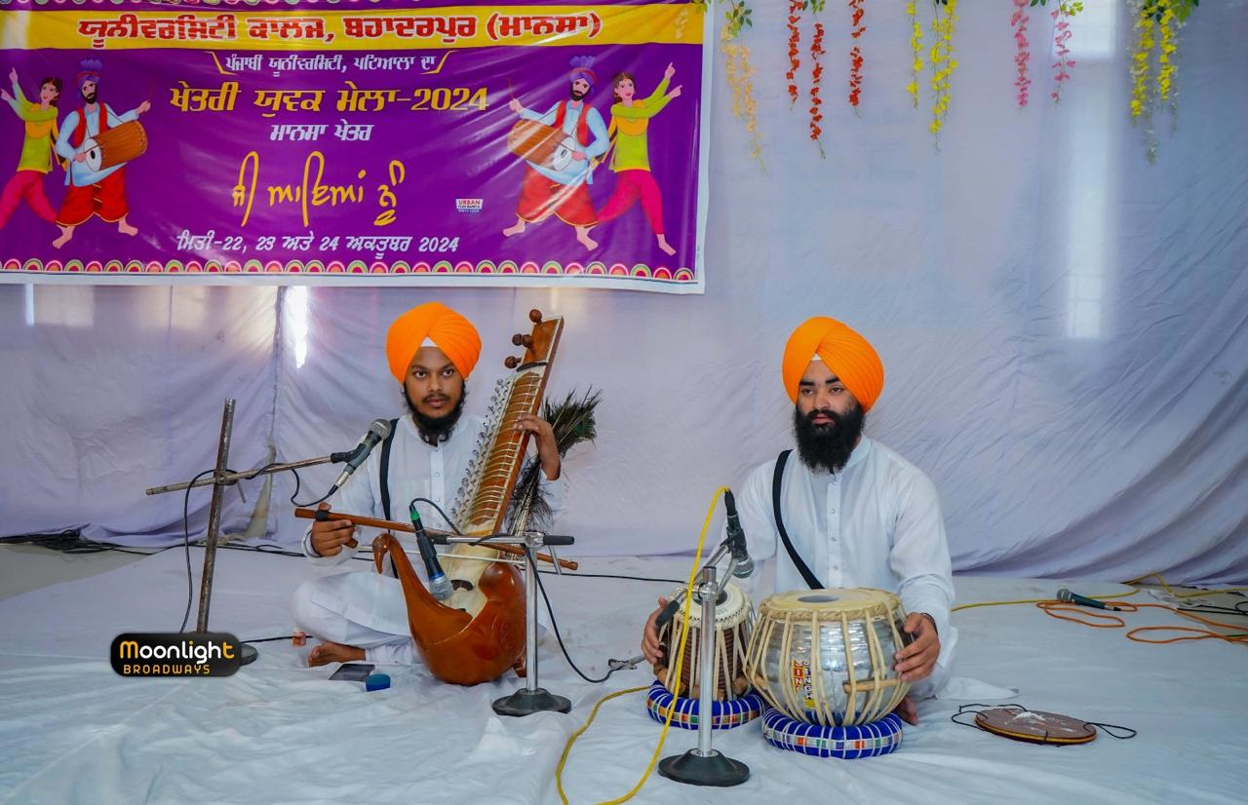
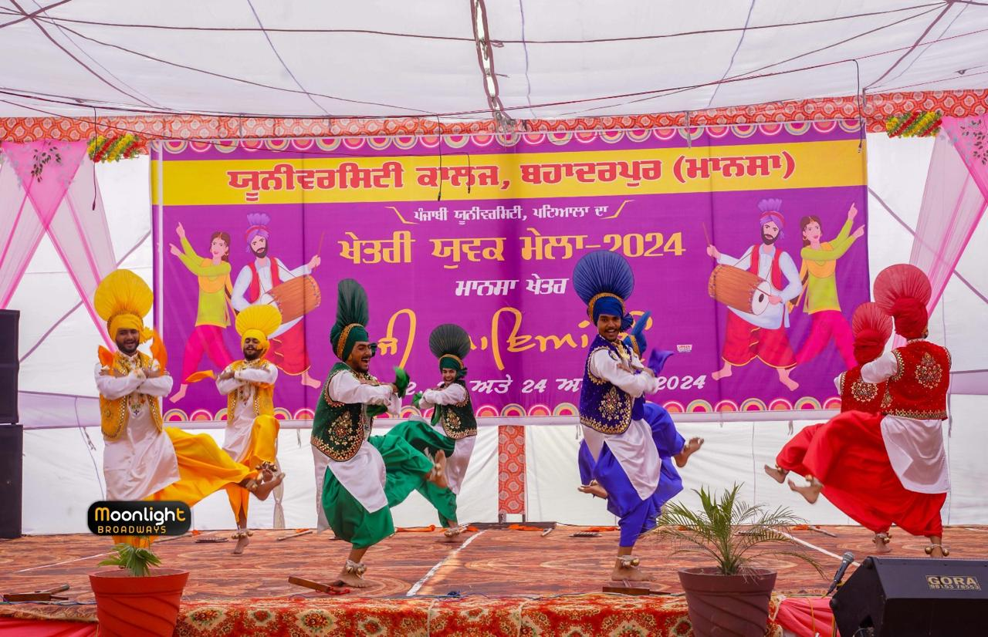
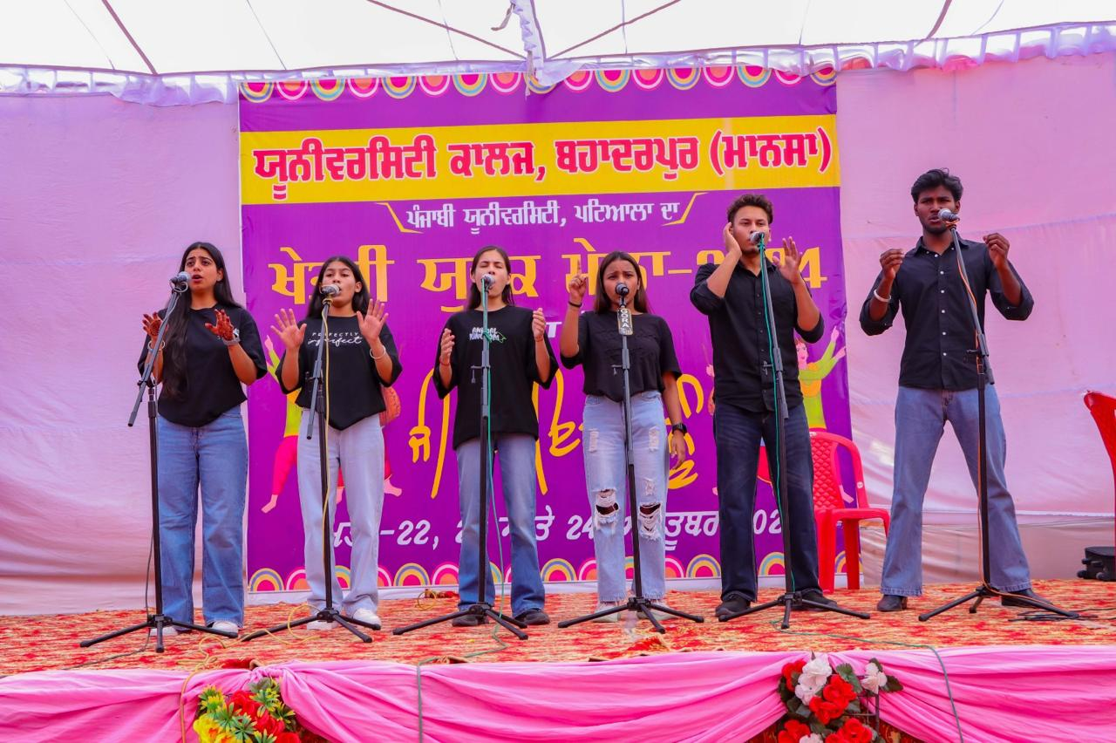
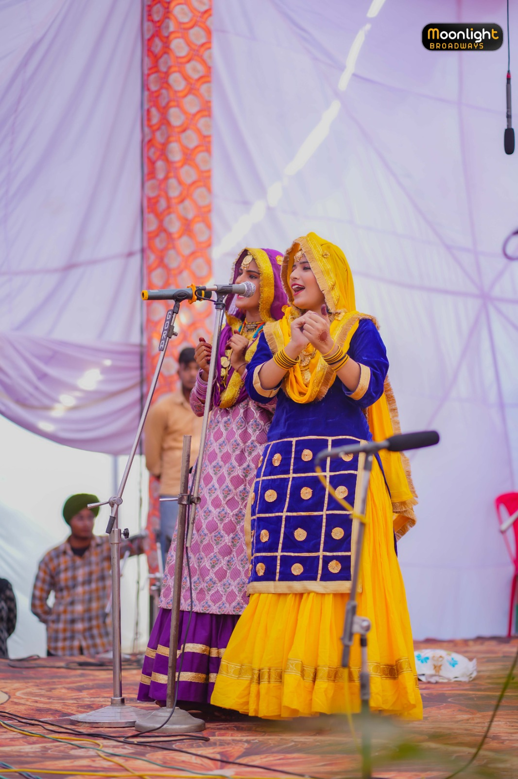
College students bagged distinguished positions at Inter-Zonal Youth and Folk Festival held at Punjabi University Patiala from 20 to 23 November 2025. College became the First Runner Up in this festival of Punjabi University Patiala.
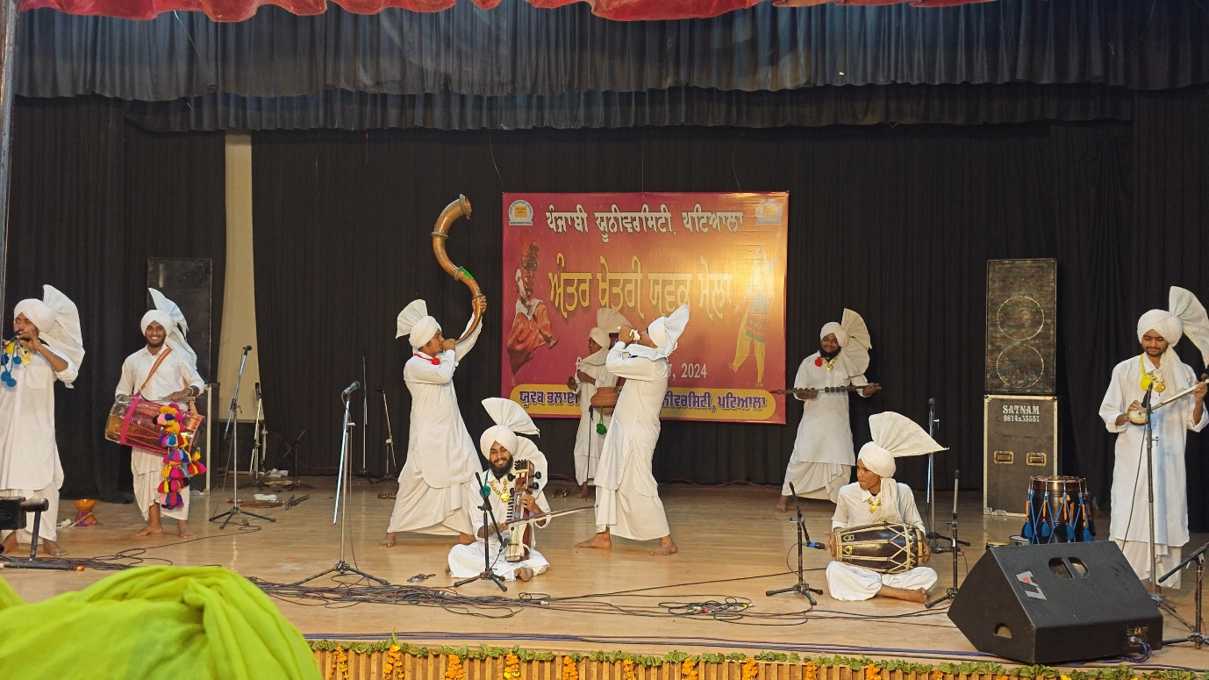
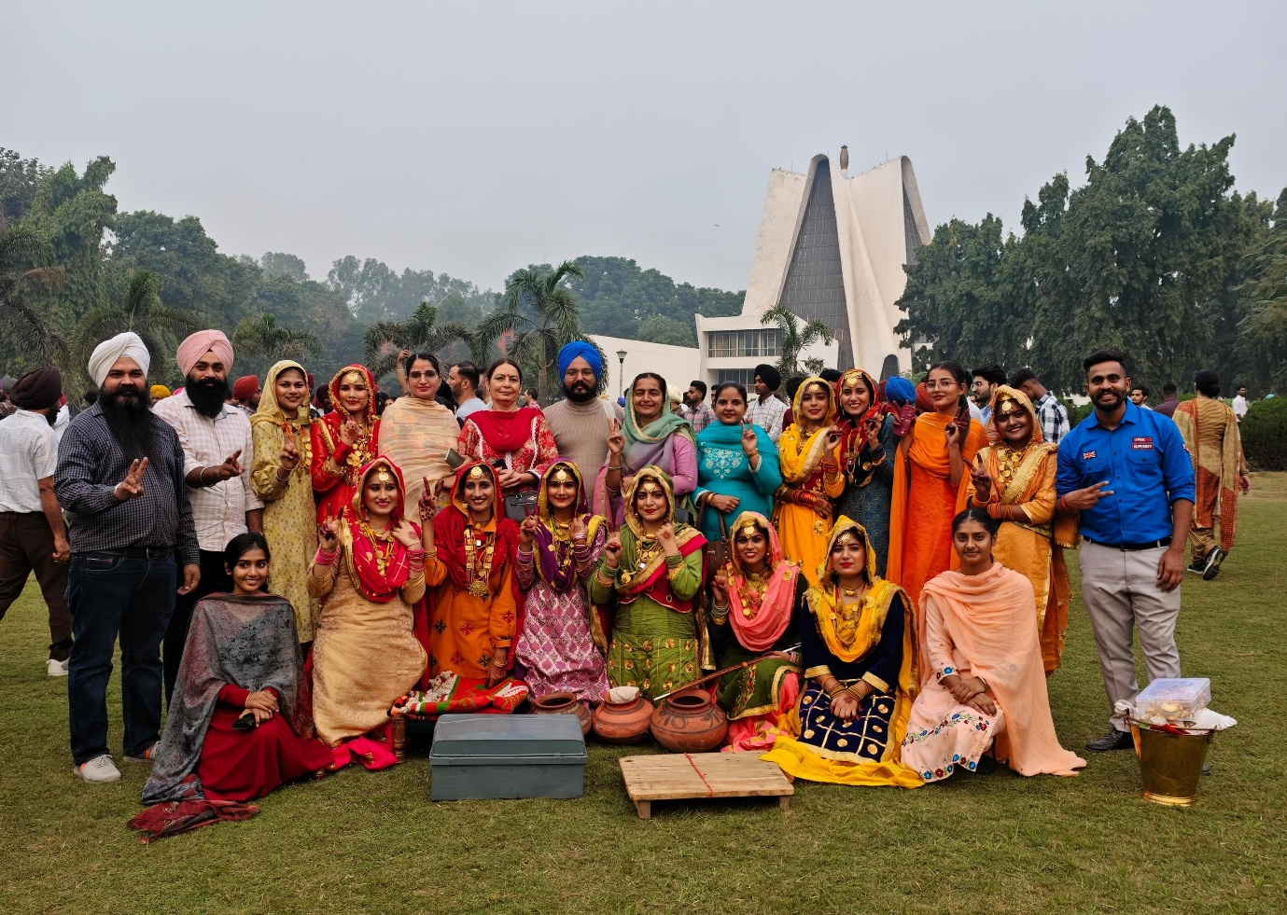
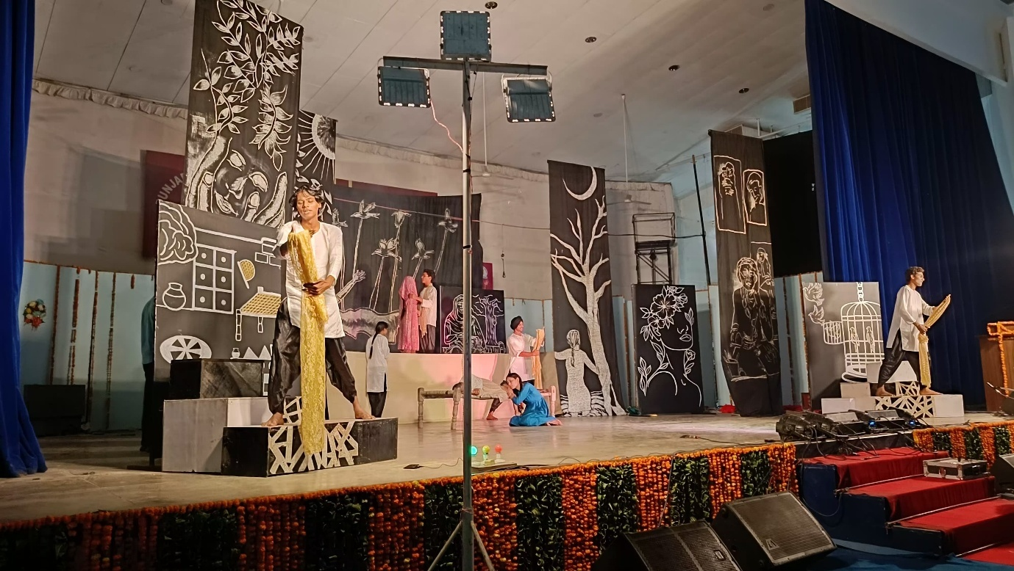
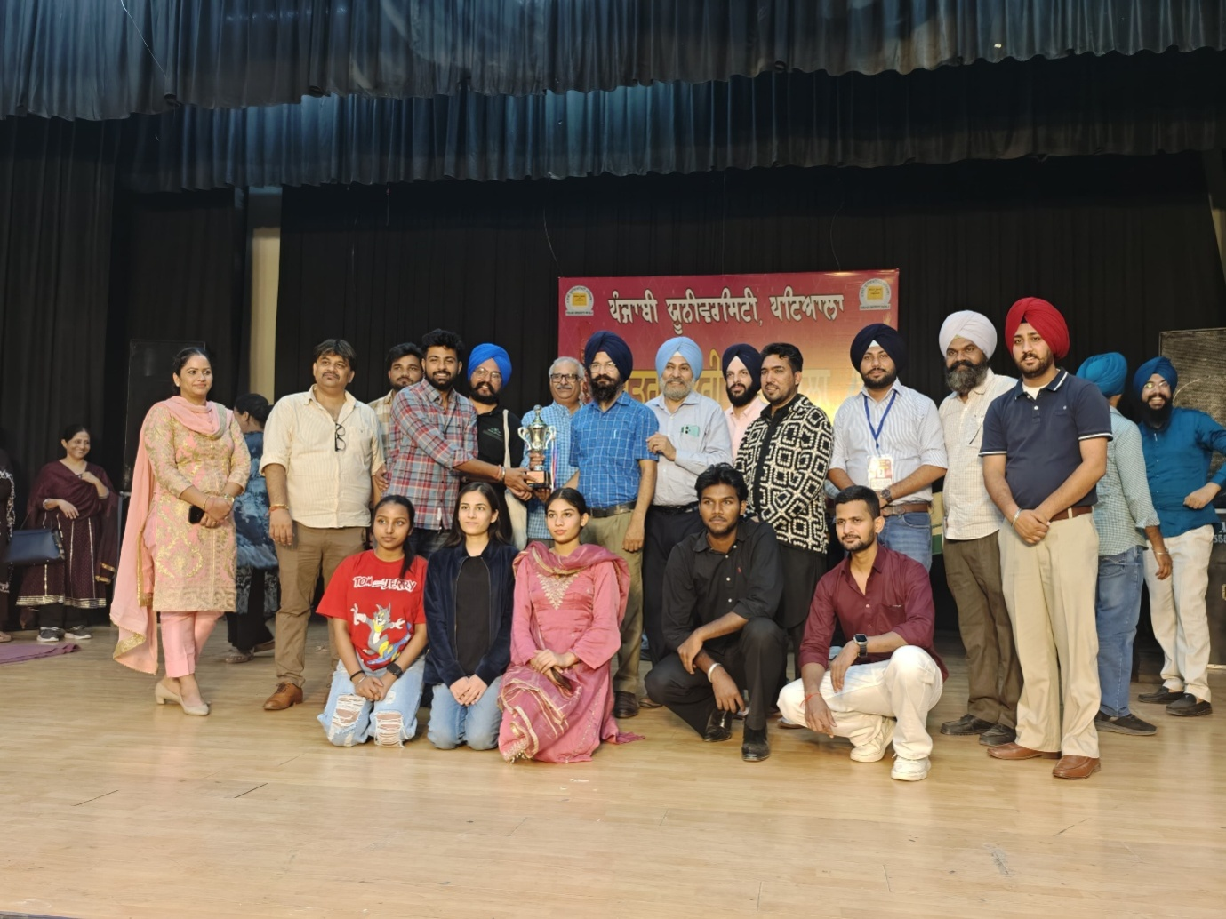
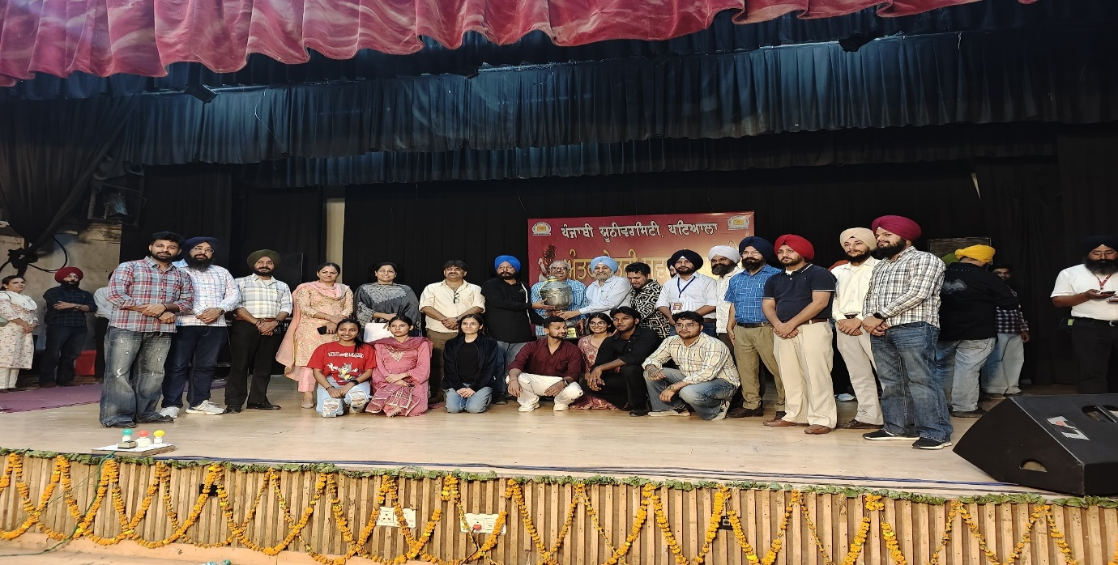
Guru Nanak College organises “Satrang” -An Educational, Technical and Cultural Fair annually. During this session Satrang was organised on 5 to & April 2025. During this fair different departments organise exhibitions in college premises such as Science exhibitions, technical exhibitions, book fair, cultural and heritage exhibitions, fun games, flower shows, literary exhibitions, etc. This fair is visited by the local people enthusiastically.
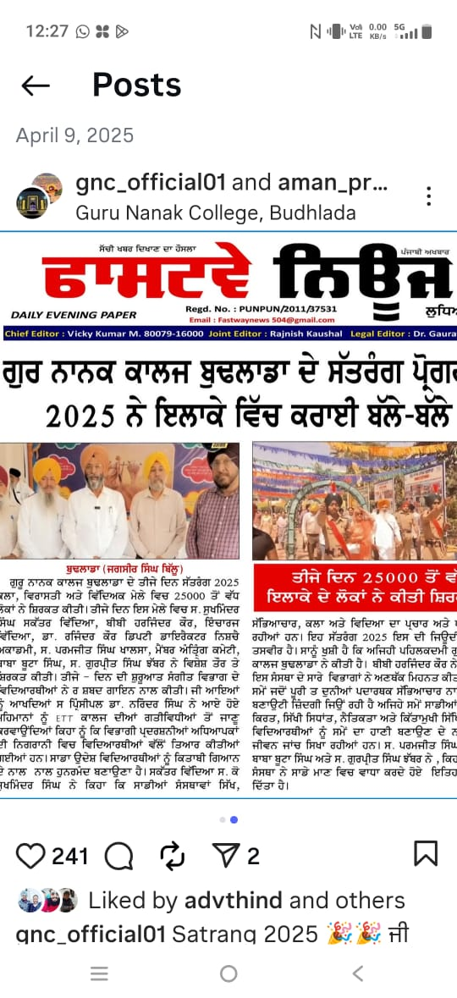
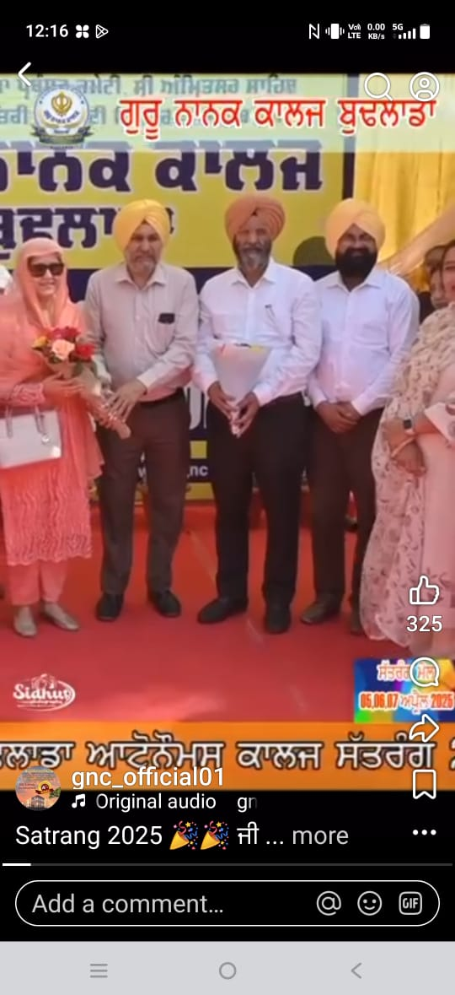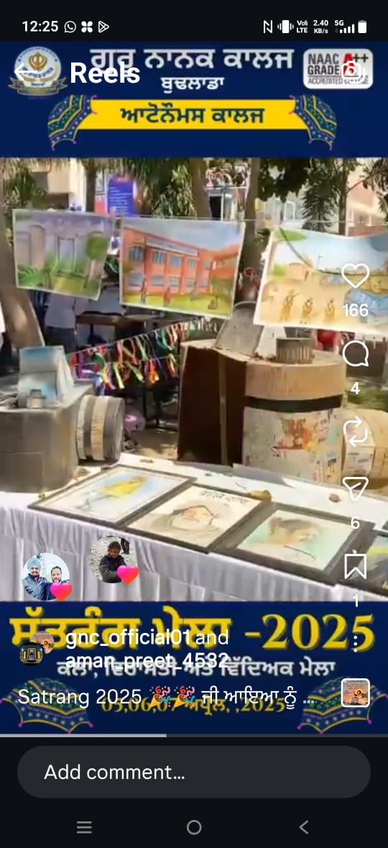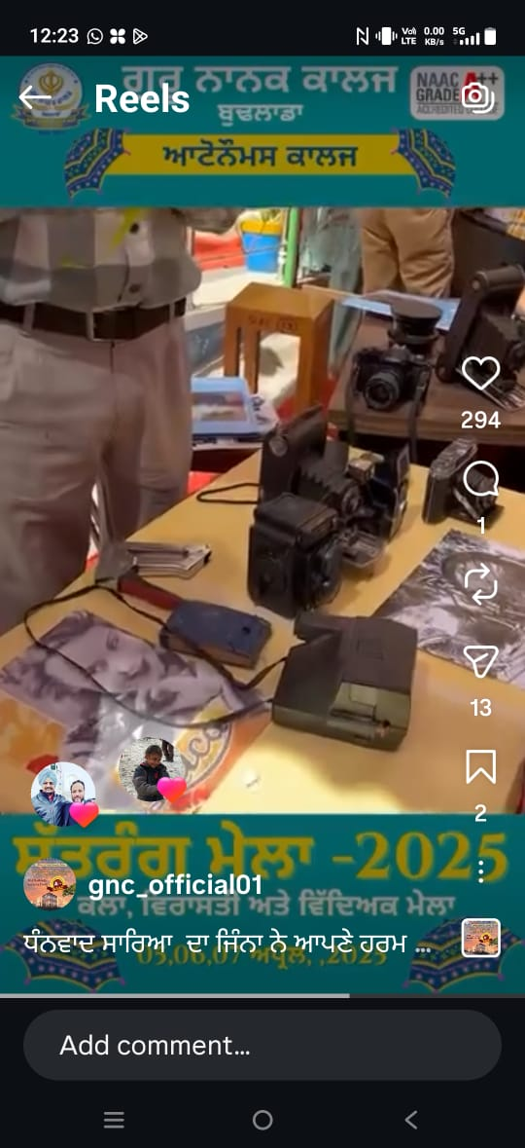
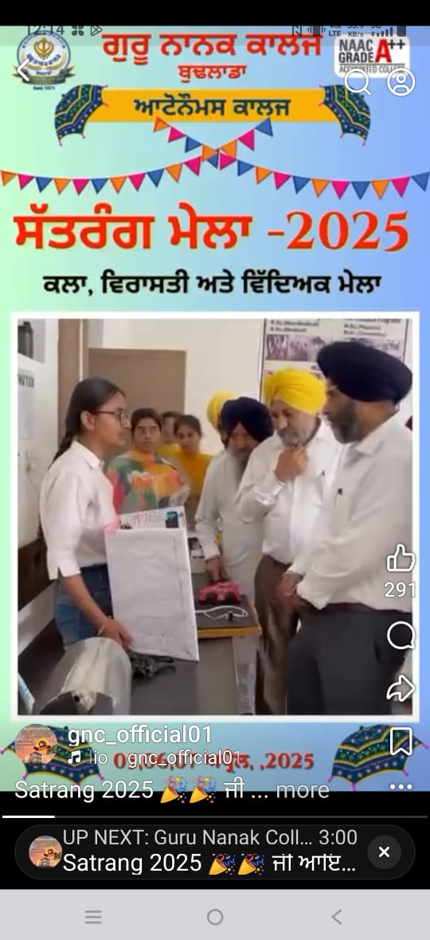
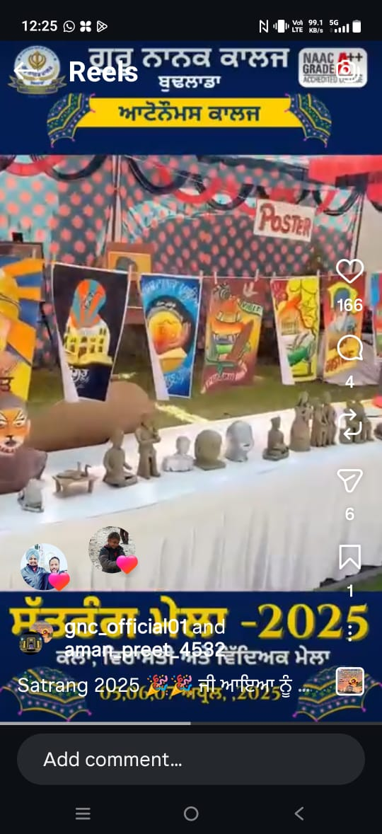
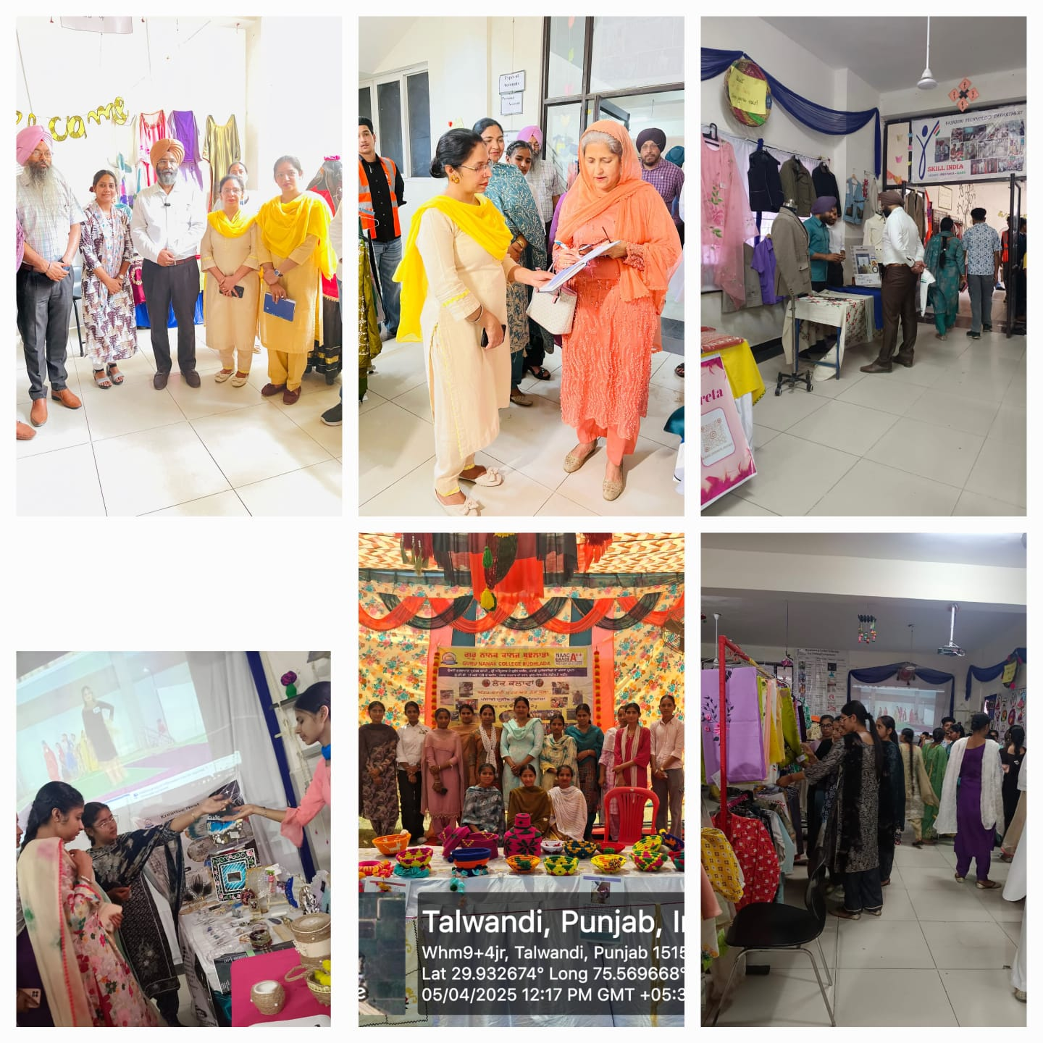
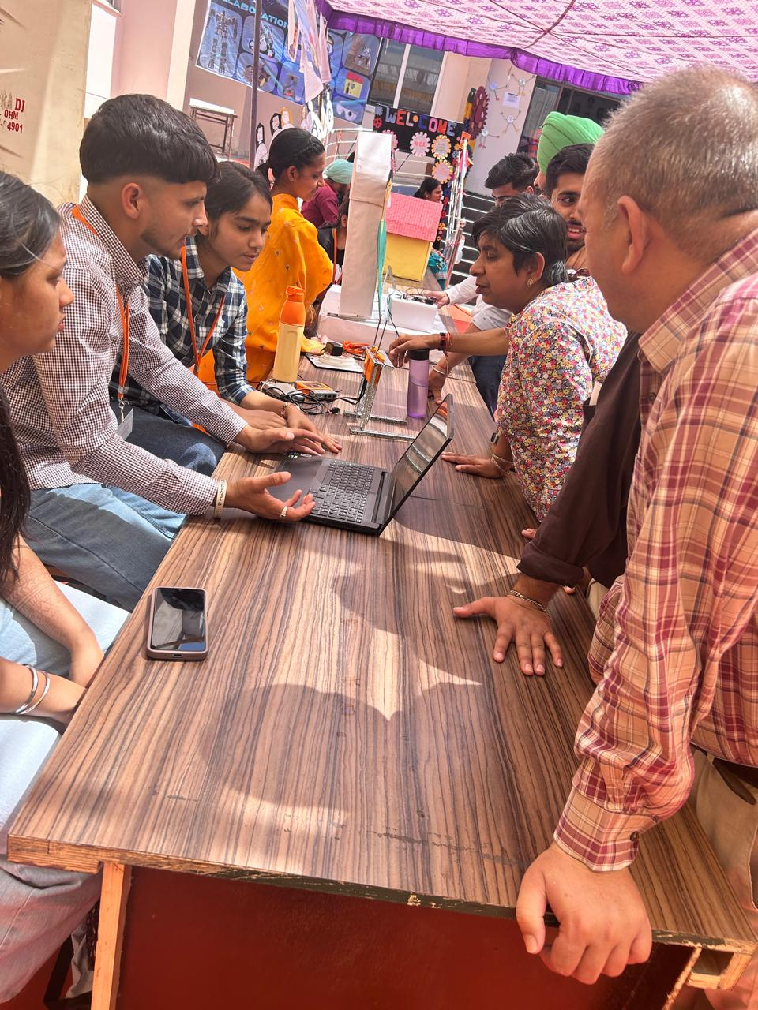
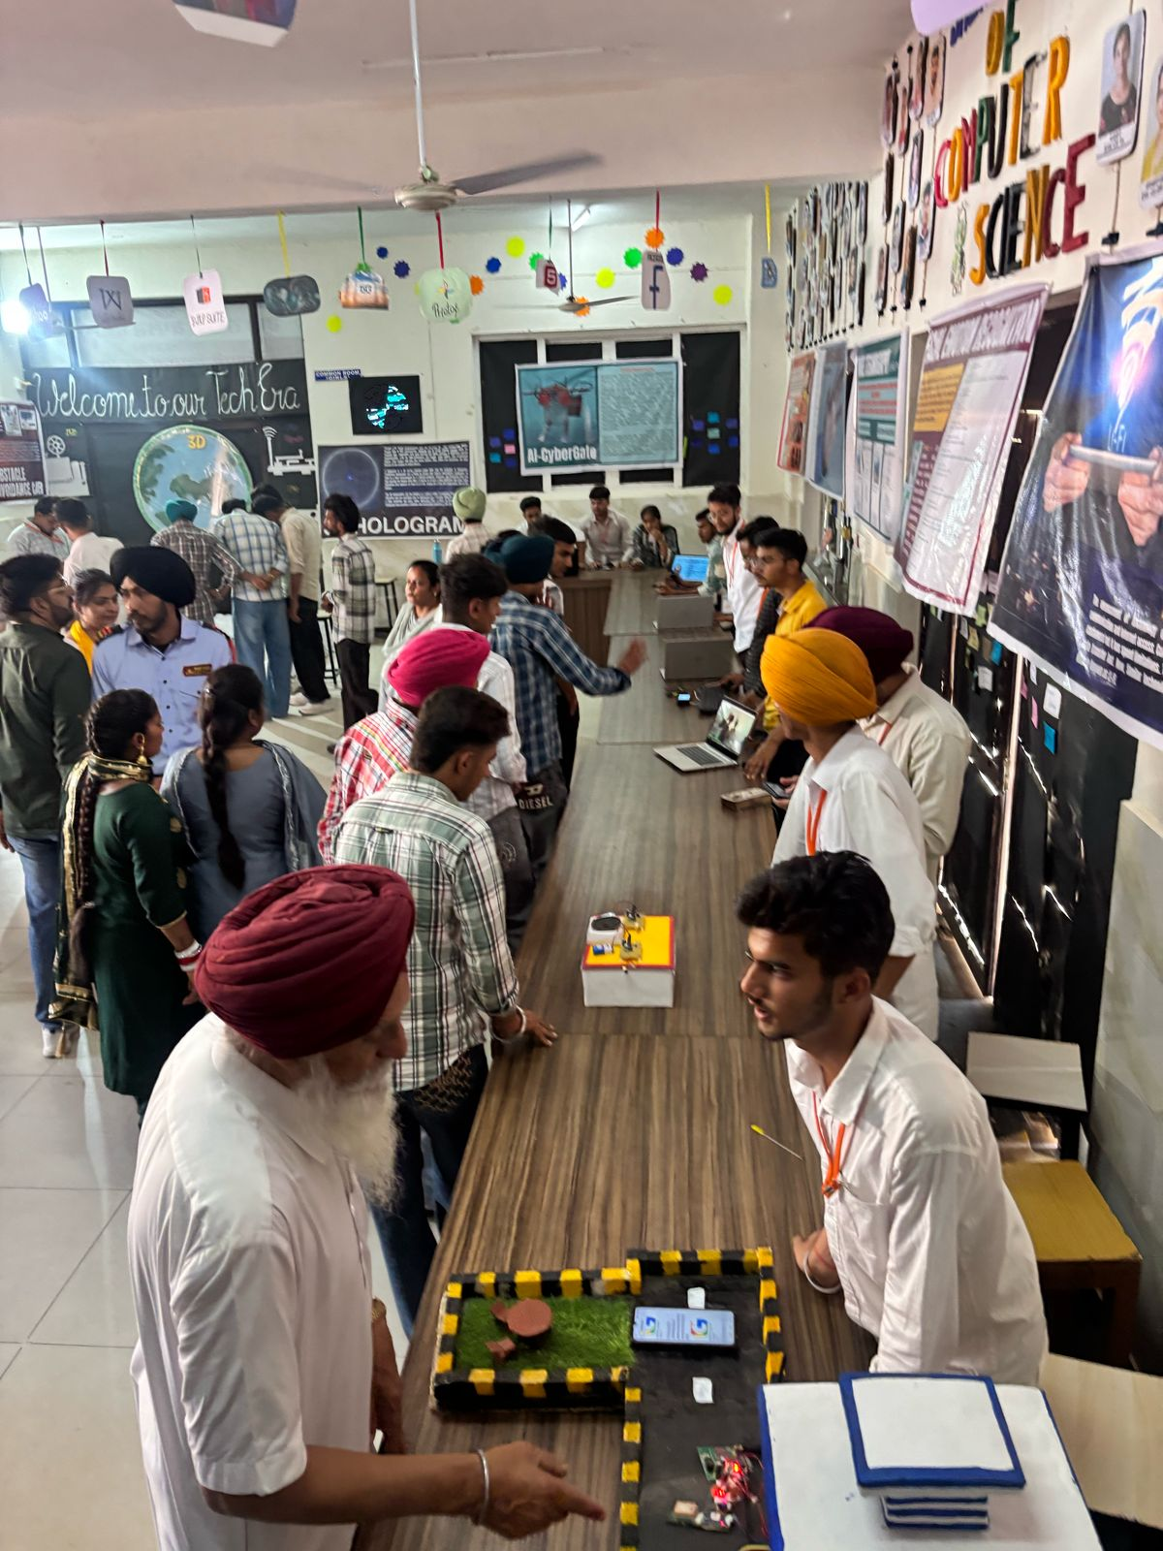

Guru Nanak College celebrated Lohri, a cultural and traditional Indian festival in college campus with great zeal and enthusiasm.
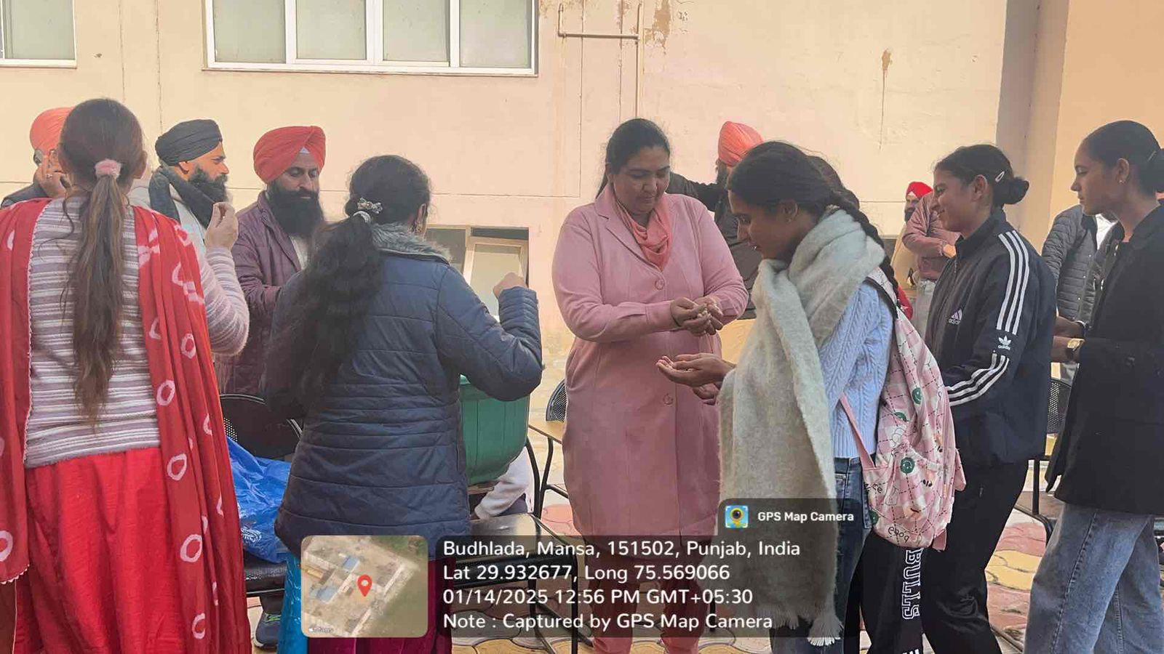
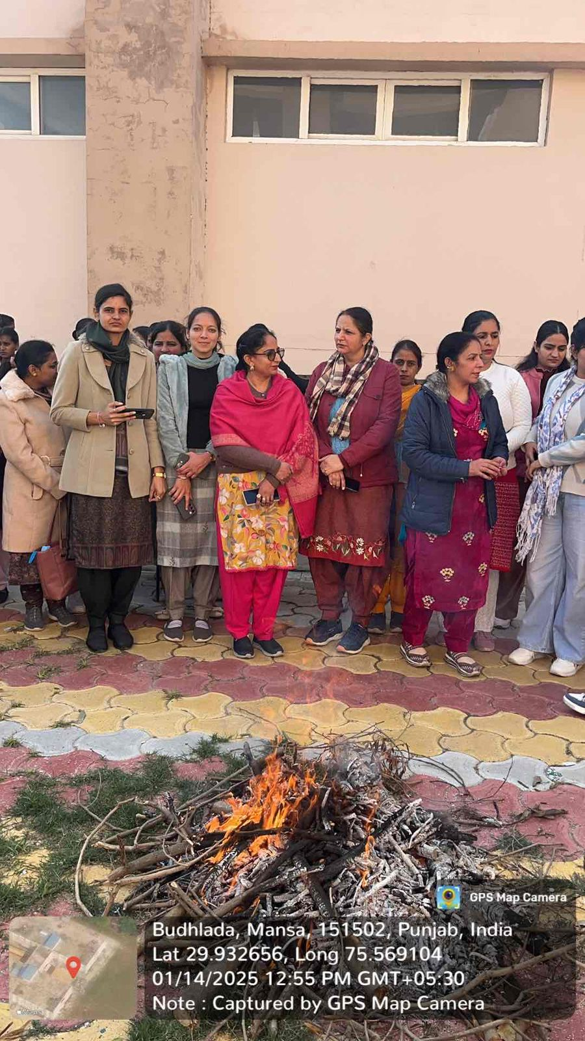
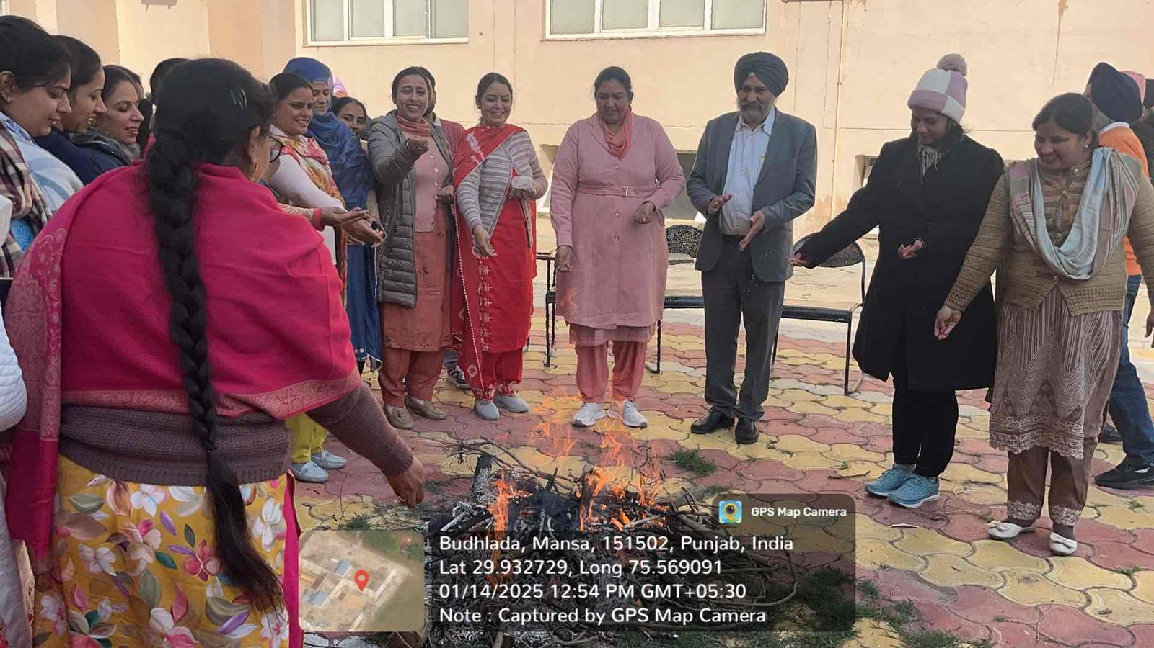
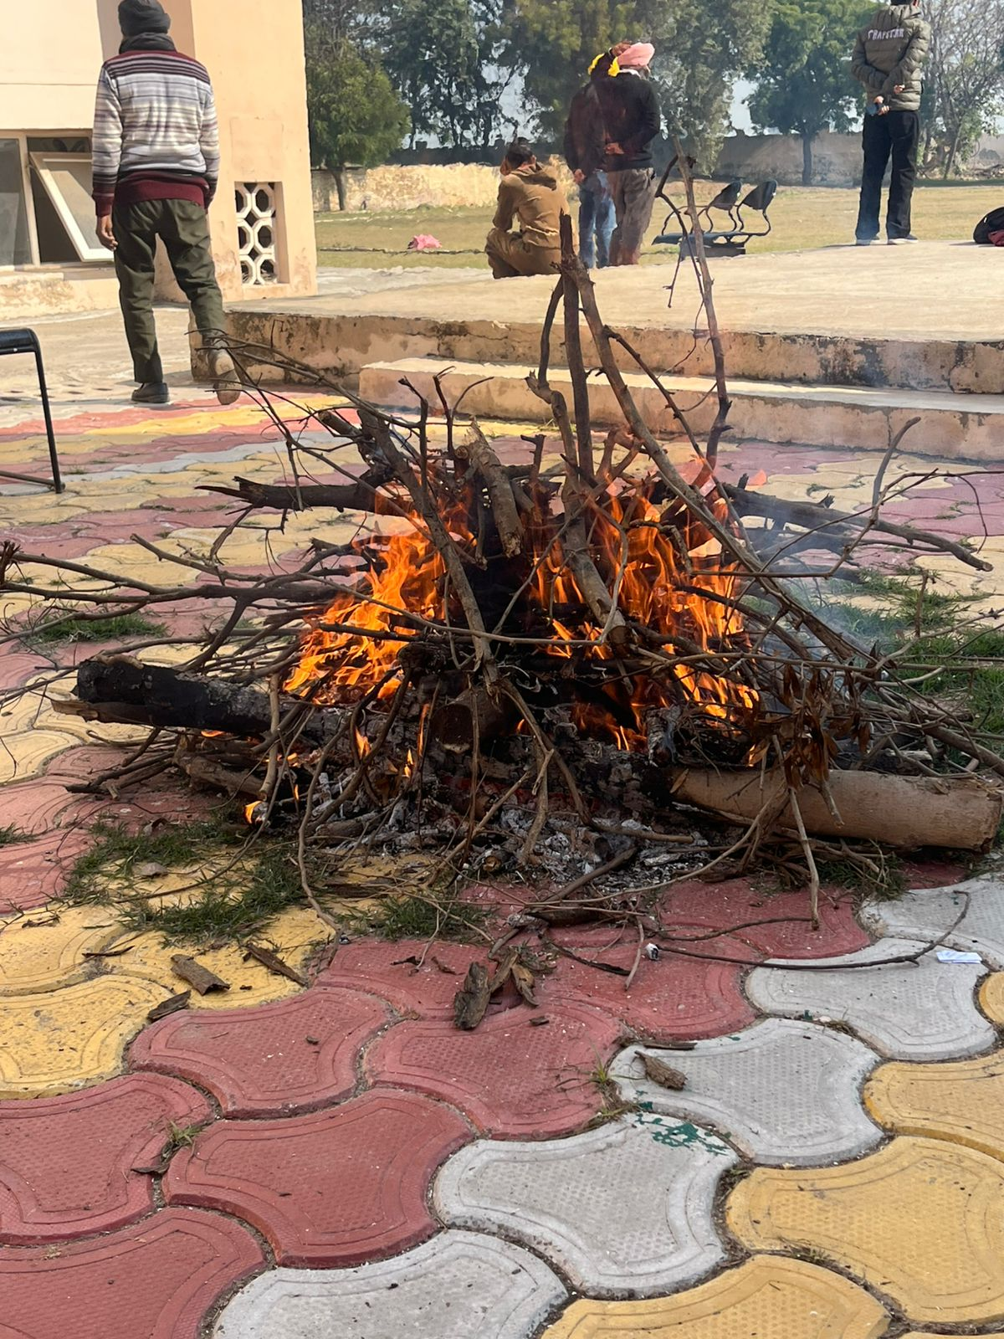
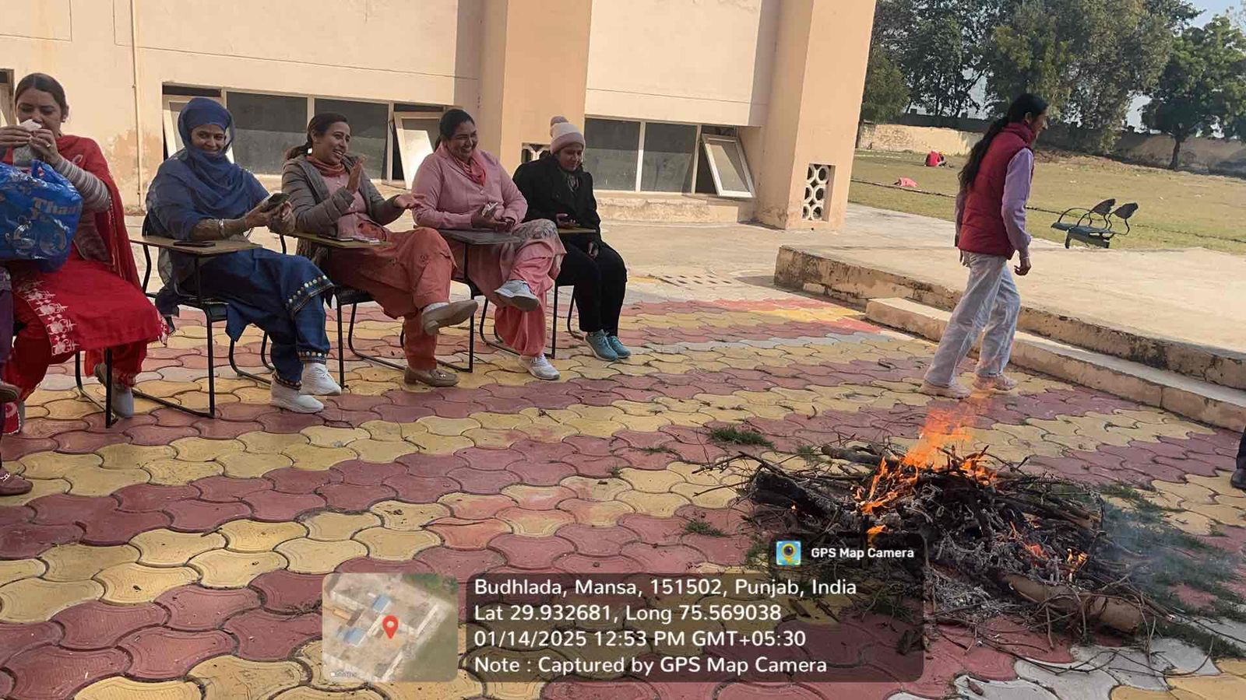
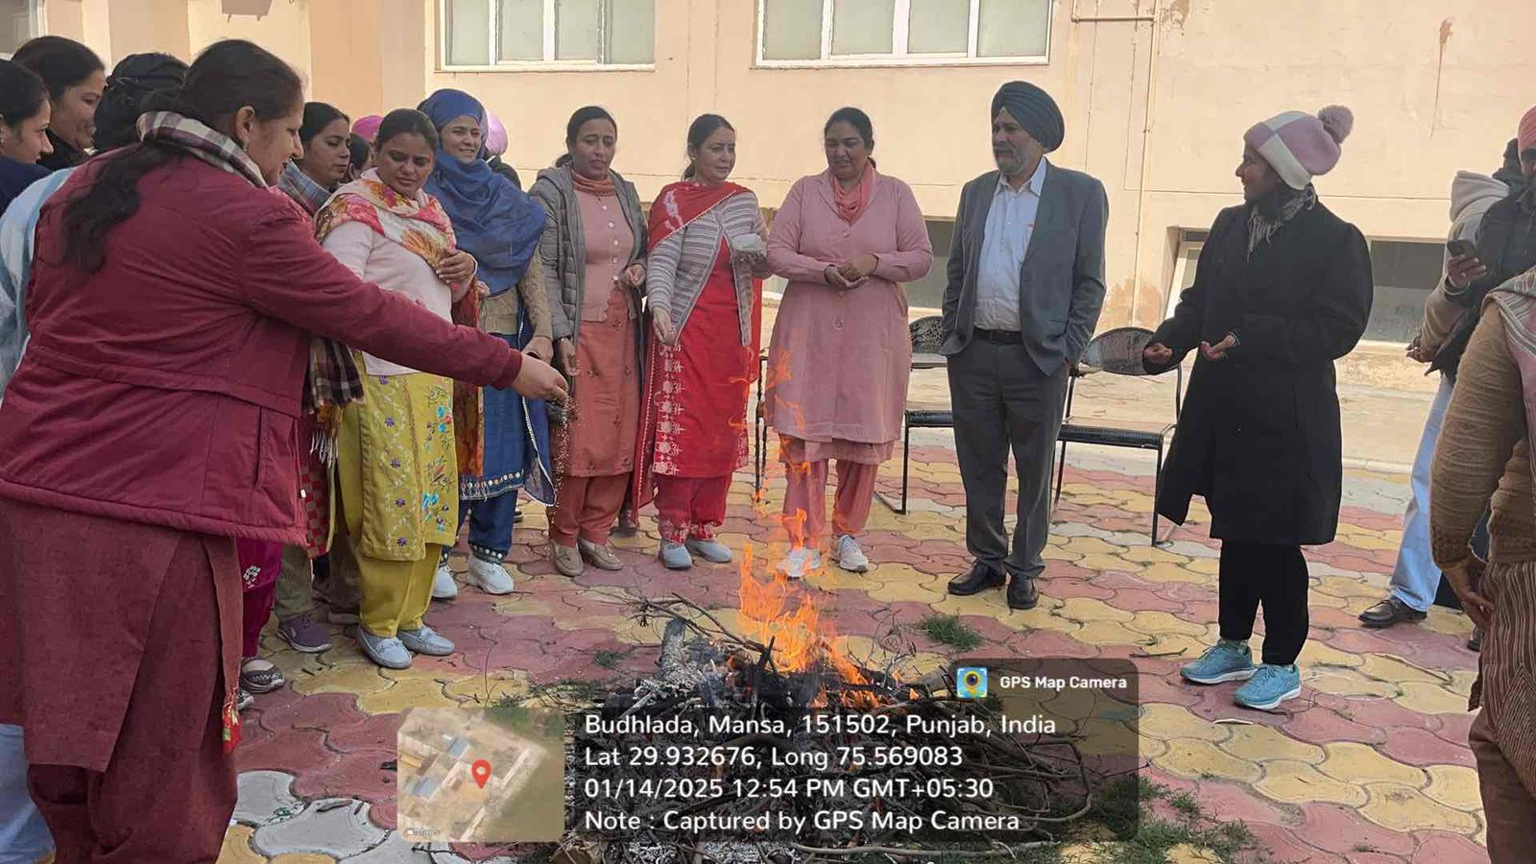

The History Department organised a Dastar Camp on 29/3/2025 in collaboration withDastar Fateh Academy under the theme 'Importance of the dastar, highlighting the importance of the dastar. The main objective of this camp was to inspire today's youth towards the Sikh way of life.
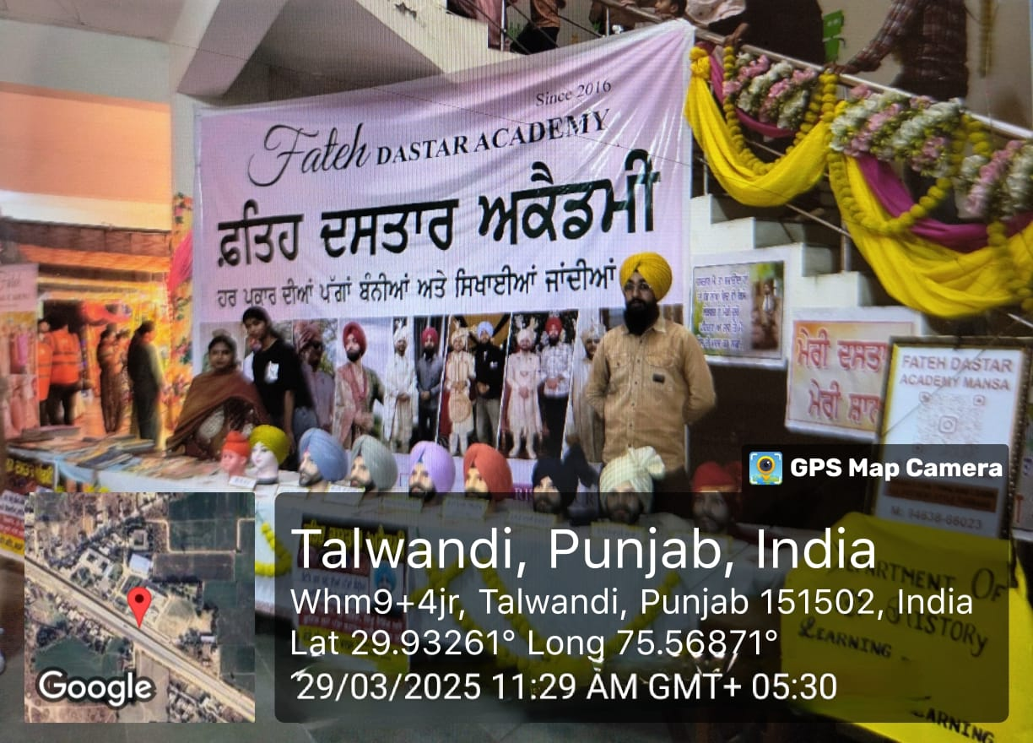
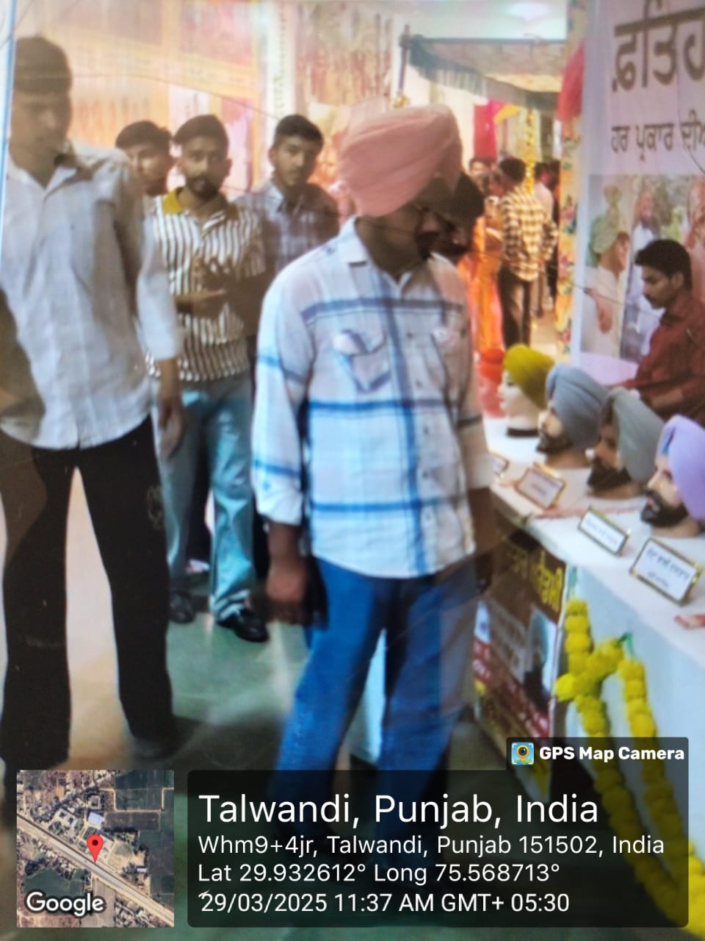

Department of Computer Science organised a Workshop of Calligraphy on 03/03/2025.
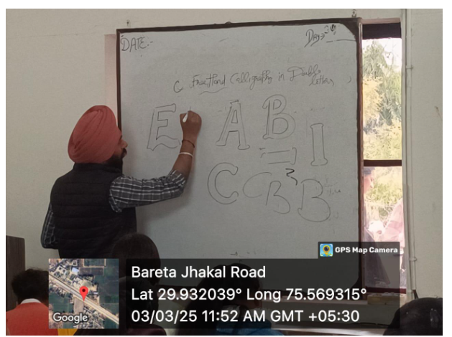
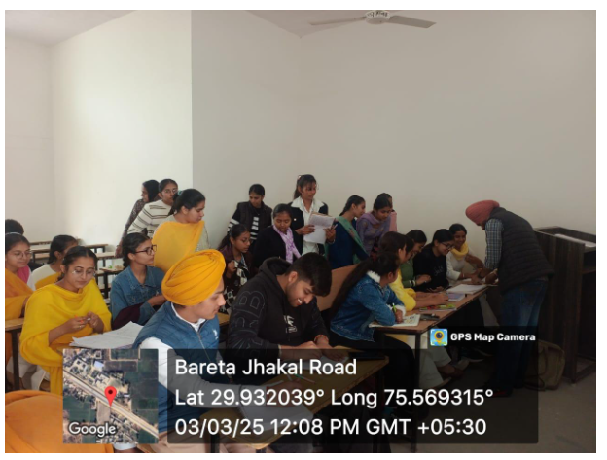
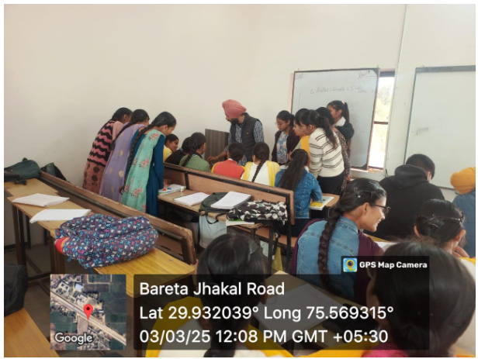
On February 23, 2025, Guru Nanak College celebrated World Day of Peace and Understanding with a special guest lecture titled "Find Your Inner Peace Through Yoga." Assistant Professor Ramandeep Singh from the Department of Physical Education was the keynote speaker.
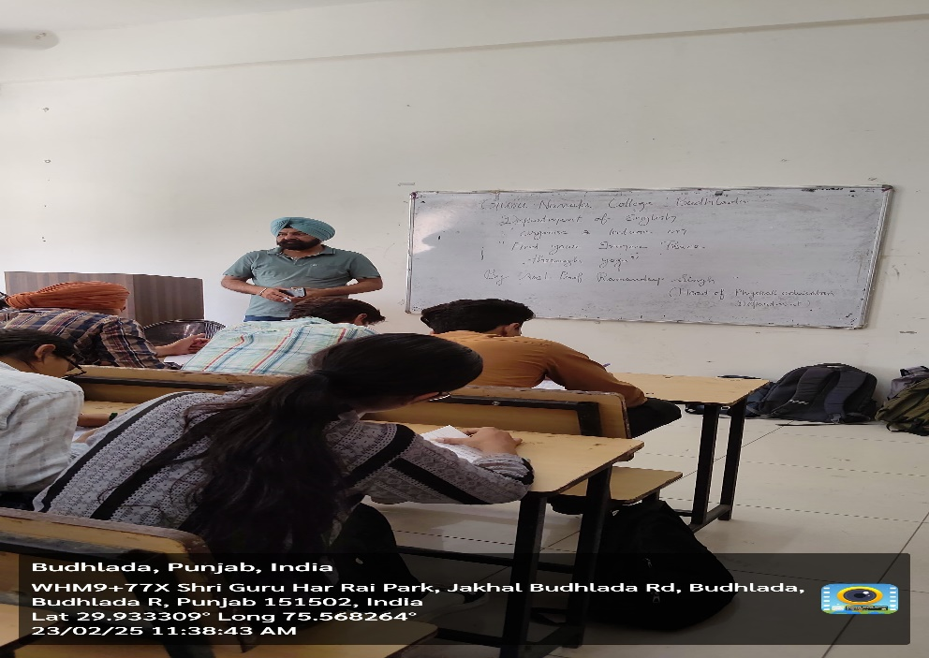
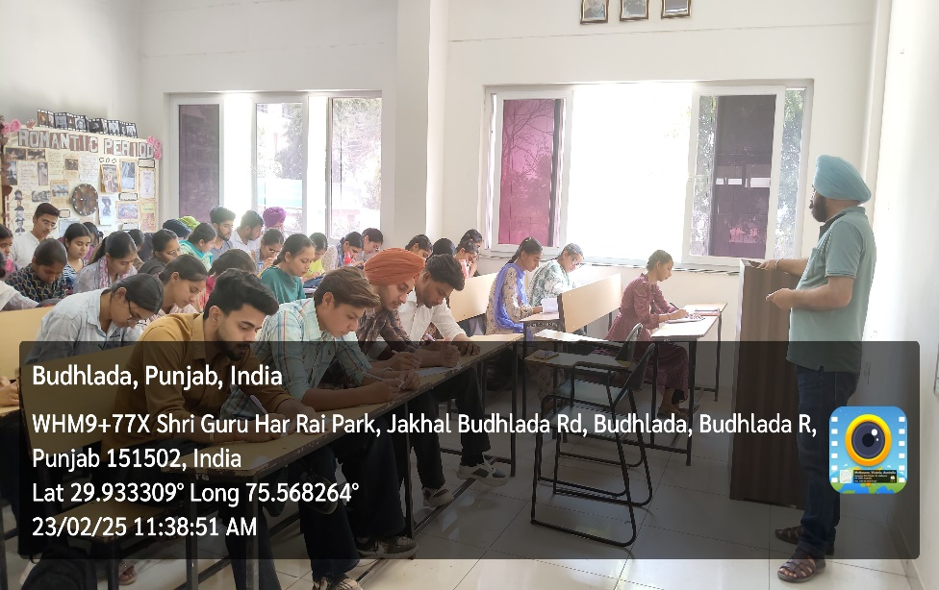
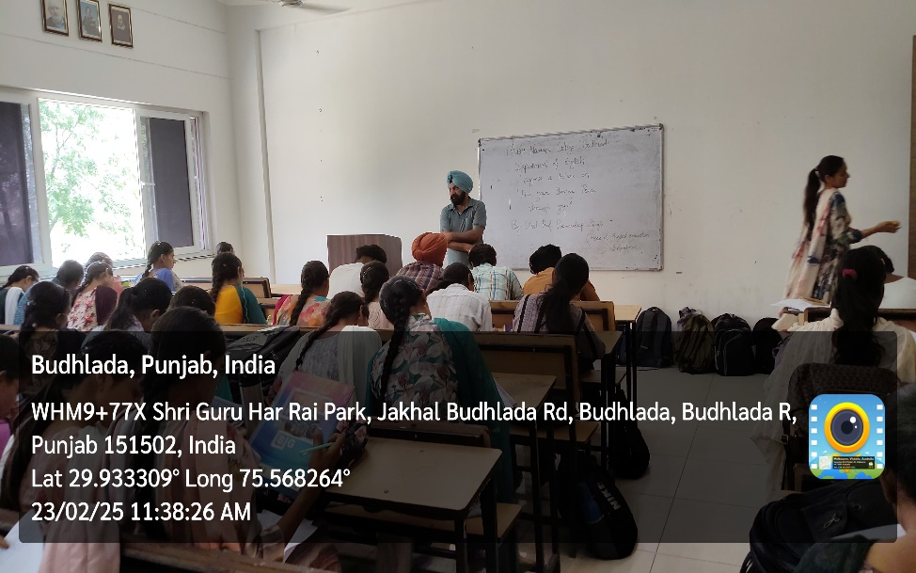
Department of Food Processing organised a Lecture and Discussion on “Promoting Heritage, Culture, Sports and Social Values among Students”on 16 October, 2024 in the department.
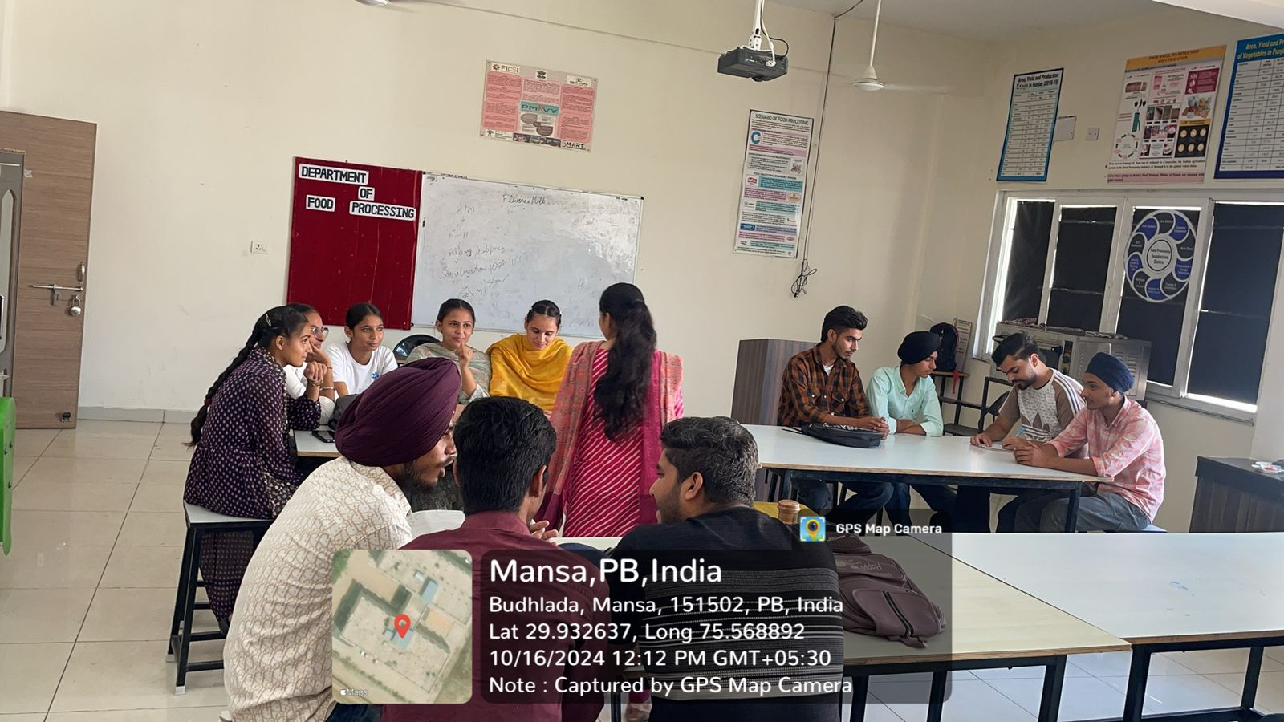
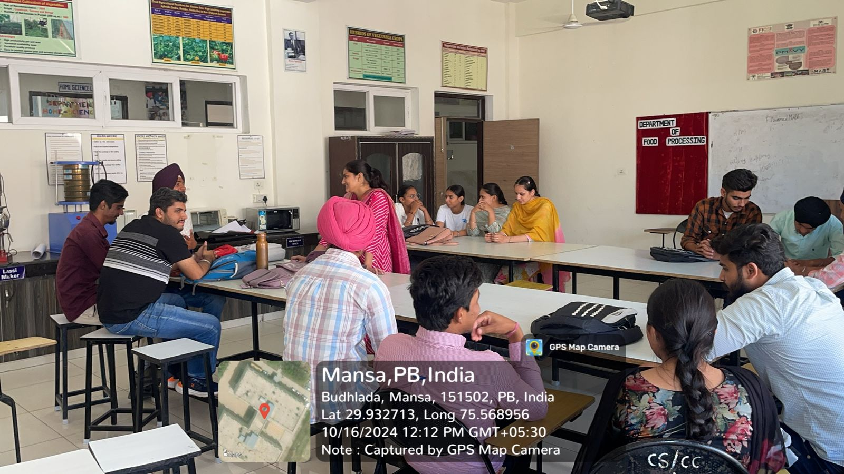
गुरू नानक कॉलेज के हिन्दी विभाग की ओर से शुभ दीपावली के अवसर पर 30अक्तूबर, 2024
प्रतियोगता करवाई गई जिसमें विद्यार्थियों द्वार दीपावली के इतिहास व महत्व पर अपनी भावनाओं को व्यक्त किया।
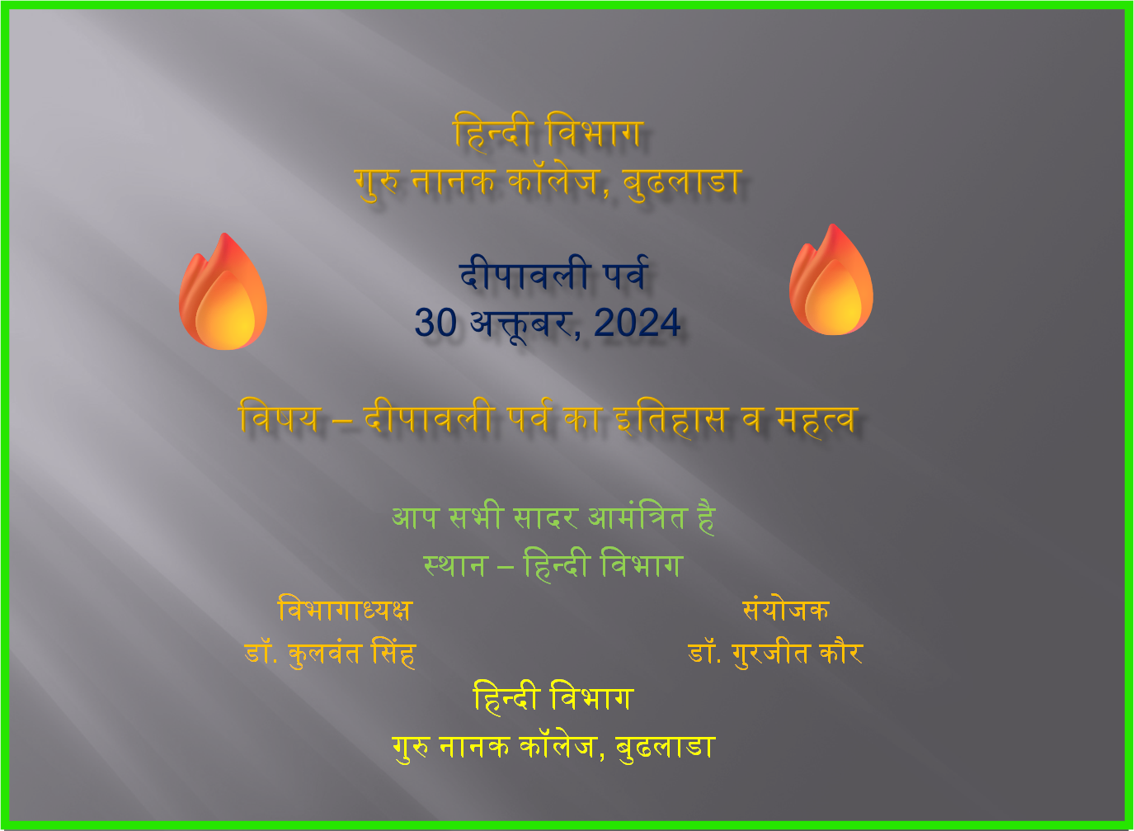
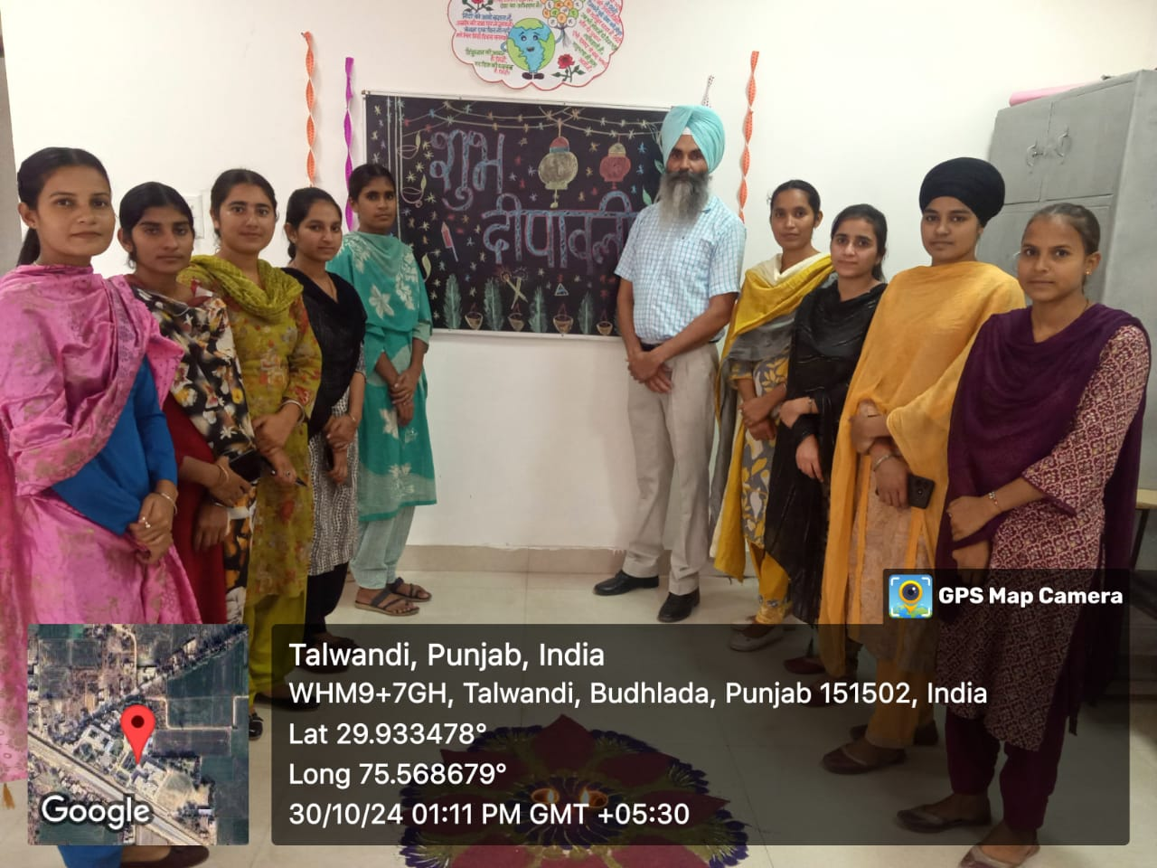

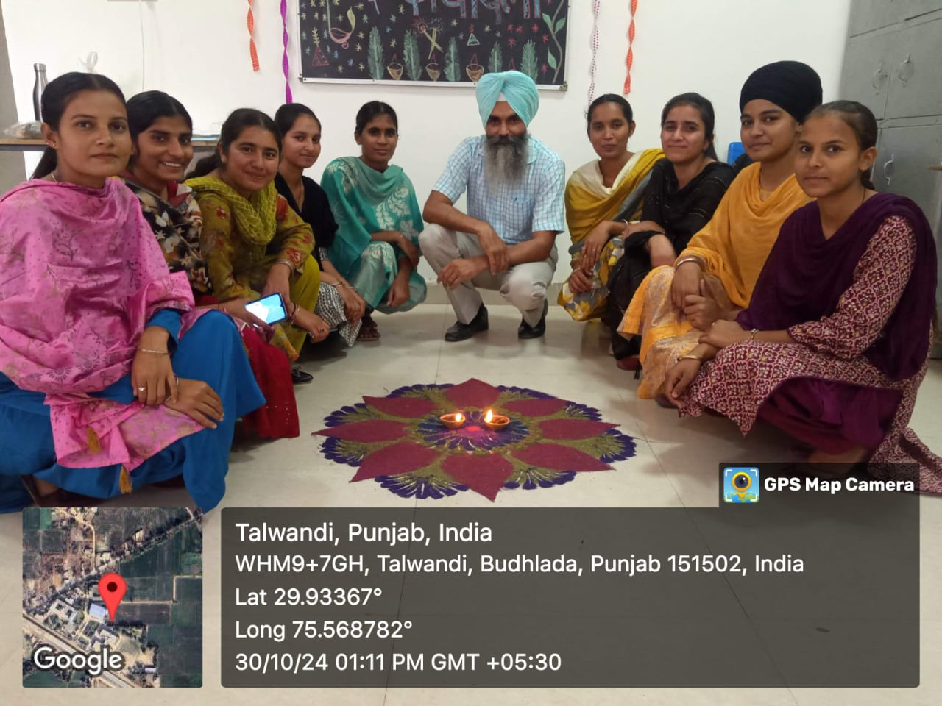

Department of Hindi organised a lecture on “Kabir Bani” to make the students aware about the sant Kabir’s contribution in Gurbani and language on 22-10-24.

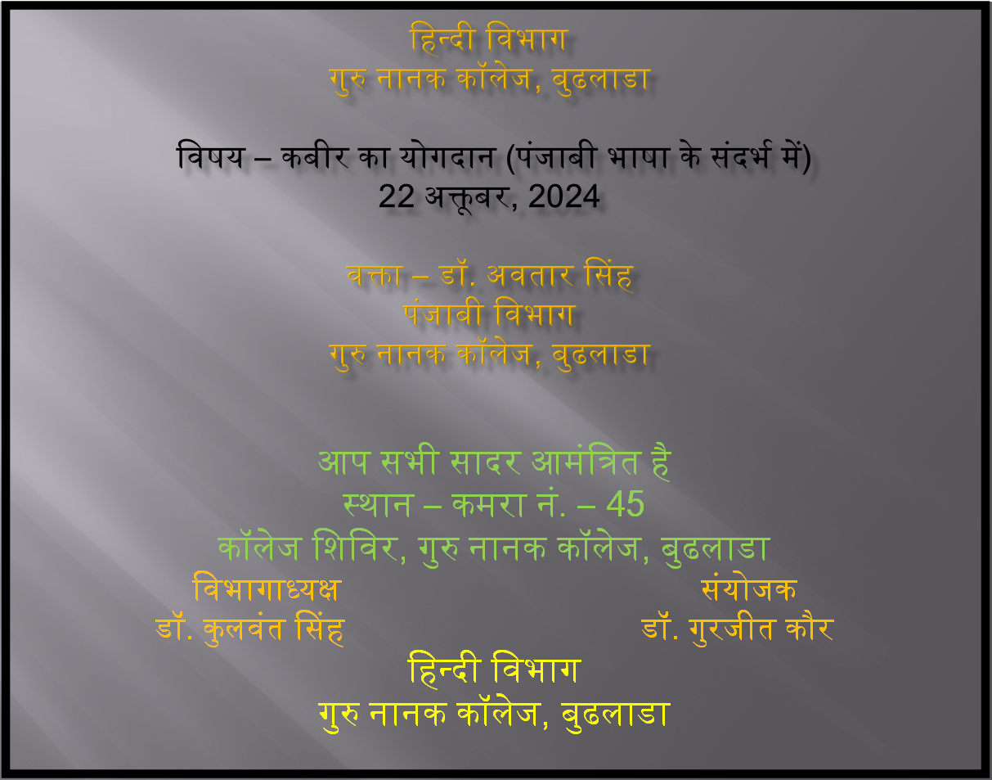

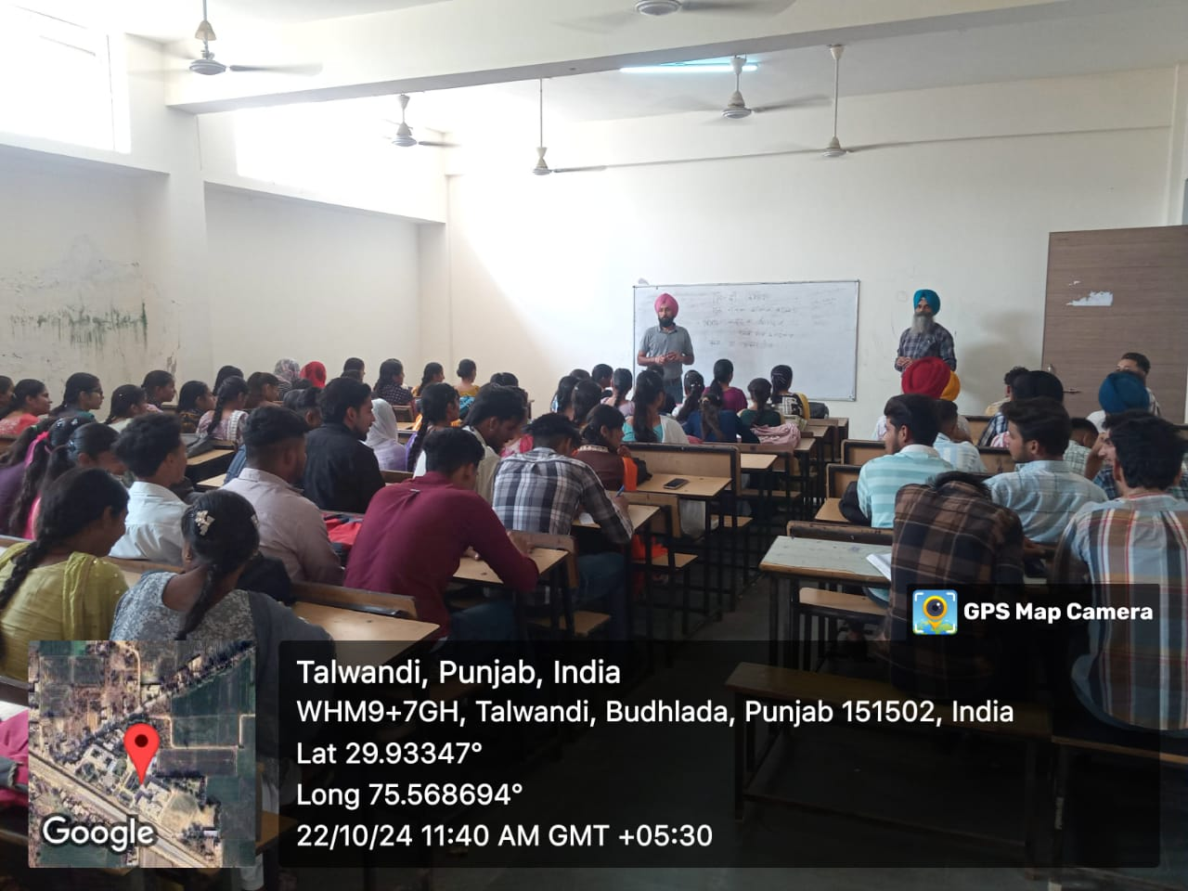
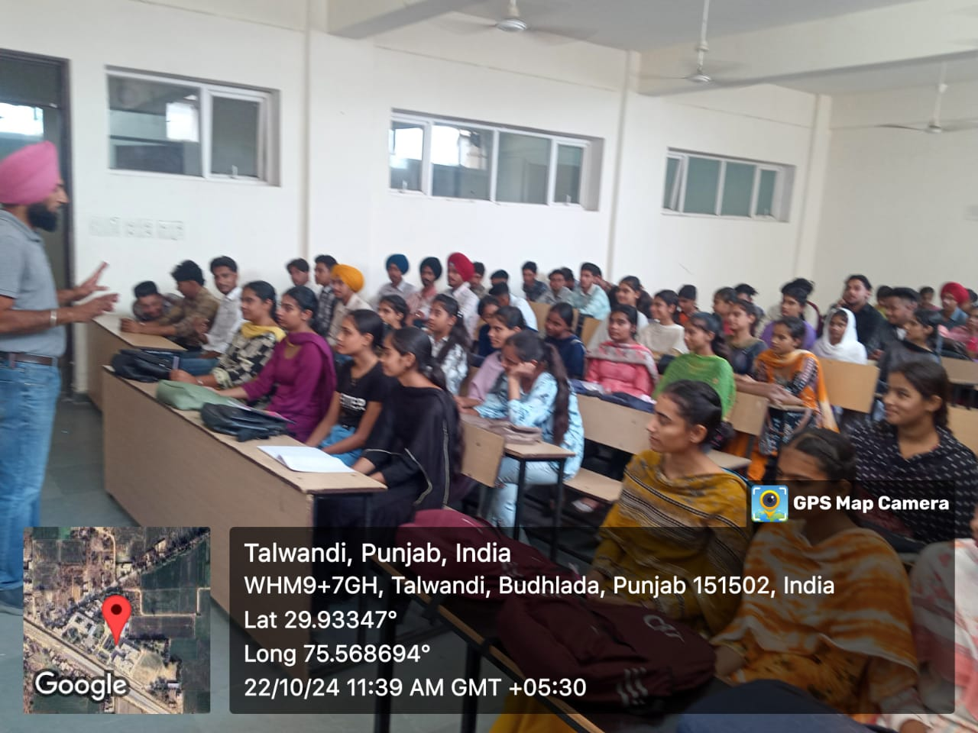

National Librarians Day in India is celebrated every year on August 12th to honor the invaluable contributions of librarians in fostering learning, research, and access to information. The day also commemorates the birth anniversary of Dr. S.R. Ranganathan, regarded as the Father of Library Science in India.
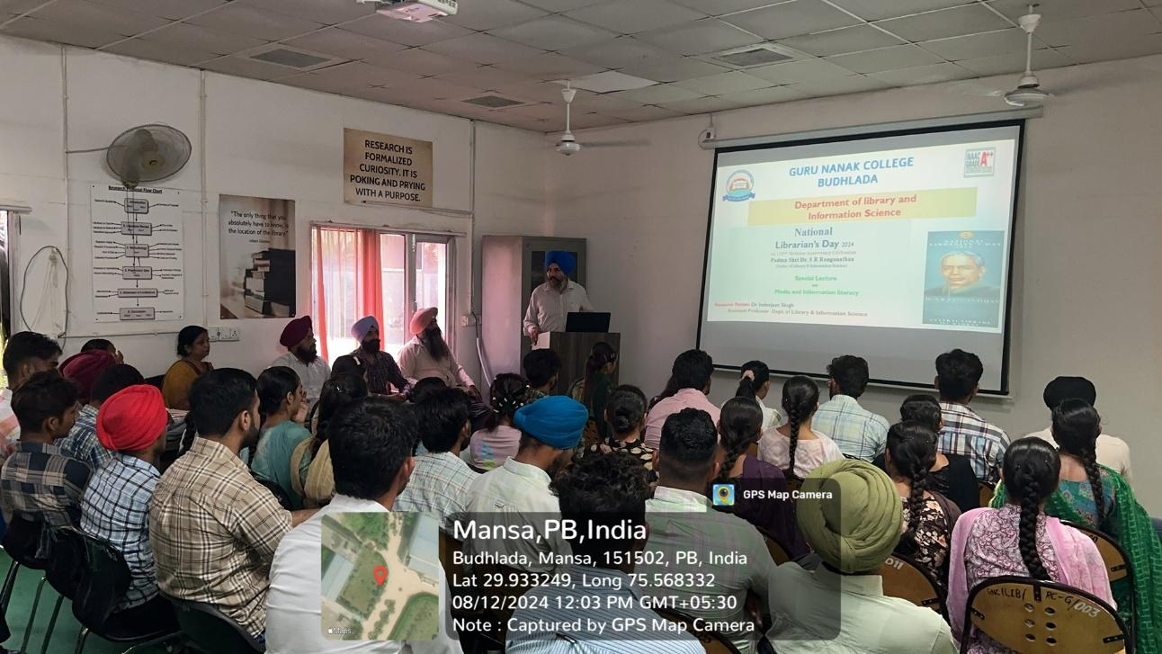
Green Diwali is an eco-friendly way of celebrating the traditional Indian festival of Diwali, with a focus on reducing pollution and protecting the environment. Instead of bursting loud and harmful firecrackers, Green Diwali encourages people to celebrate with lights, sweets, family gatherings, and sustainable practices. Department of Library Science organised Green Diwali on 30-10-2024.
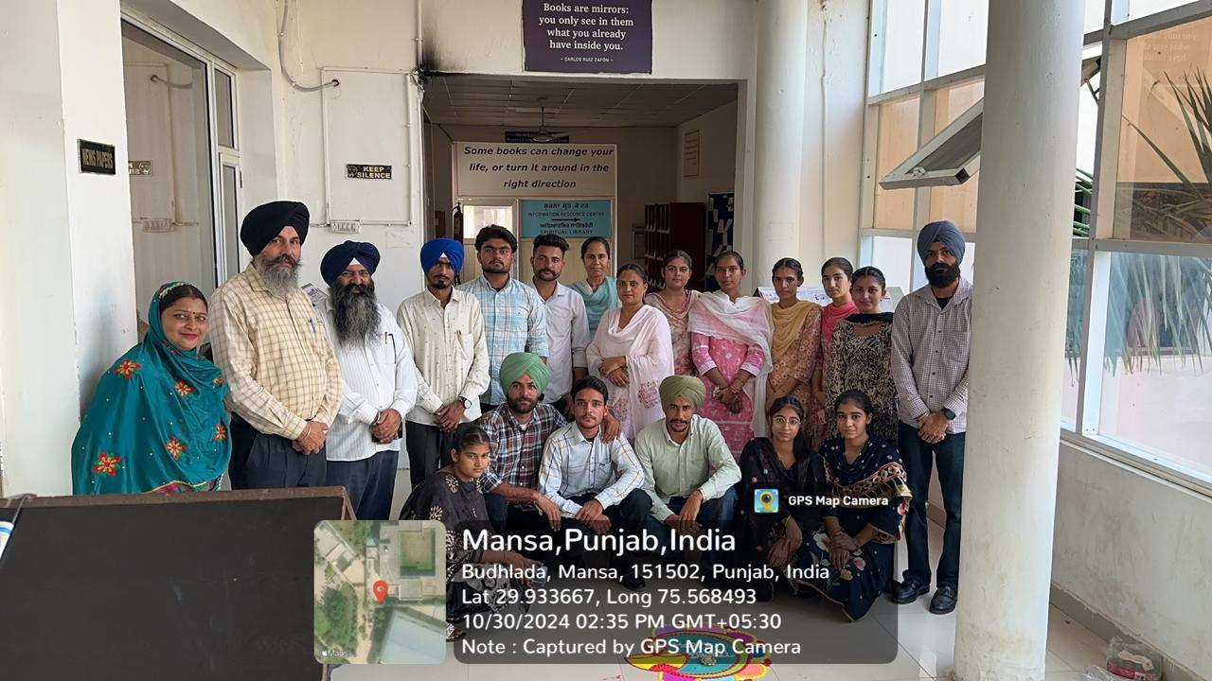
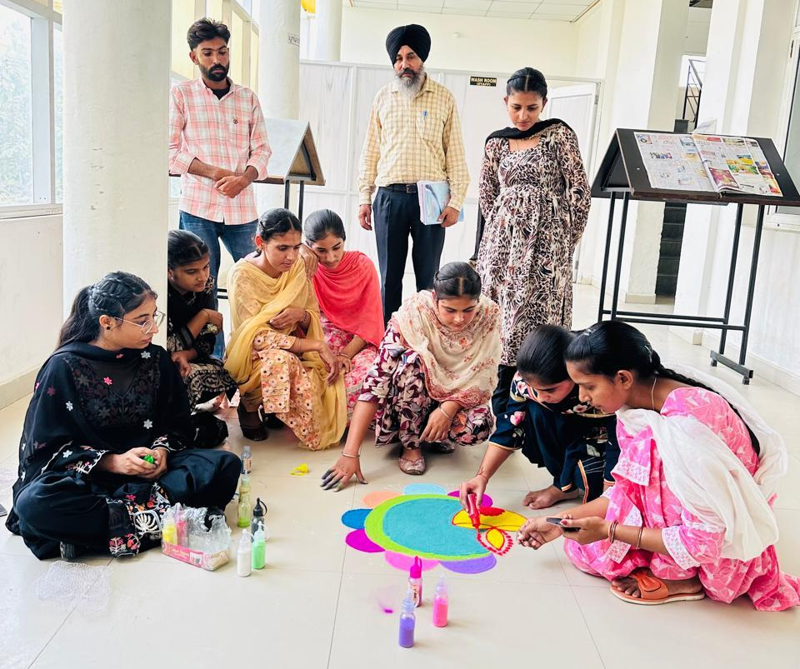
A Poster making competition was organized on 7th November 2024 by Dept of mathematics to encourage creativity and raise awareness on socially relevant themes. The competition provided a platform for self-expression and promoted awareness among peers. The best entries were appreciated and displayed on the notice board, creating an inspiring visual impact.
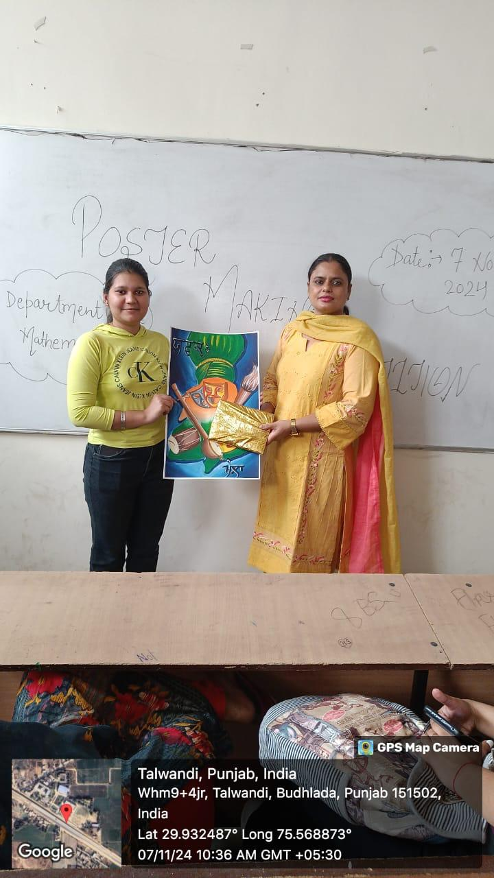

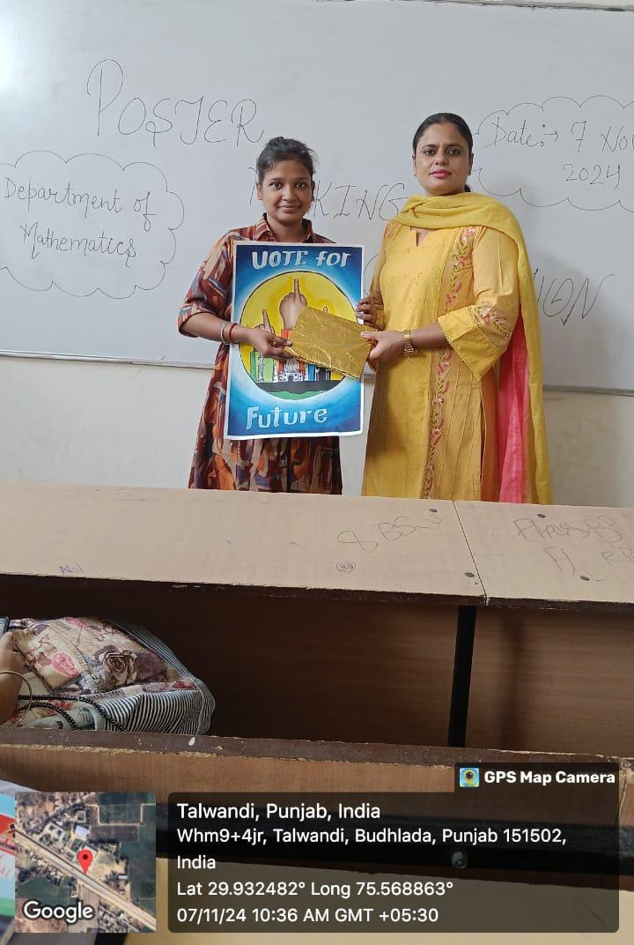
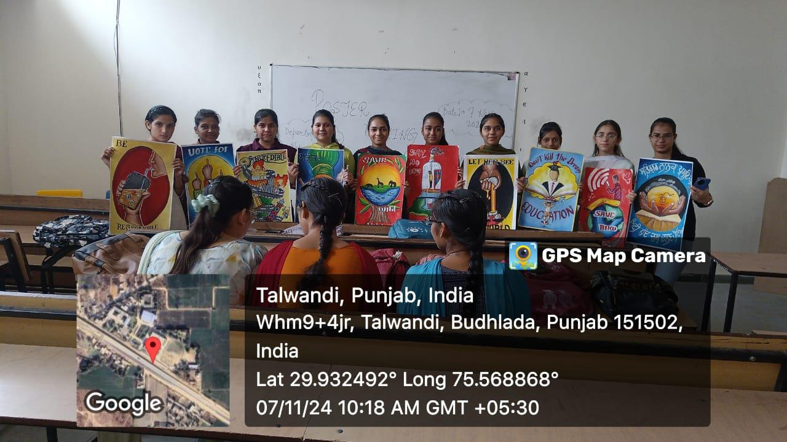
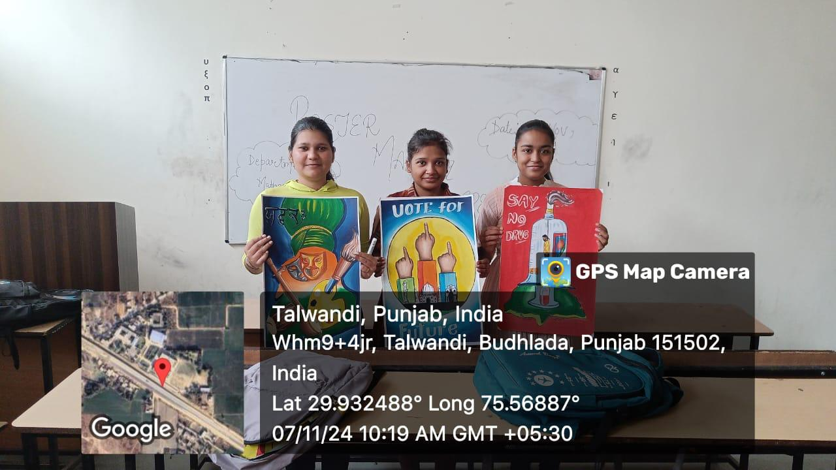
fwsh 7^2^2025 ƒ r[o{ BkBeekbi p[Ybkvkfty/ fgqz;hgbvkeNoBfozdof;zxekbVk dh ofjB[wkJh j/m ;zrhsftGkrt~b'ArIbrkfJeh s/ ftP/P b?euo fi; dk ftPk'Analysis of Gazal Gayaki : Traditional and Modern Fusion' eotkfJnkfrnkfJ; ft~u w[~y teskti'A ;qh ;bhw e[wko B/ fPoesehsh ;qh ;bhw e[wko B/ p'bfdnKrIb d/ fJfsjk; s/ ukBDkgkT[AfdnKGkosh ;[rw ;zrhsft~urIbrkfJeK dh rkfJeh dk s[bBkswenfXn?Bpko/ d~f;nkfJ; d/ Bkbjh tv/oh ghVh d/ T[;skd r[bkwnbh ns/ irihsf;zx j[oKdhnKrIbK ;[DkJhnK ns/ toswkBghVh d/ ;[fozdoykB ns/ i?iwPowkdhnKrIbKBkbftfdnkoEhnK ns/ ;o'fsnK ƒ wzso w[rXehsk. fJ; ;w/A ;zrhsftGkr d/ w[yhvkeNowBgqhsf;zx ;jkfJegq'c?;o p/Bshe"o ns/ ;jkfJegq'c?;o r[oftzdo f;zx jkIooj/
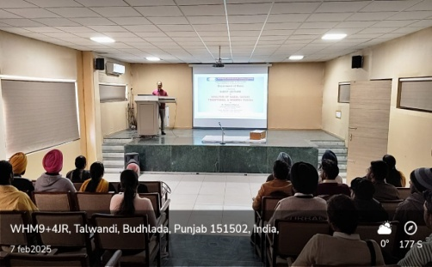
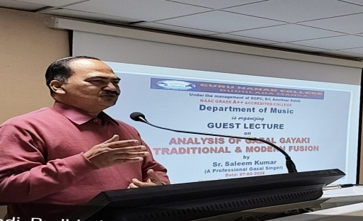
Eco-friendly initiatives and honour the legacy of Guru Har Rai Ji through plantation drive was organized on16-3-2025, led by the S.SukhminderSinghEducation Secretary of SGPC (Shiromani Gurdwara Parbandhak Committee).It added inspiration and significance to the event, encouraging students and staff to actively participate in greening the campus and embracing sustainable practices.The plantation drive aimed to spread awareness about the importance of environmental conservation and living in harmony with nature, in alignment with the teachings of Sikhism.
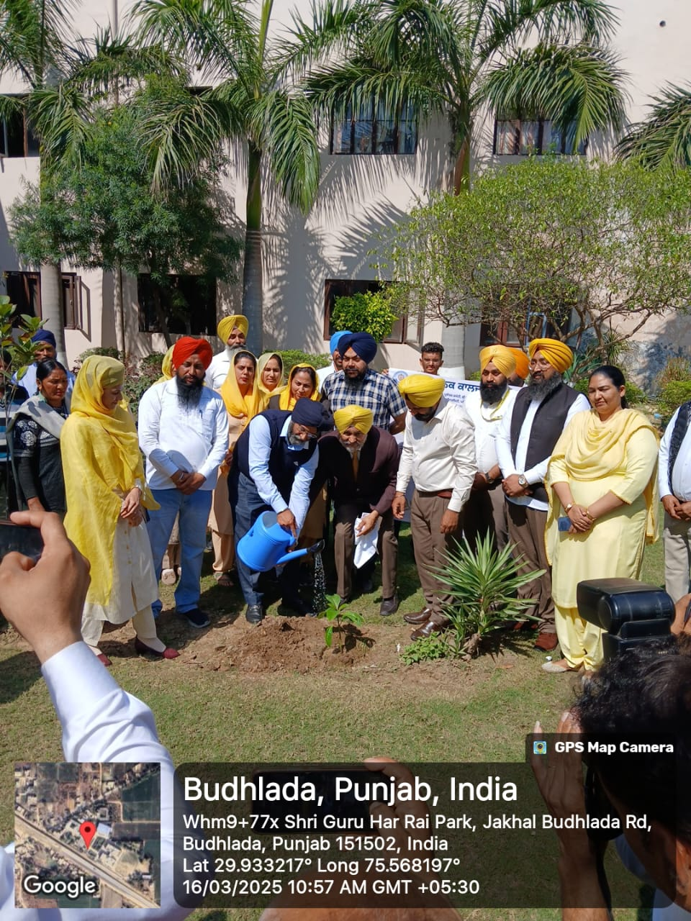
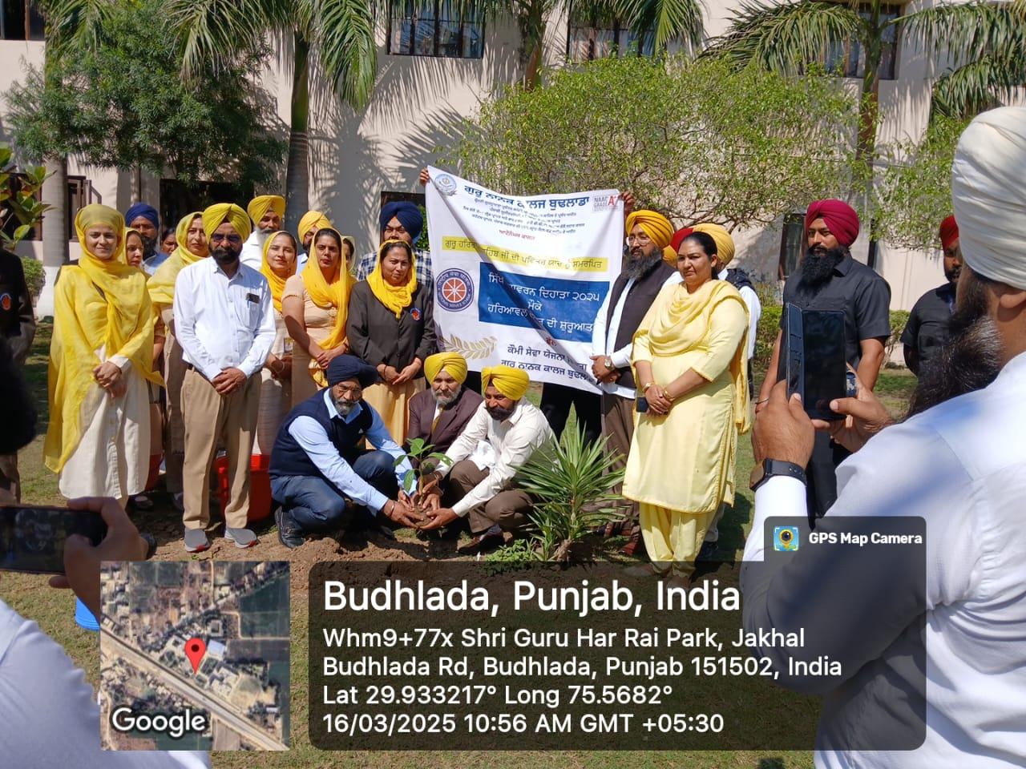

ਪੰਜਾਬੀਵਿਭਾਗਦੁਆਰਾਭਾਈਵੀਰਸਿੰਘਦੇਜਨਮਦਿਹਾੜੇ05-12-2024ਨੂੰਸਮਰਪਿਤਮਾਂ-ਬੋਲੀਦਿਵਸਮੌਕੇਅਲੂਮਨੀਦੇਮੈਂਬਰਾਂਦੁਆਰਾਵੱਖਵੱਖਸਕੂਲਾਂਵਿਚਕਰਵਾਏਗਏਮੁਕਾਬਲੇਕਰਵਾਏਗਏ। ਇਸਵਿਚਅਲਮੂਨੀਭਾਈਵੀਰਸਿੰਘਸਾਹਿਤਸਦਨਦੇਘੱਟੋਘੱਟਦਸਮੈਂਬਰਾਂਦੁਆਰਾਆਪਣੇਮਕੂਲਾਂਵਿਚਪ੍ਰੋਗਰਾਮਕਰਵਾਇਆਗਿਆ।
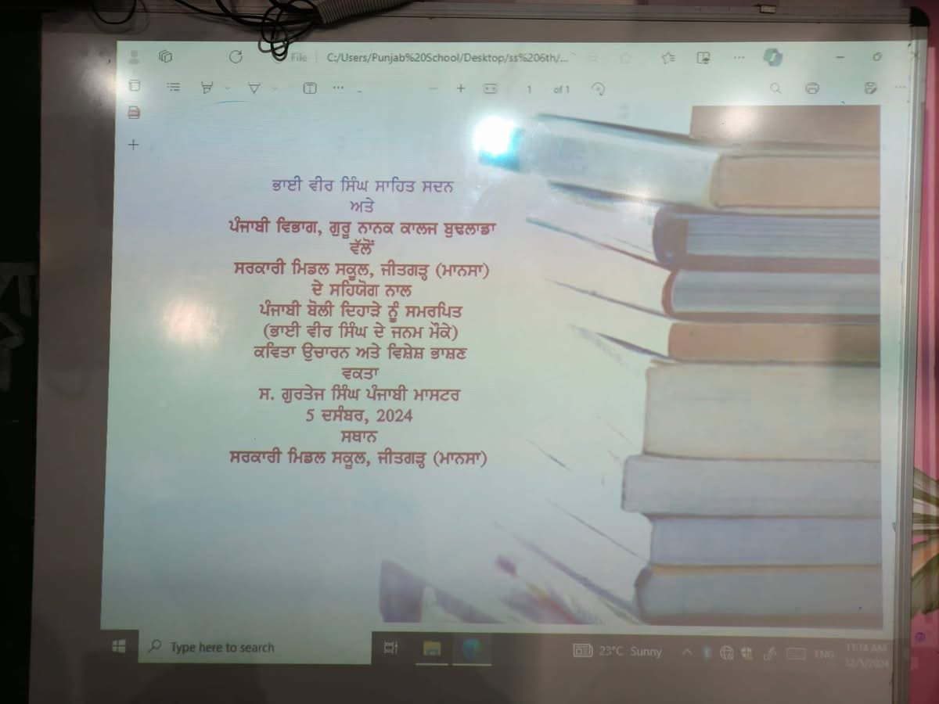
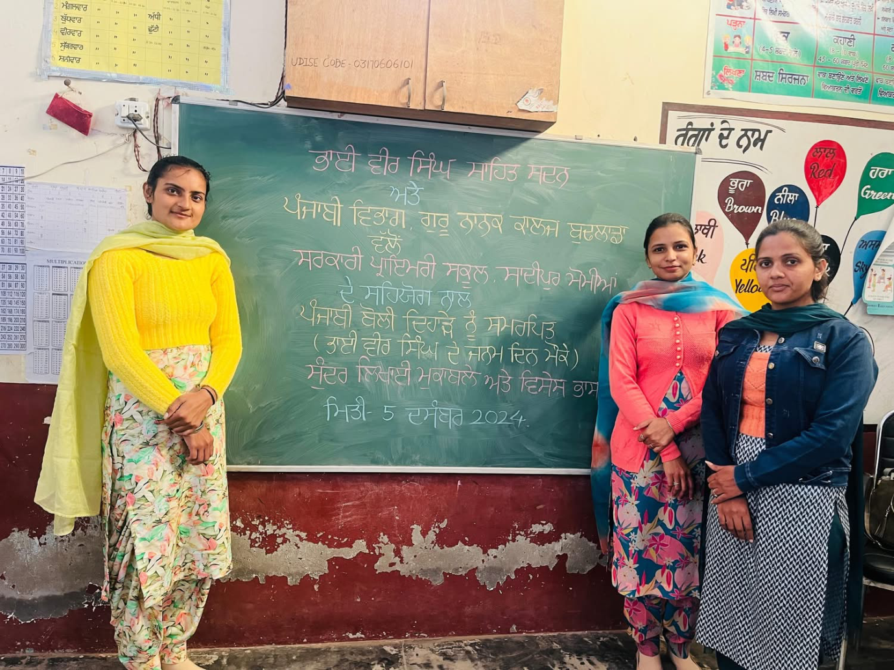
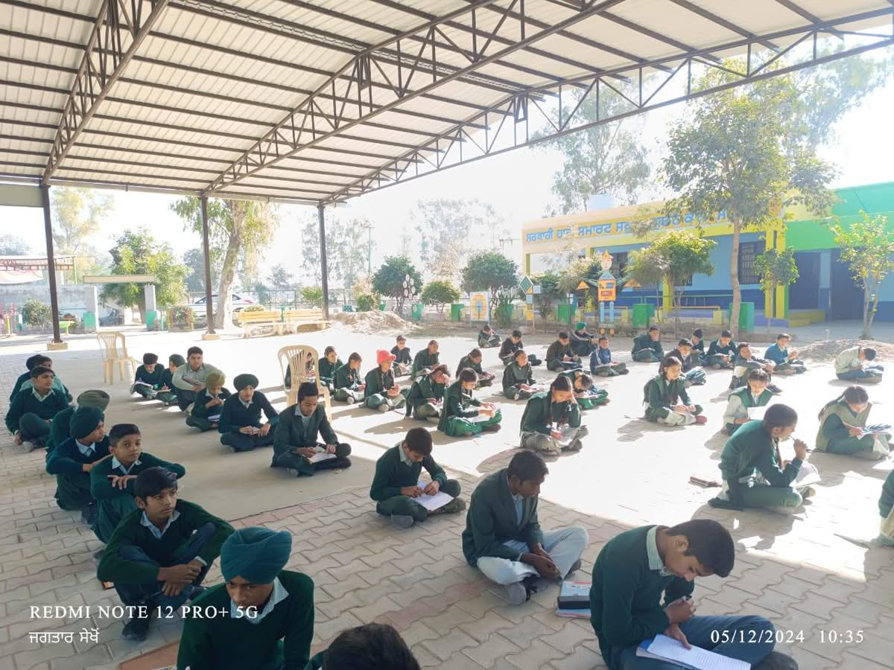
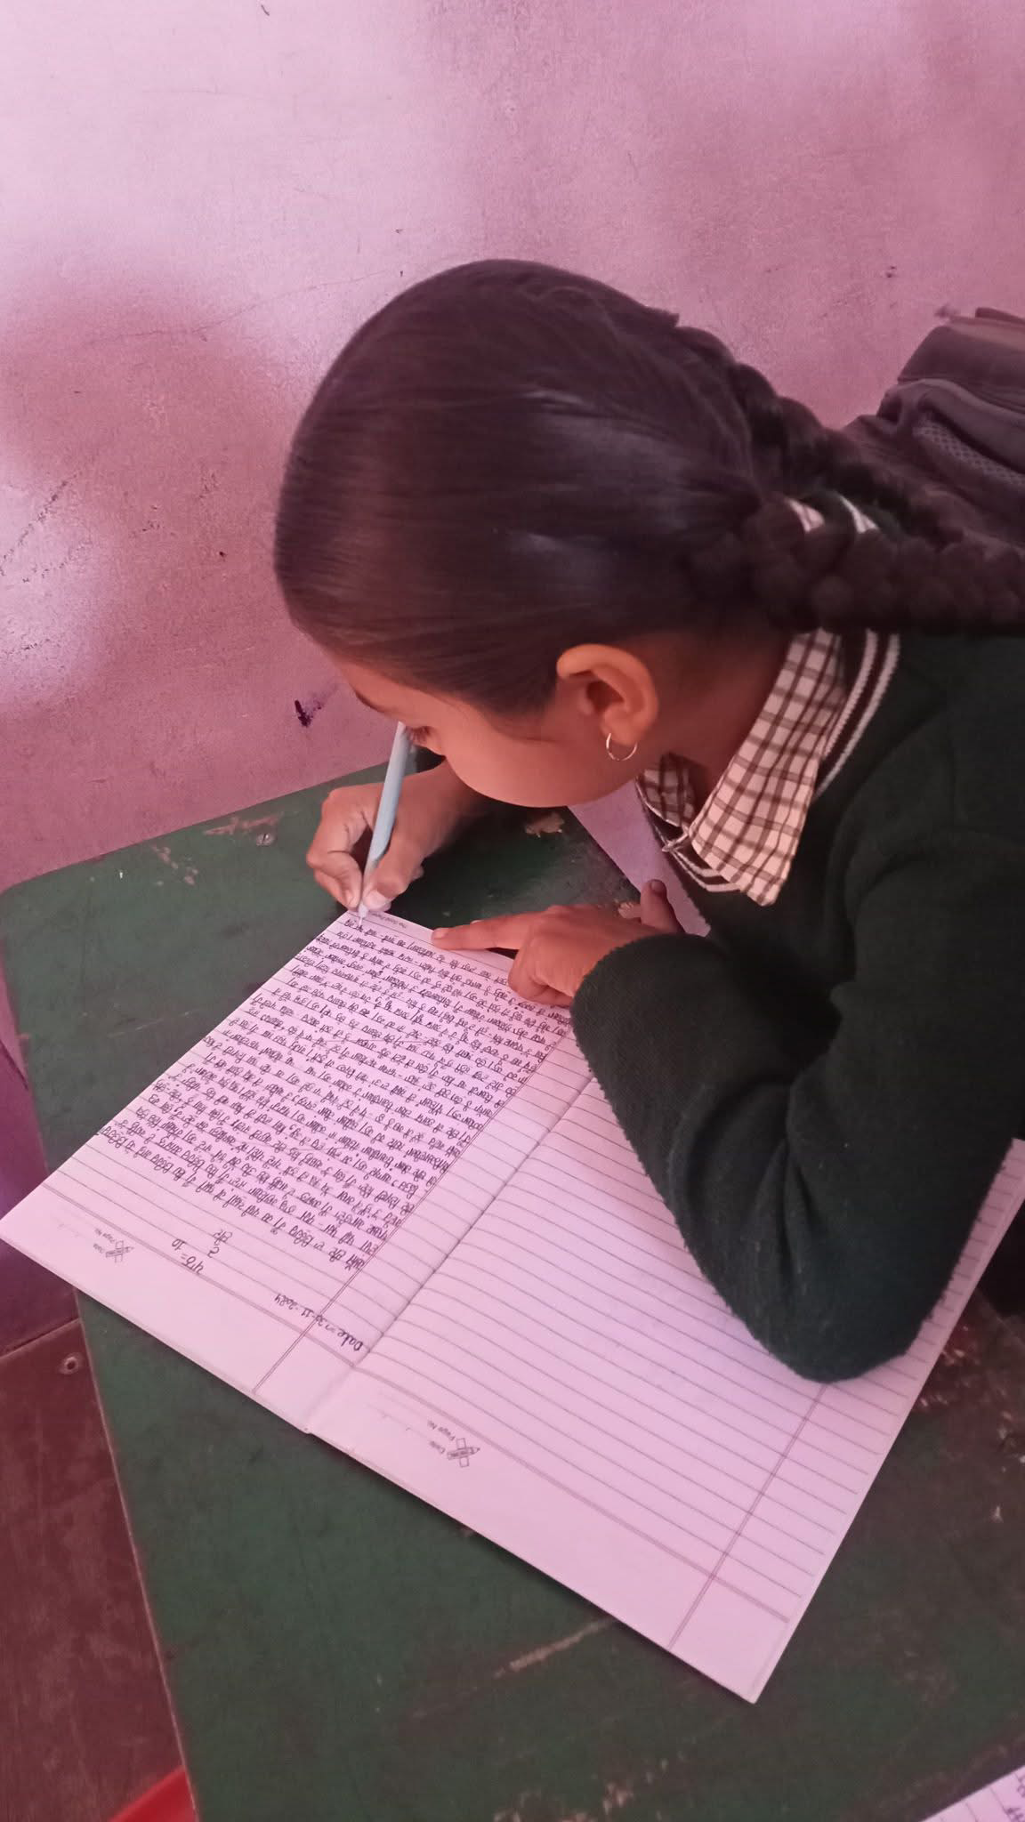
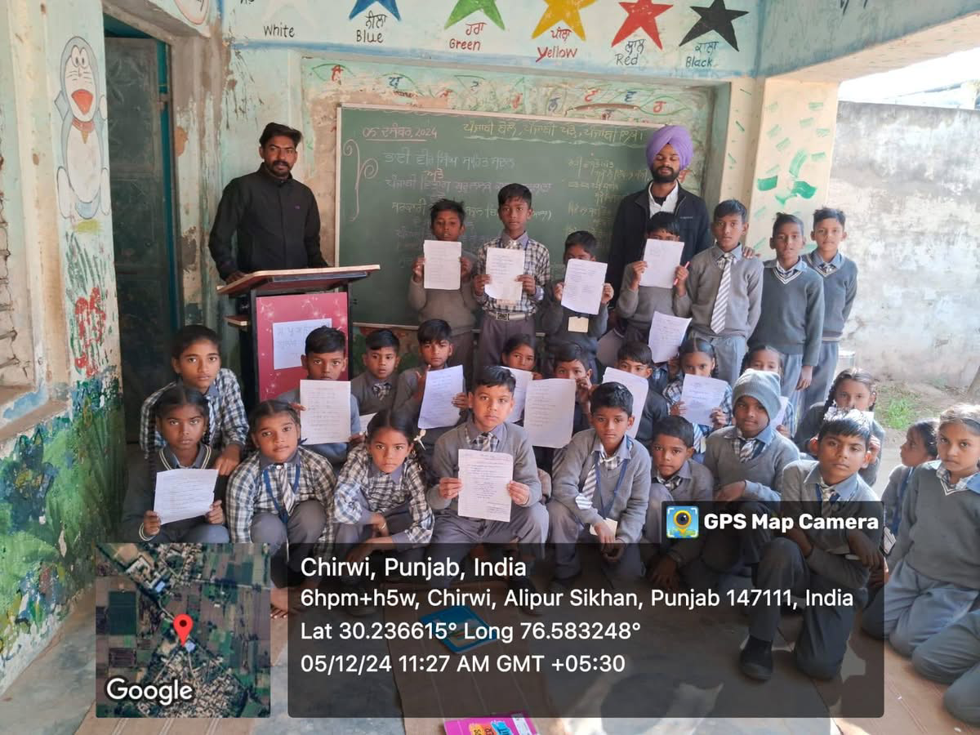
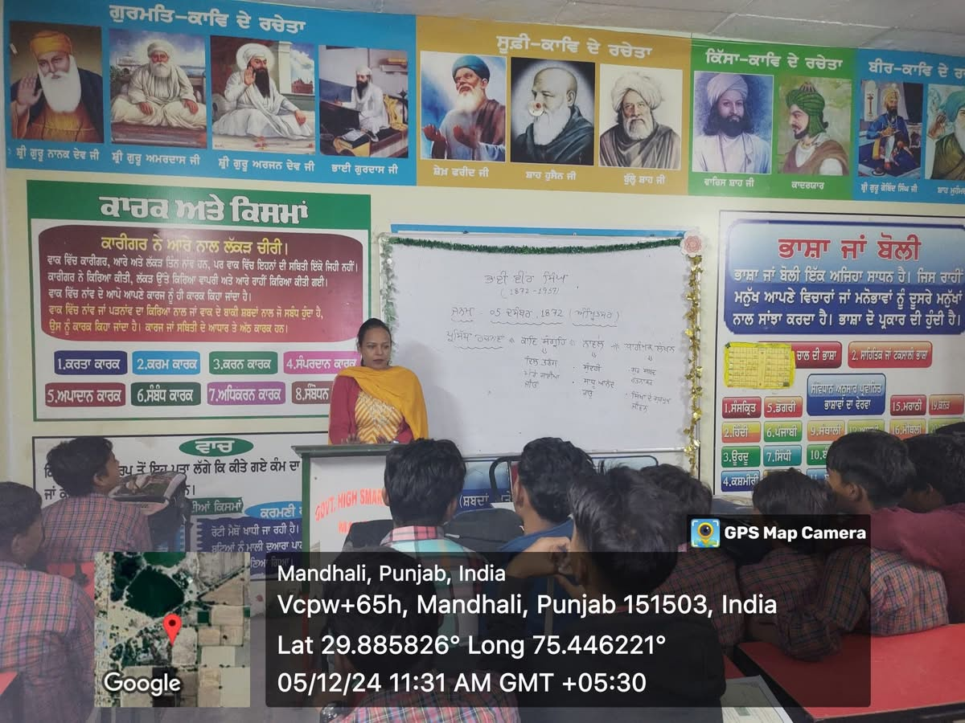
Department of Science celebrated Green Diwali on 30-10-2024. Diwali embodies joy, unity, and introspection. As global awareness of environmental conservation grows, adopting eco-friendly practices allows for the celebration of tradition while safeguarding our planet. By implementing small changes to reduce pollution, limit waste, and encourage sustainability, we can help ensure that future generations inherit a cleaner, healthier Earth.
Nanhi Chhan and Green Brigade Cell celebrated Green Diwali on 30-10-24 by planting trees and also organised poster making competition to motivate students to celebrate cracker free and pollution free Diwali.
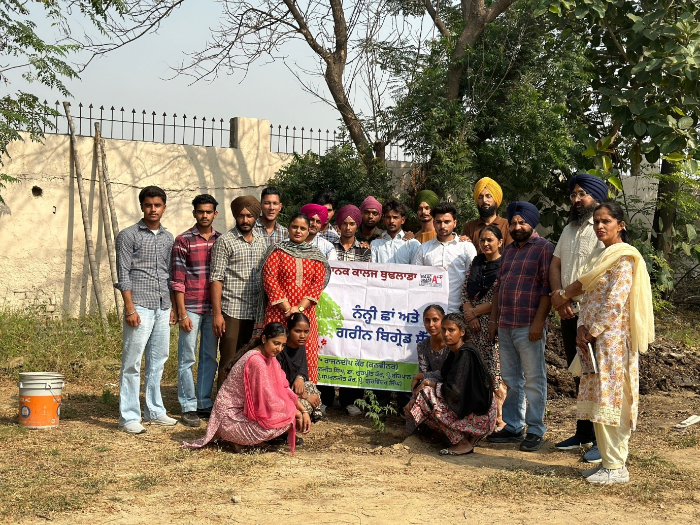
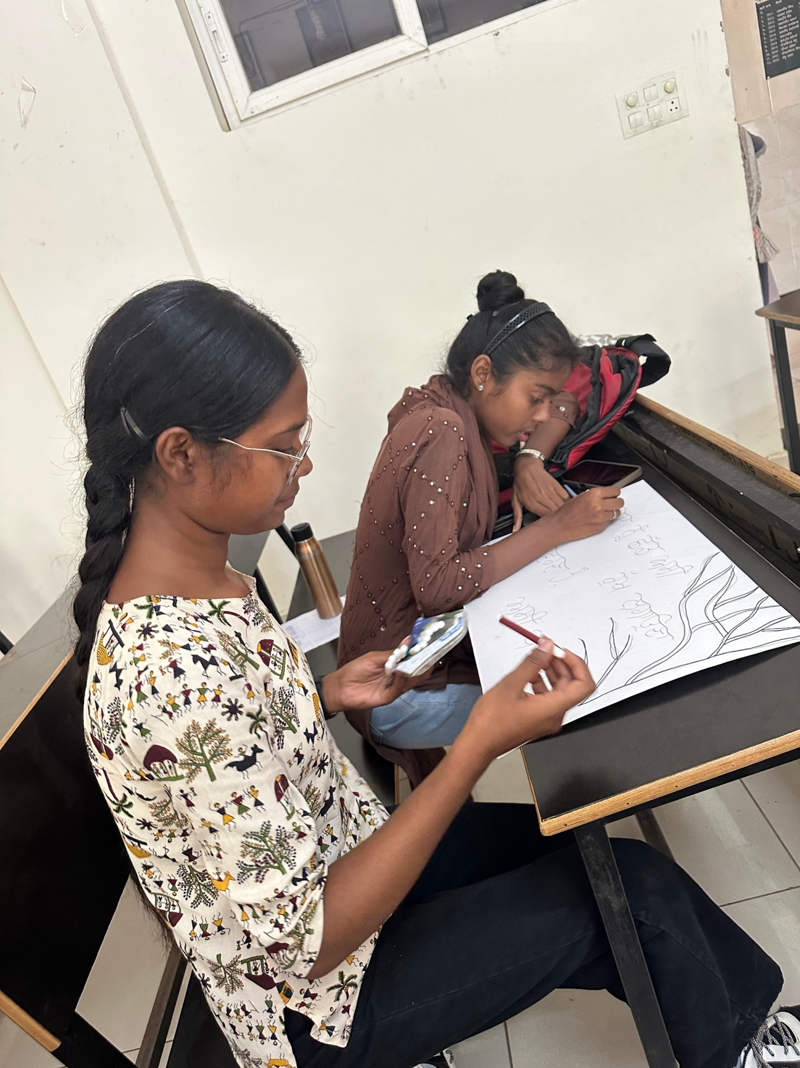
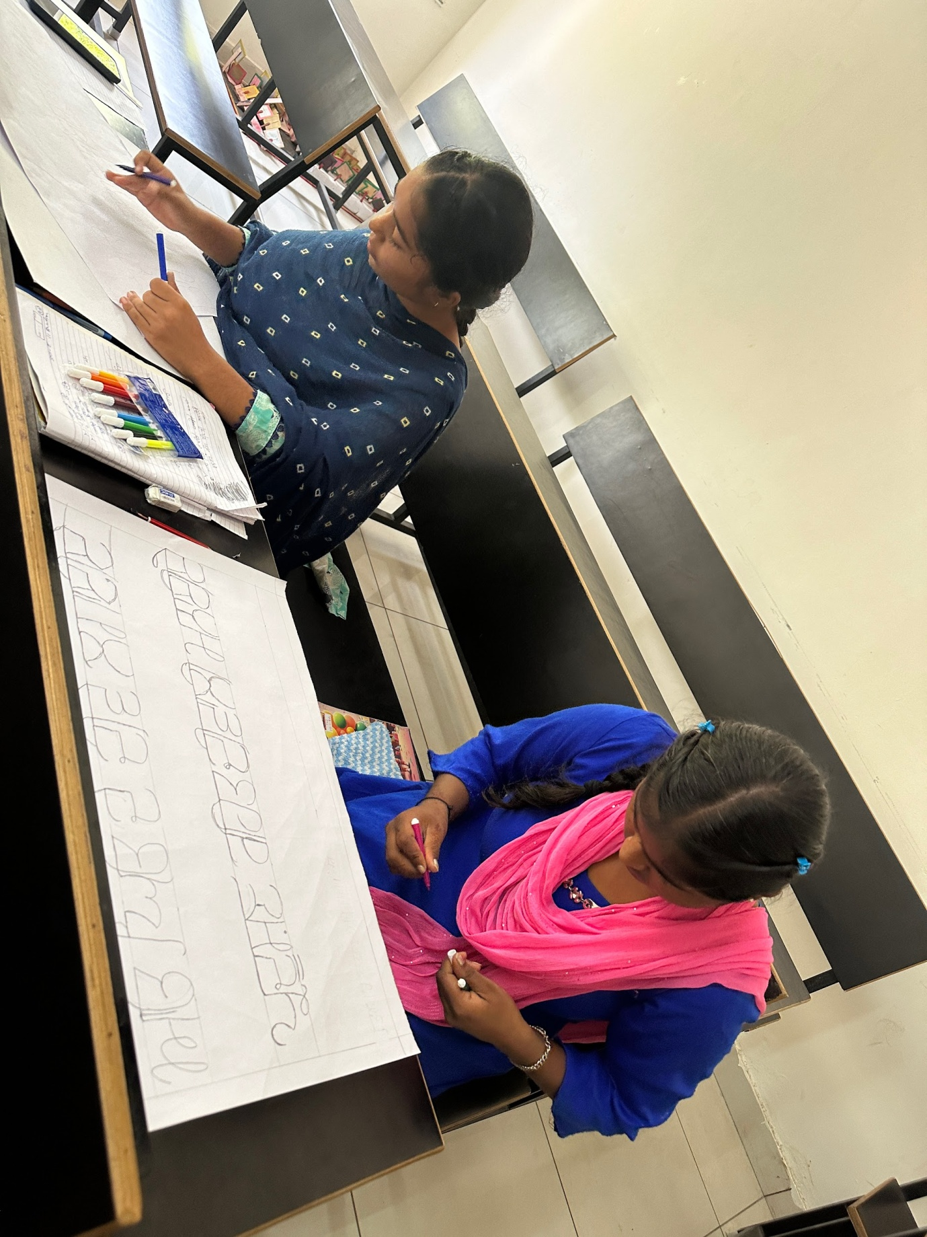
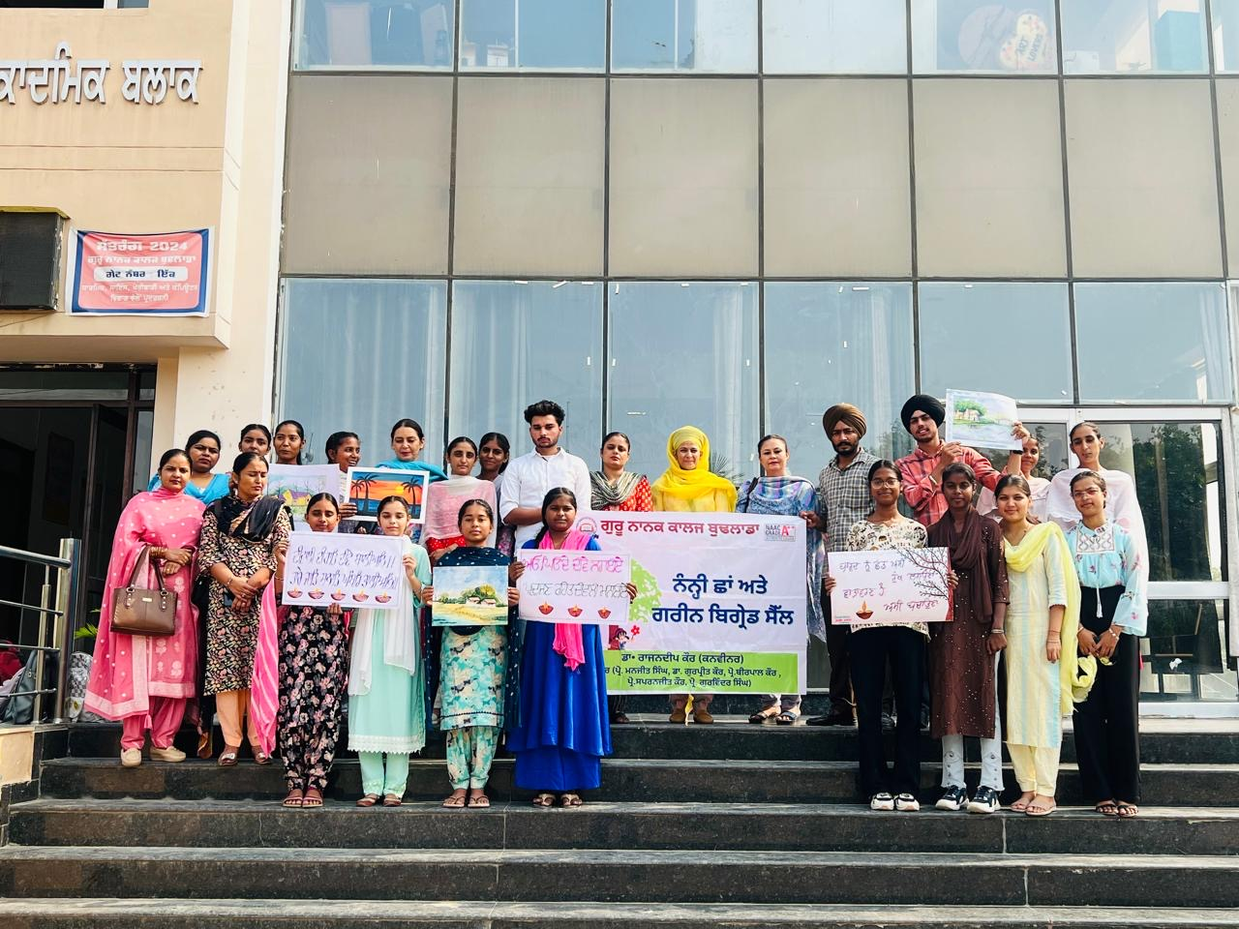
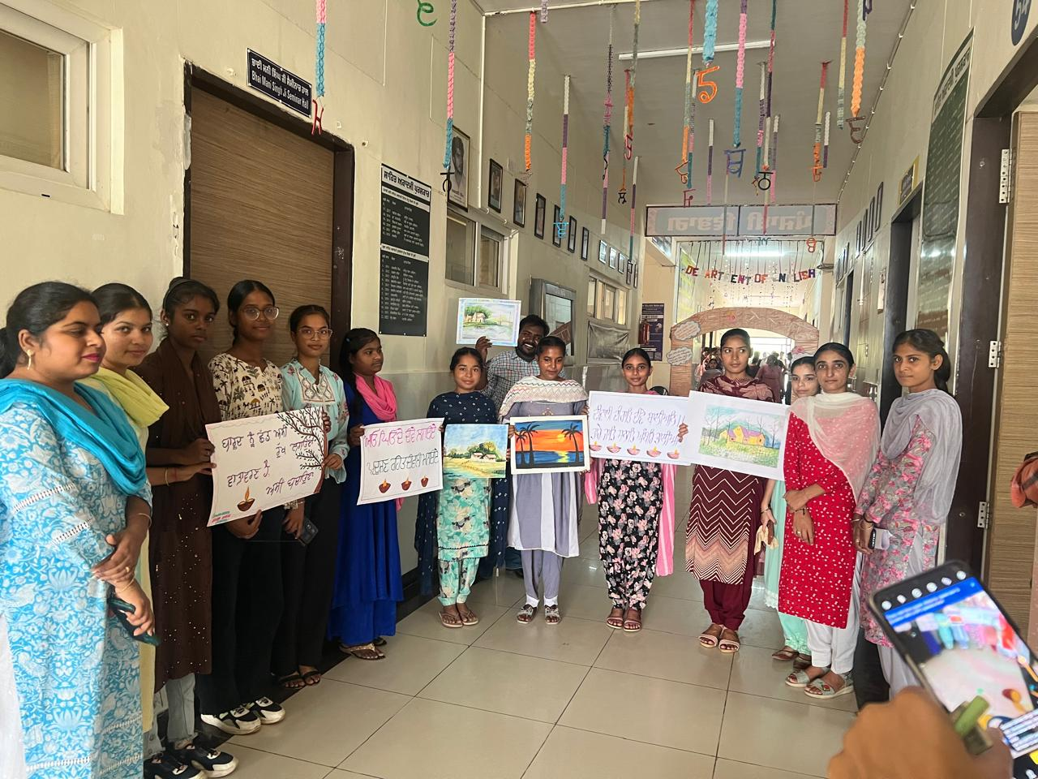
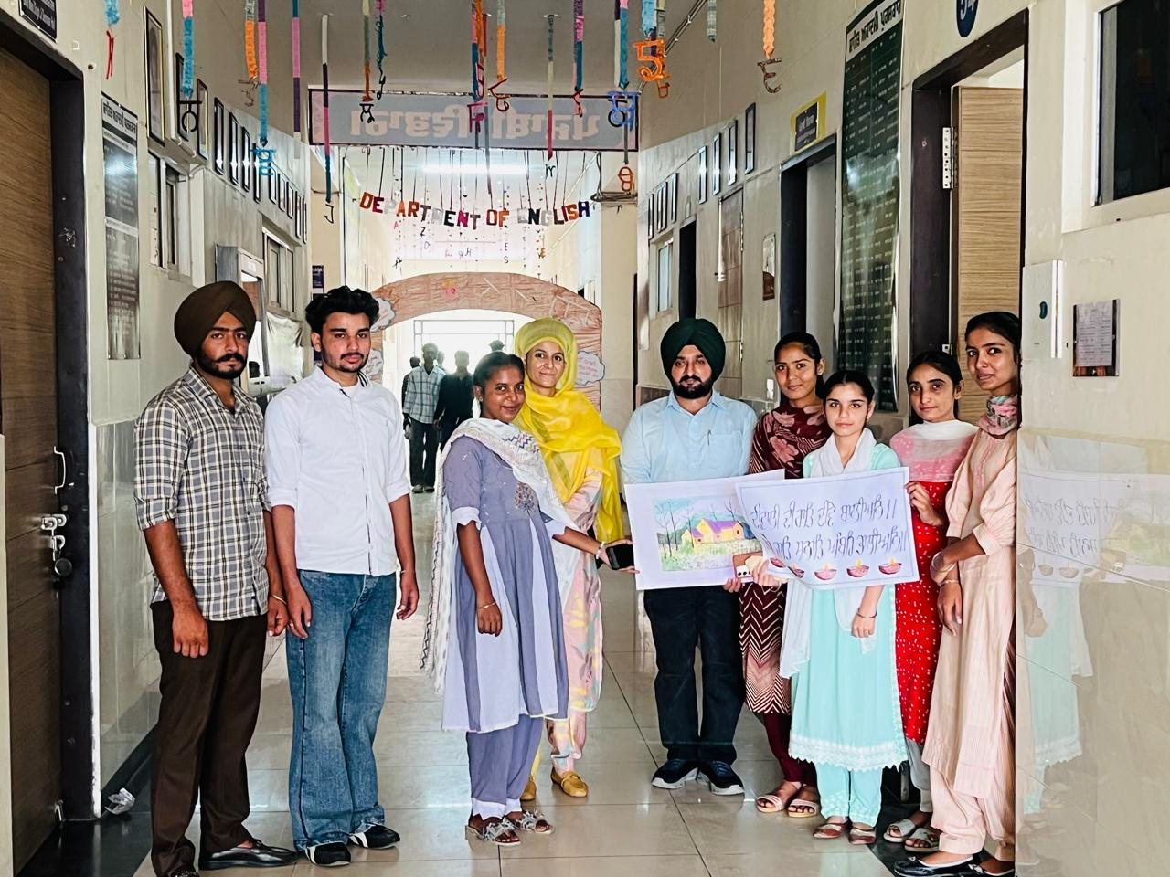
Department of Commerce and Management organised A Mehandi competition as “Mehandi Magic: A Colourful Celebration” on 19-10-24.
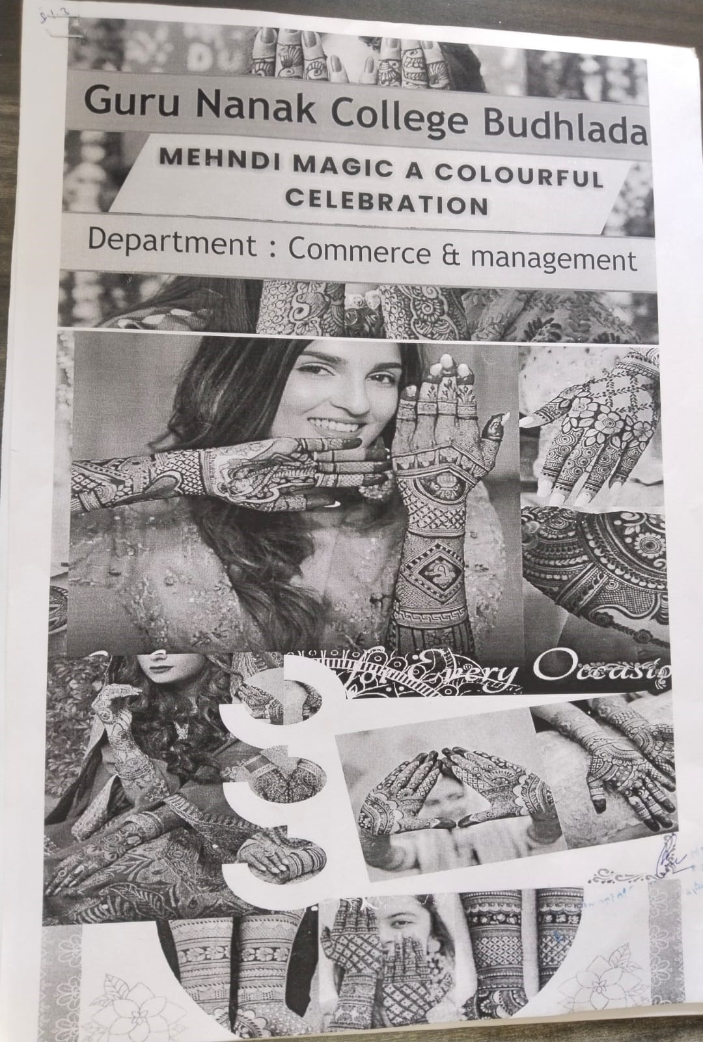
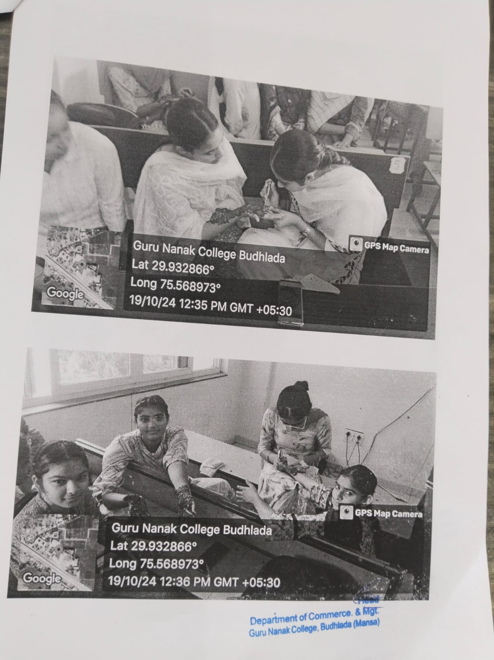
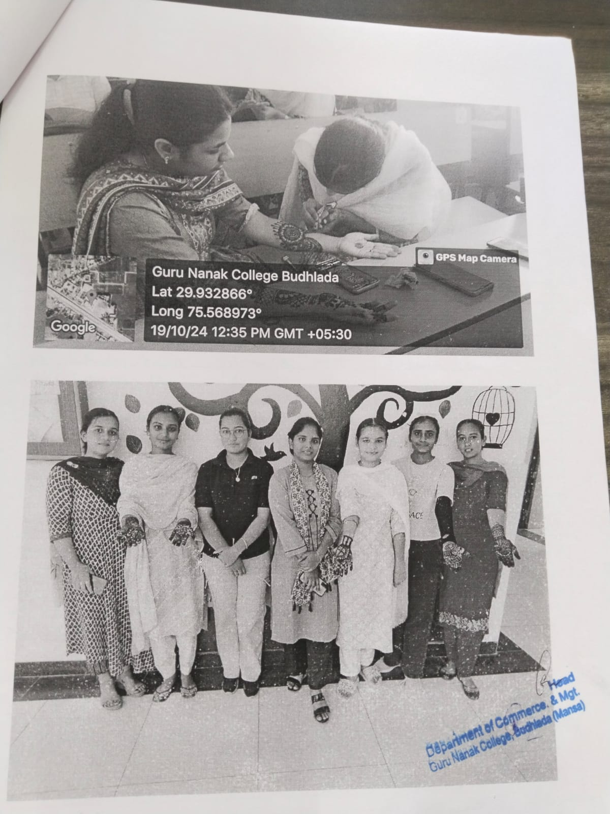
S. Sukhminder Singh ji, Education Secretary of SGPC, S. Dilraj Singh Bhundar (Ex-MLA), and S. Gulzar Singh Moonak, an international kabaddi player, attended the events as chief guest organized by the Department of Physical Education and Sports Guru Nanak College, Budhlada as chief guest.
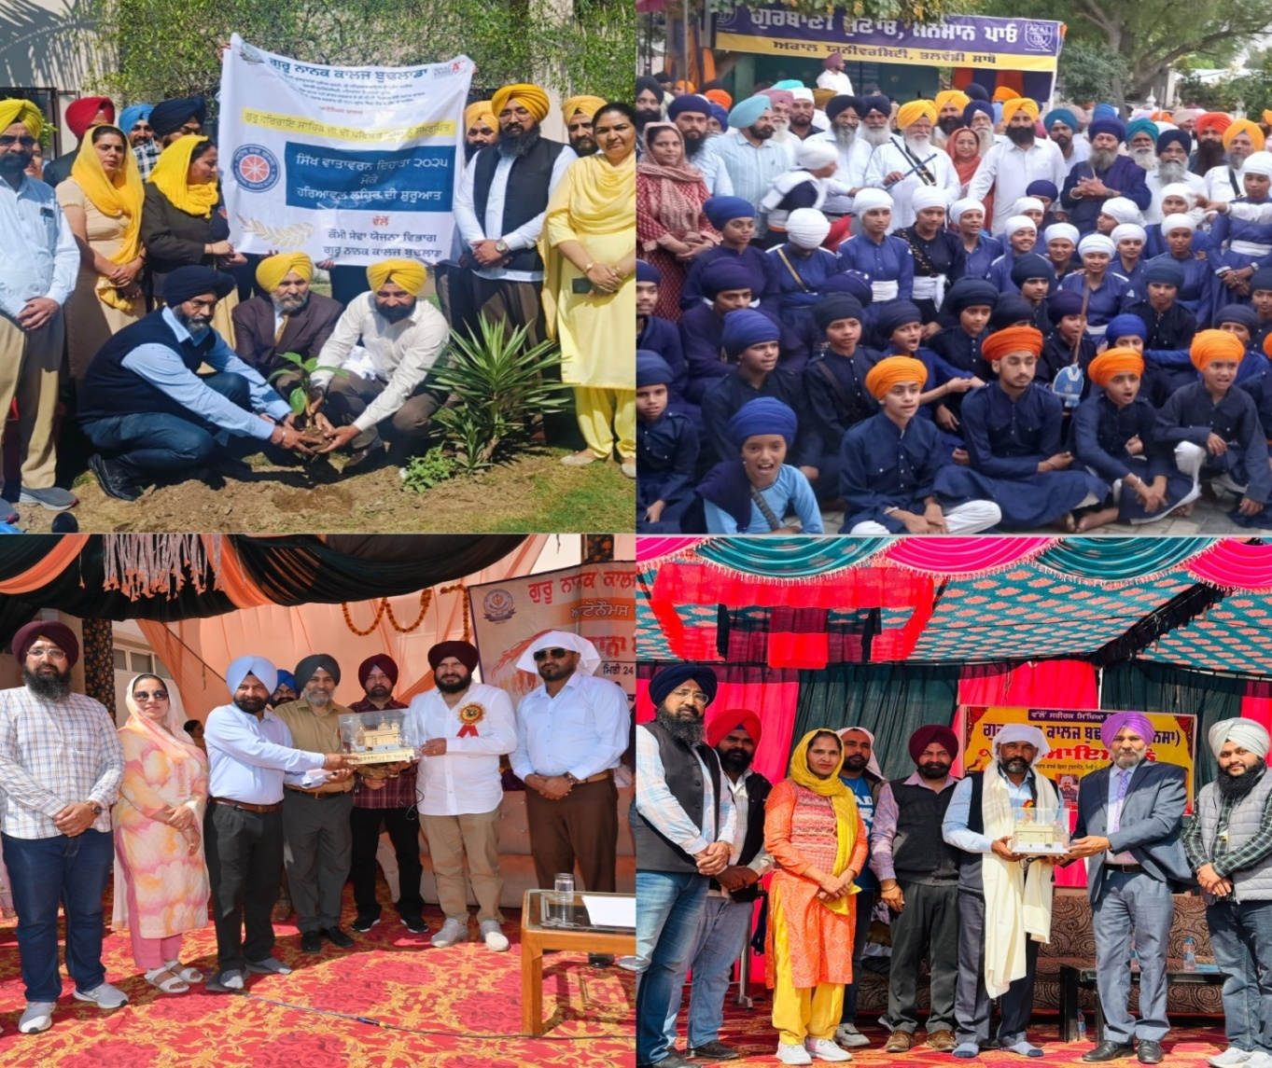
Guru Nanak College became Champion in Punjabi University Table Tennis Inter College 2024-25.
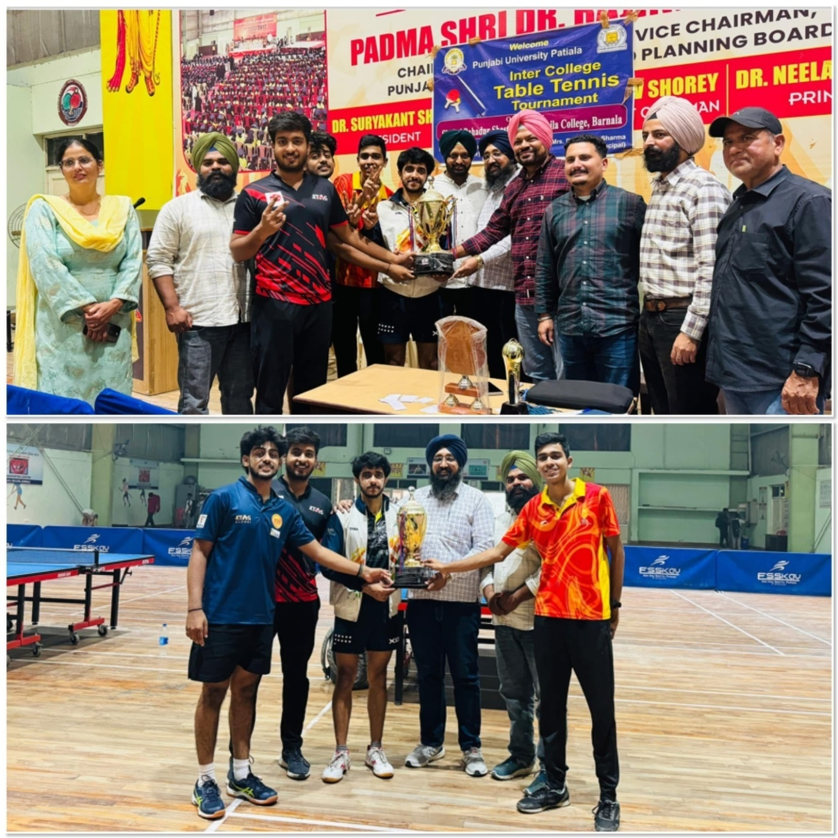
Guru Nanak College became Champion of Punjabi University Badminton Inter College 2024-25
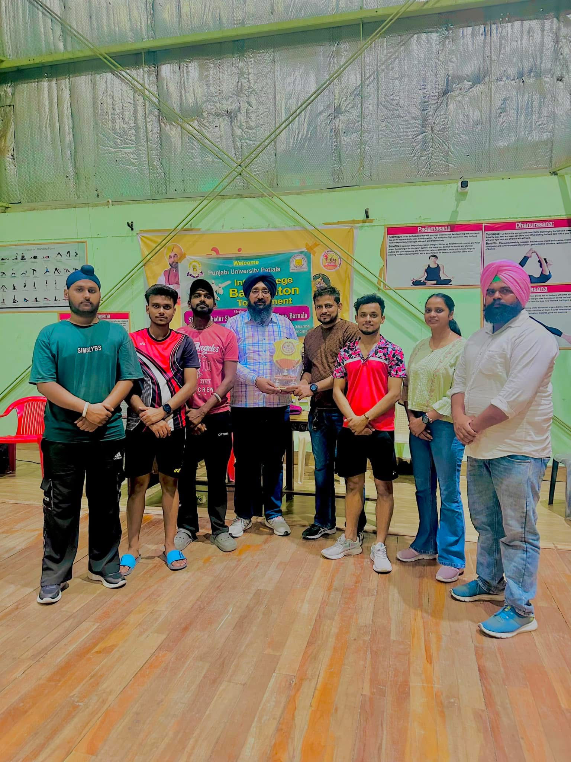

Punjabi University Gatka Championship organised by Physical Education Department GNC Budhlada 2024-25
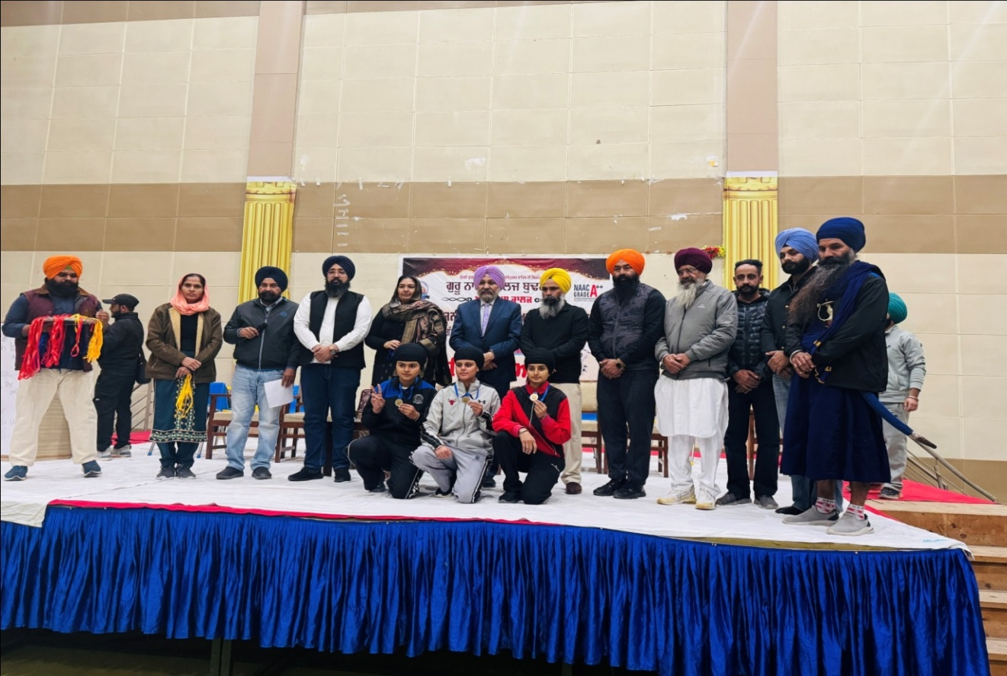
GNC became Punjabi University 2nd Runner Up Girls 61st annual Athletic meet and Boys achievement 2024-25
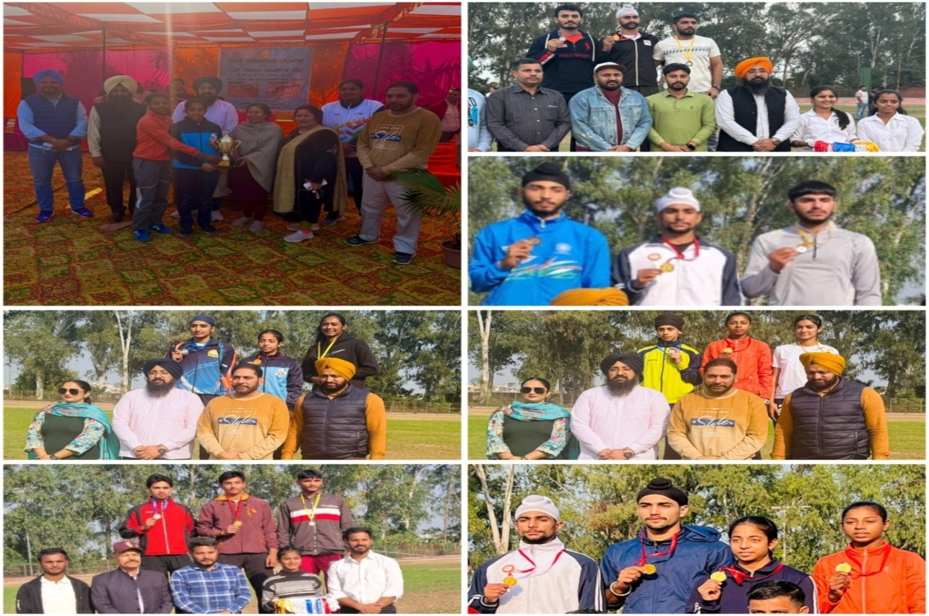
GNC as Runner Up in Punjabi University Volleyball Inter College 2024-25
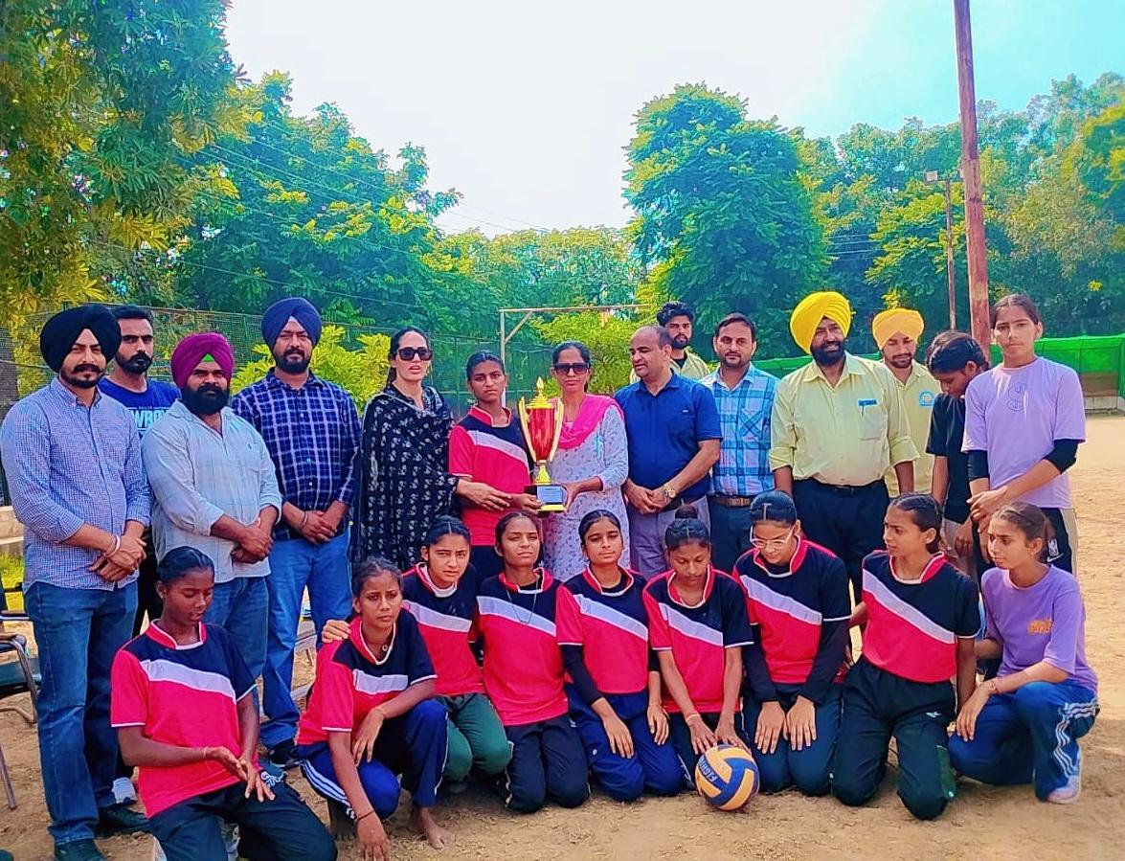
GNC became Overall Champion in Karate Girls Trophy in Punjabi University Inter College 2024-25
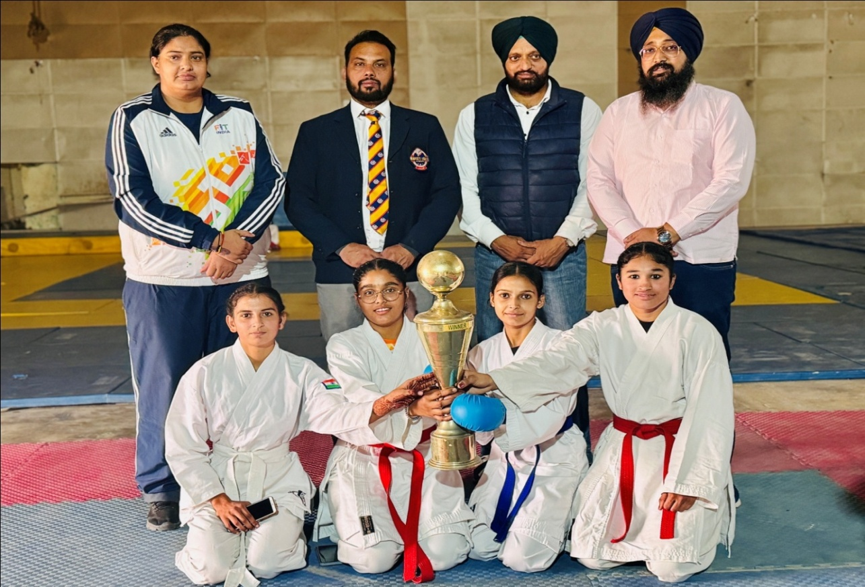
Girls became overall Champion and Boys achieved Third position in Punjabi University Chess Tournament 2024-25
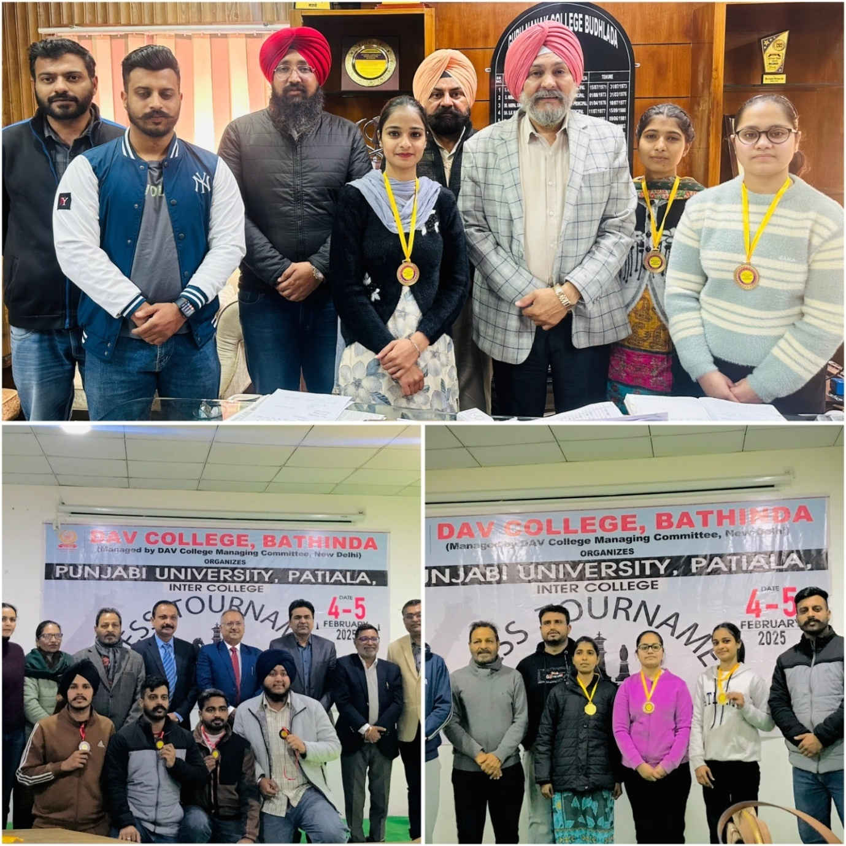
College became Champion in Punjabi University Football Inter College 2024-25
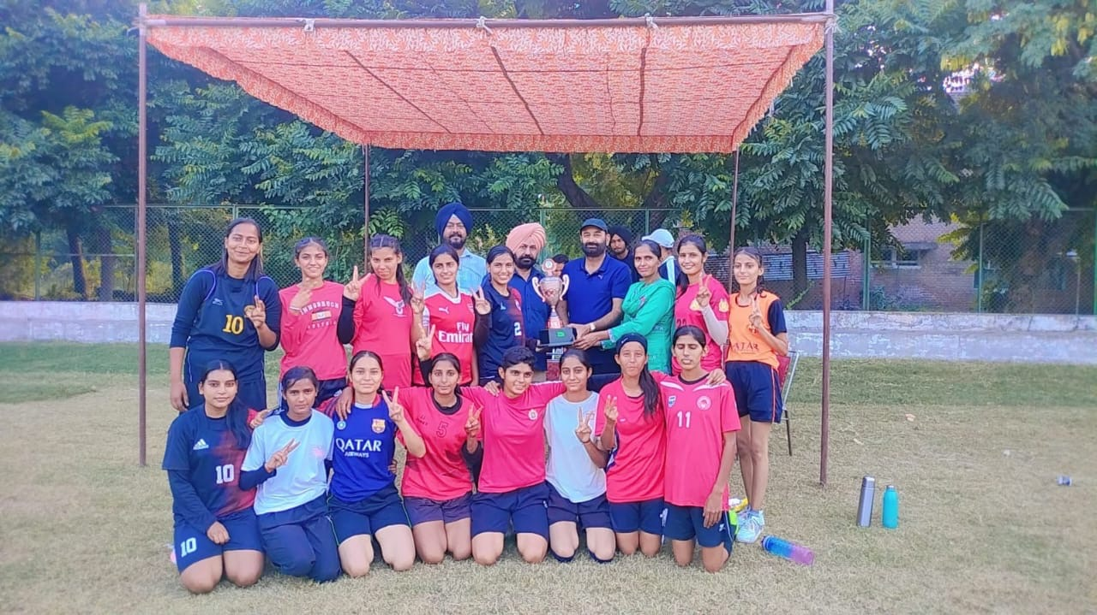
Department of Physical Education organized a lecture “Sports and Physical Well Beingness” by Dr Sanjeev Mander, HOD, Central University Bathinda
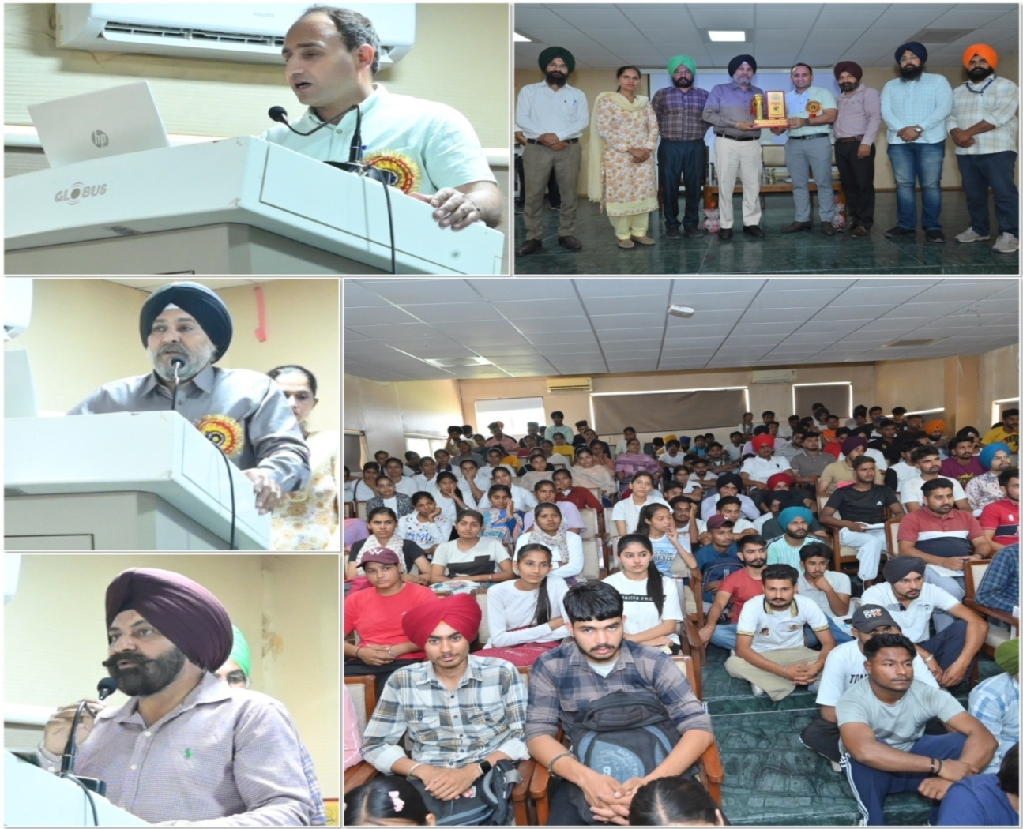
Department of Physical Education organized Inter Department Cricket Tournament 2024-25
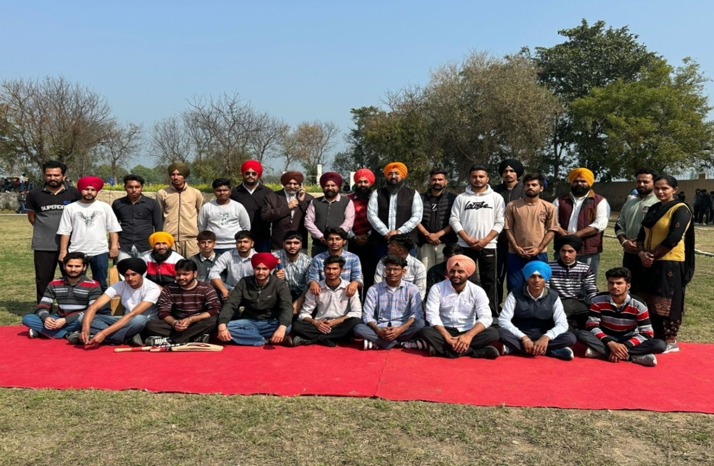
Glimpses of KhedanVattan Punjab Diyan 2024-25
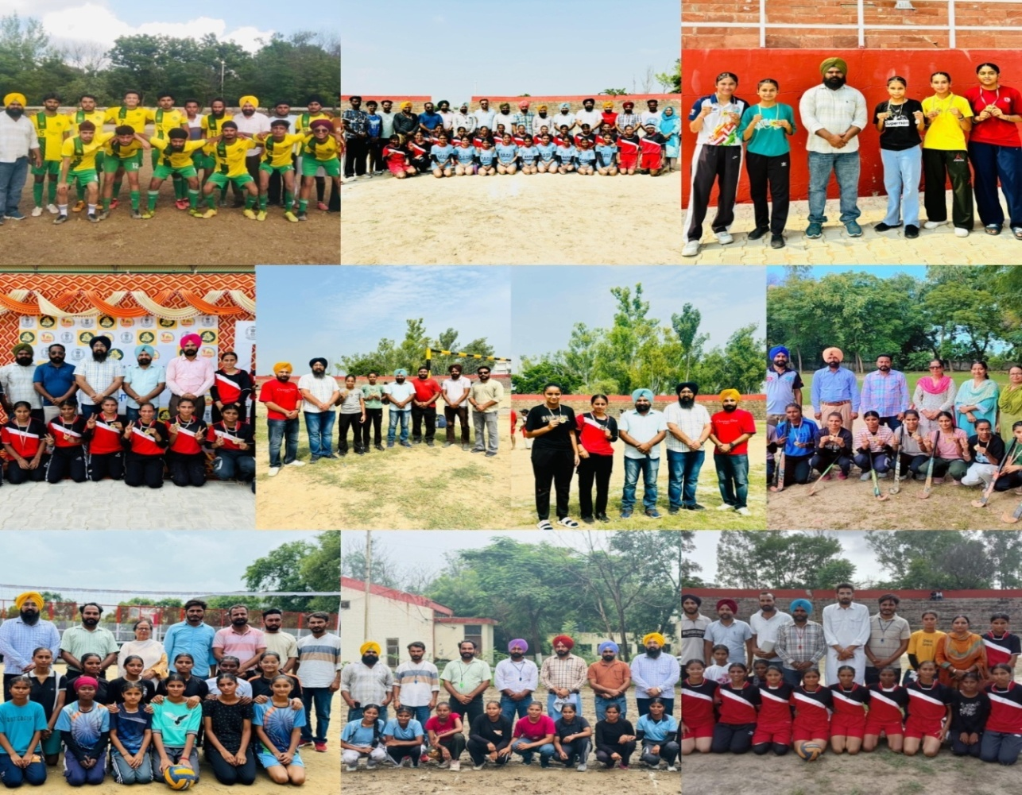
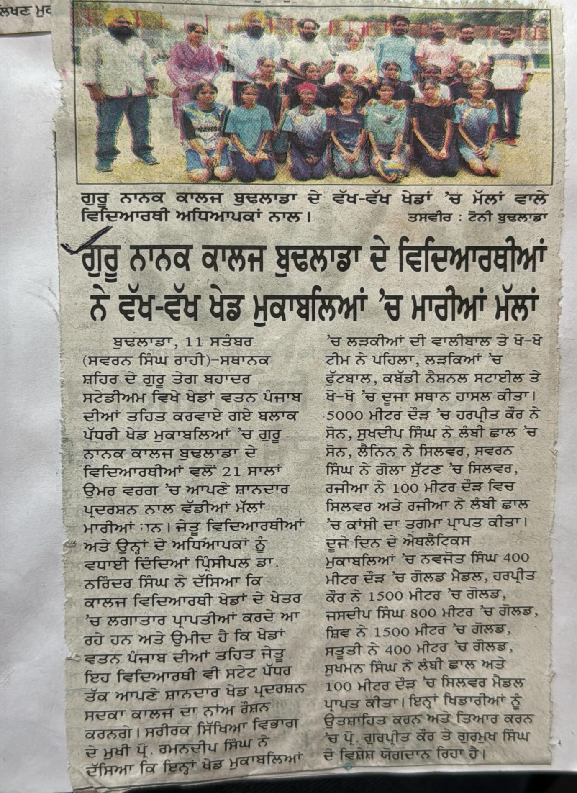
On the occasion of National Sports Day on August 29, a Fitness Workshop and Basketball Show Match were organized in the institution to raise awareness about sports among students and local residents.A cycle rally was also organized.
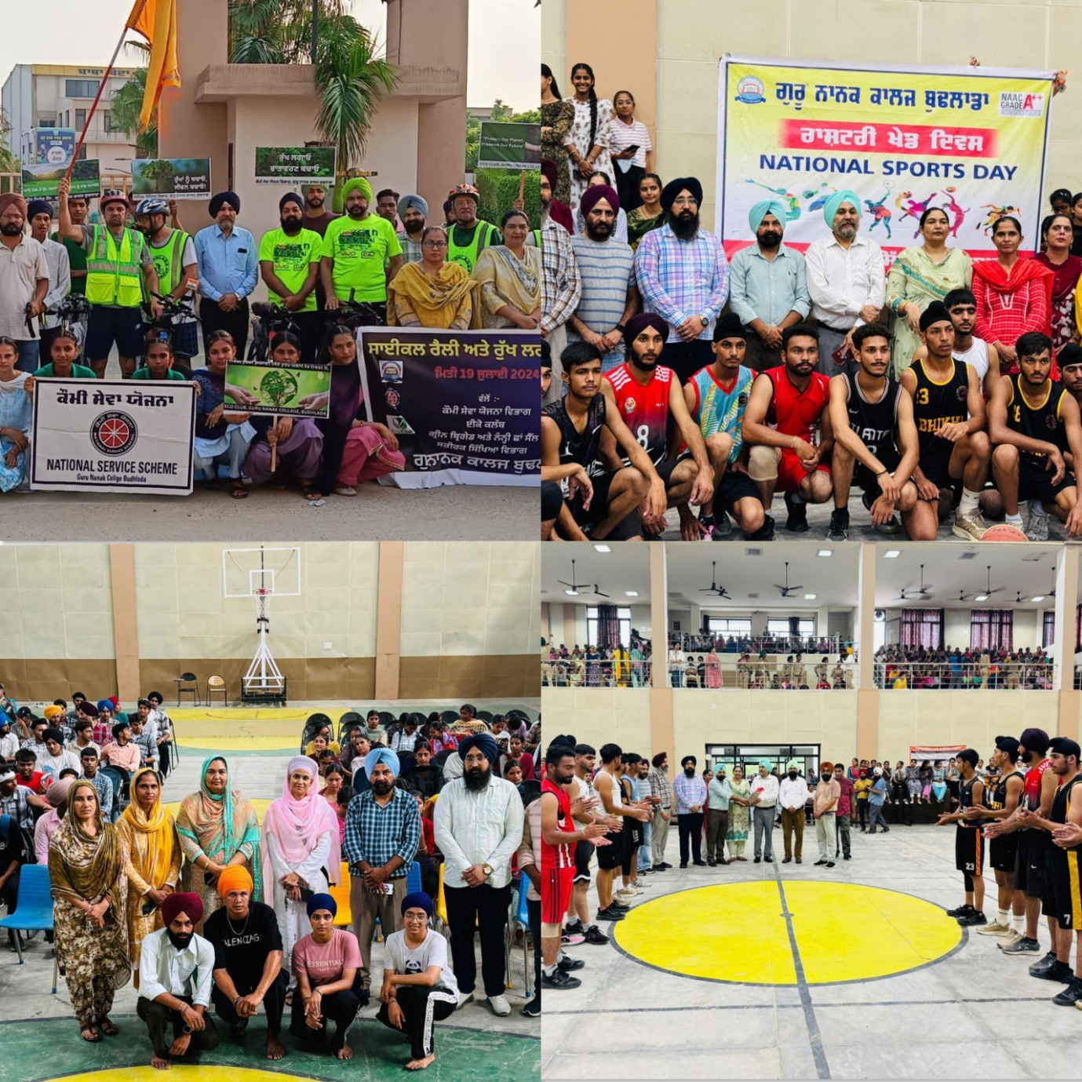
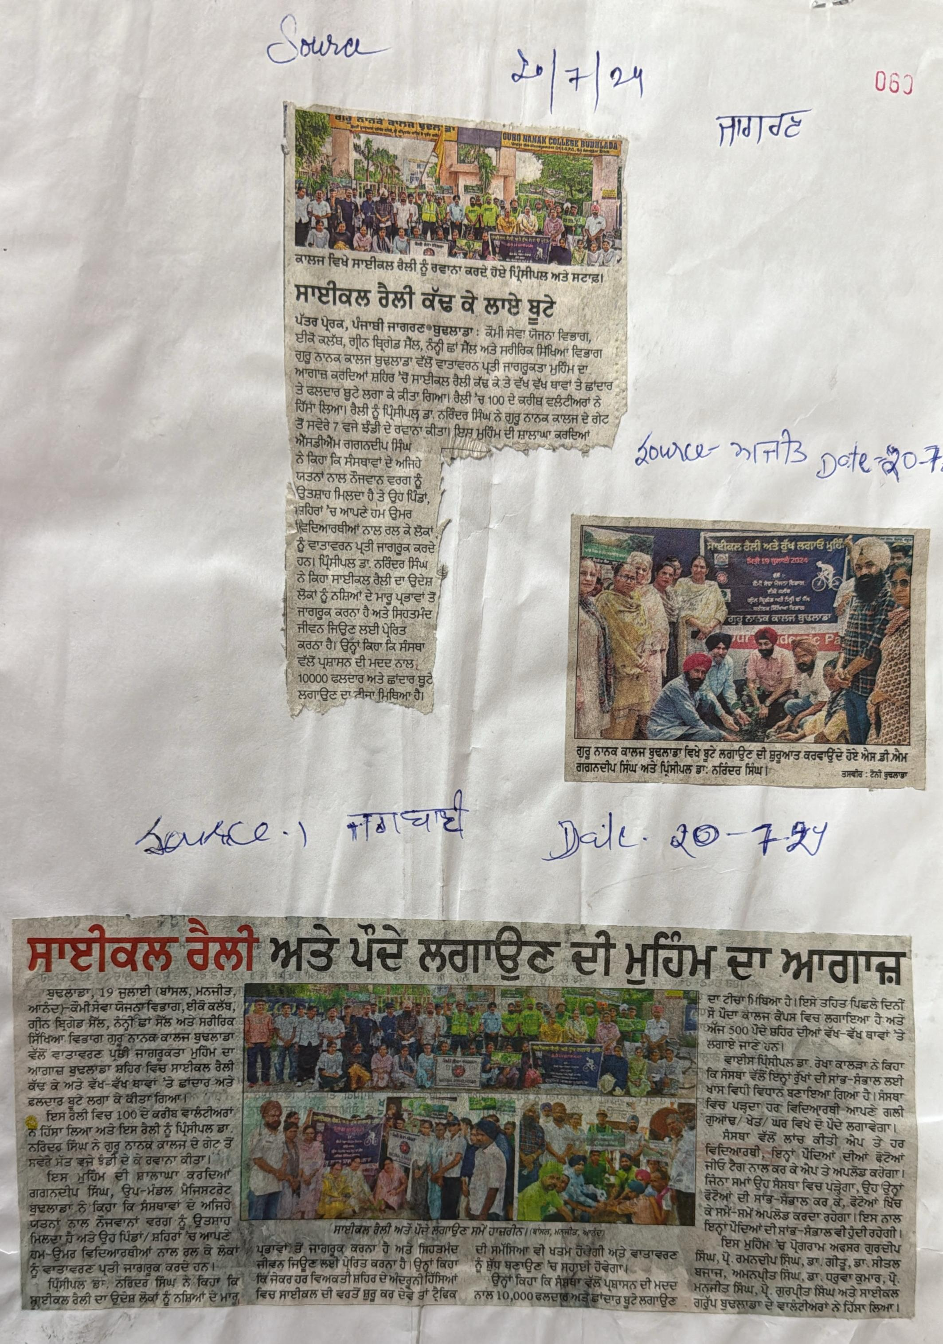

Glimpses of College Annual Athletic Meet 2024-25
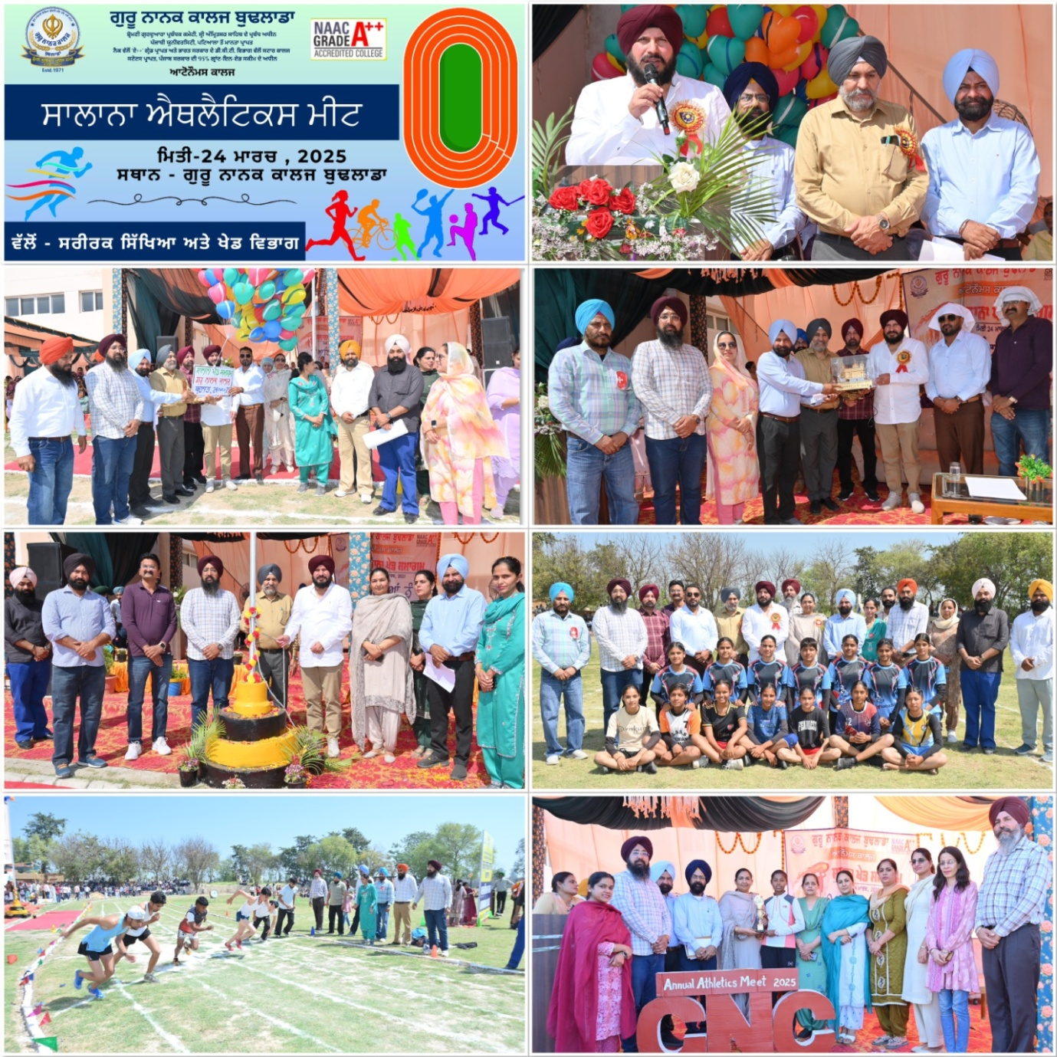
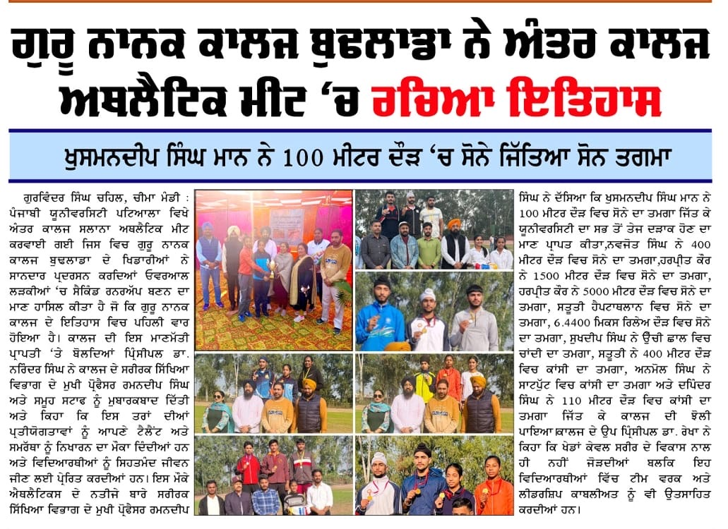
Sports Kit sponsored by College Old Students Krishan Kumar Tiwari and Shubhnamdeep Singh Cheema was distributed among the students.
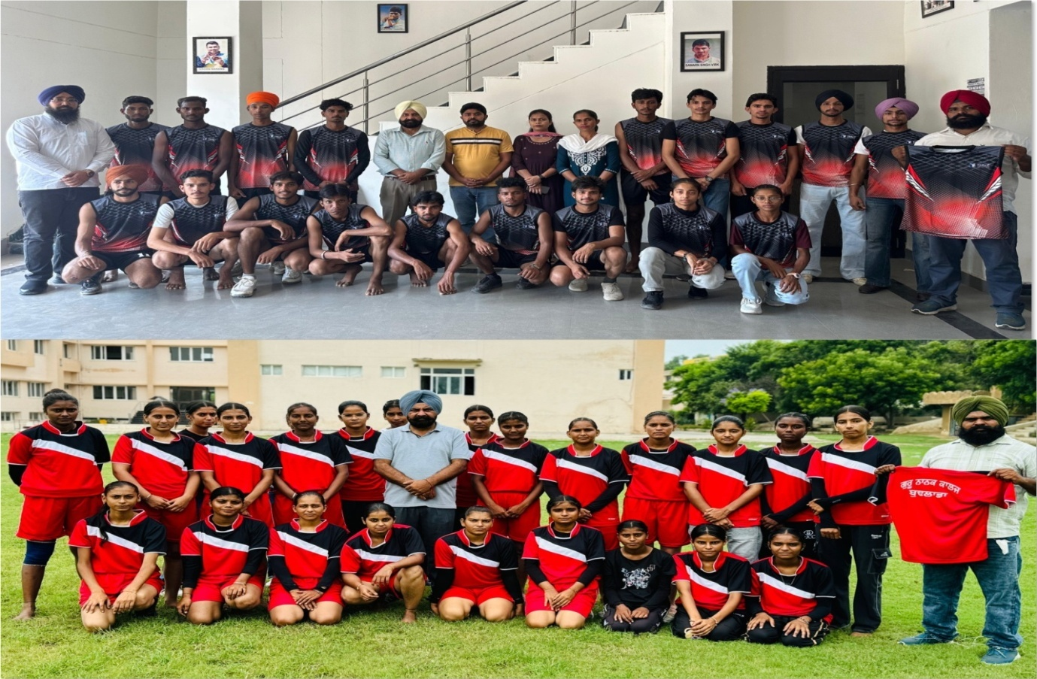
Department of Hindi organised a special lecture on “Importance of Sports and Games in the life of Students’ by Dr Gurpreet Kaur on 18-02-2025.
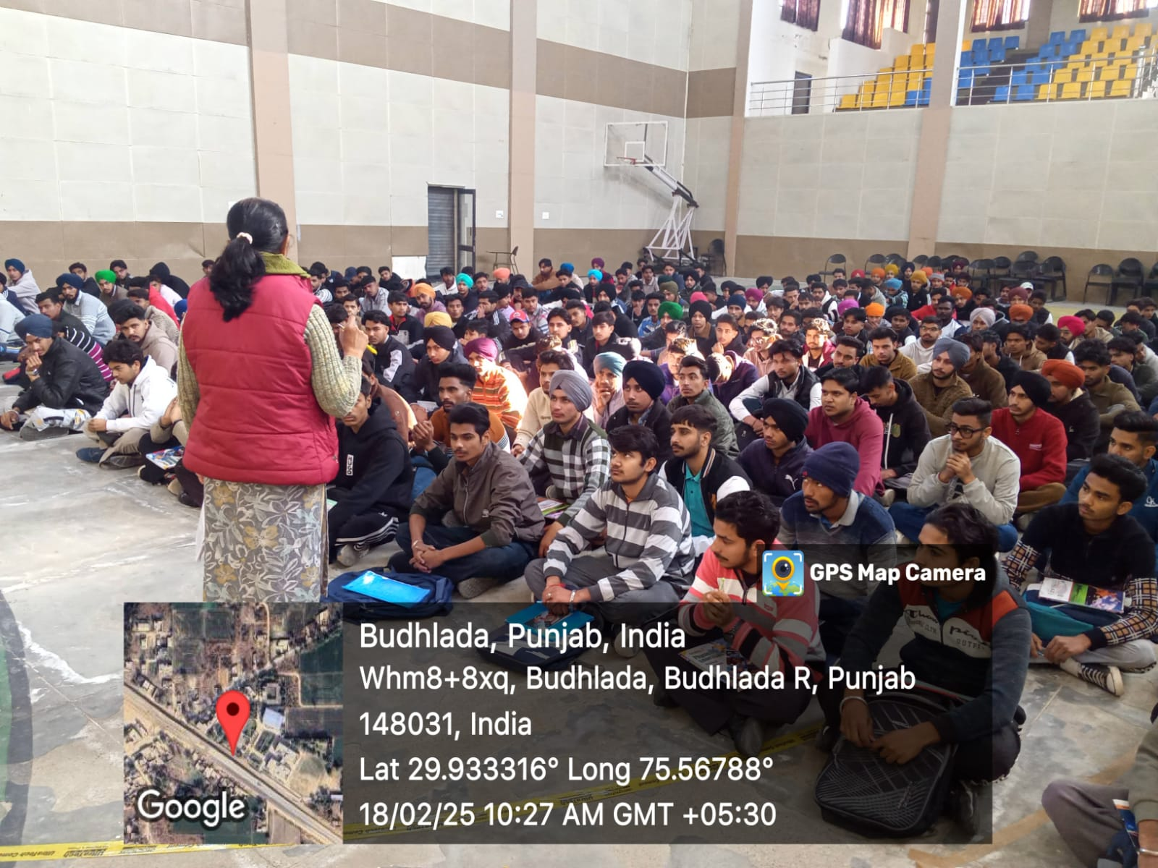
On September 21, 2024, an educational tour was organized to Gurudwara Sahib Sachin Manji Saidewala, The visit aimed to provide participants with an enriching experience of the spiritual and cultural heritage associated with Sikhism.
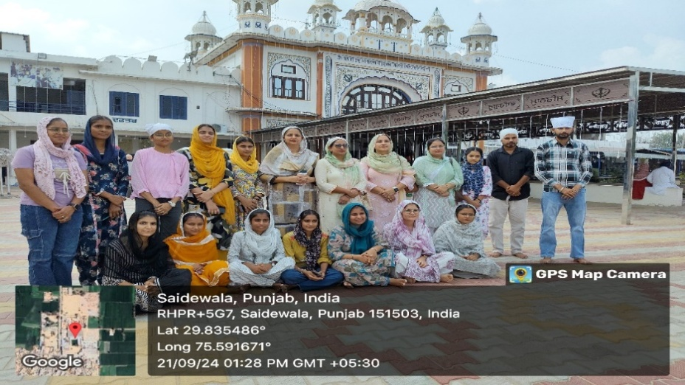
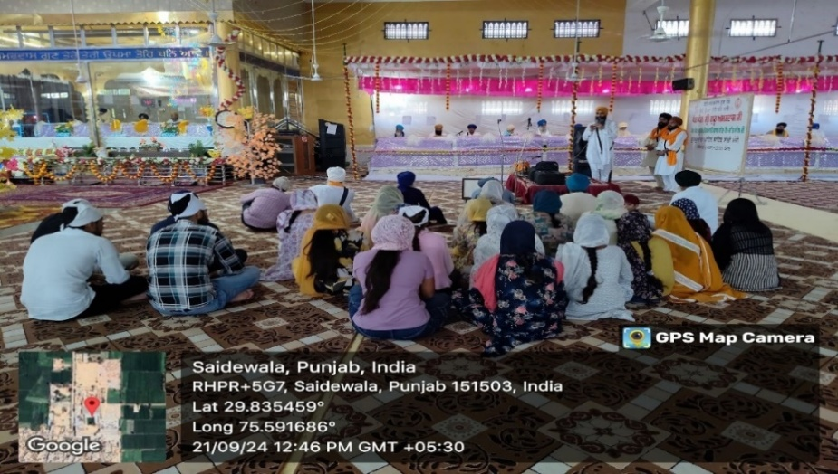

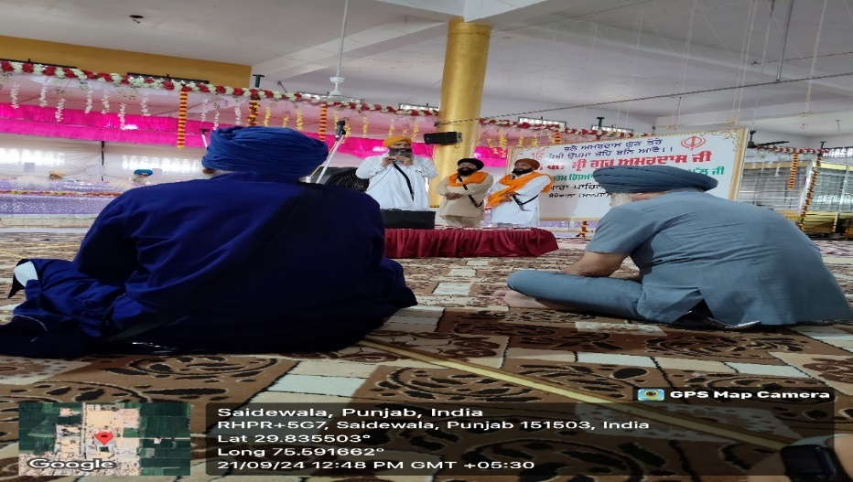
Students of Guru Nanak College participated in Gurmat Samagam on 11 April, 2025 at Shri Damdama Sahib, Talwandi Sabo.

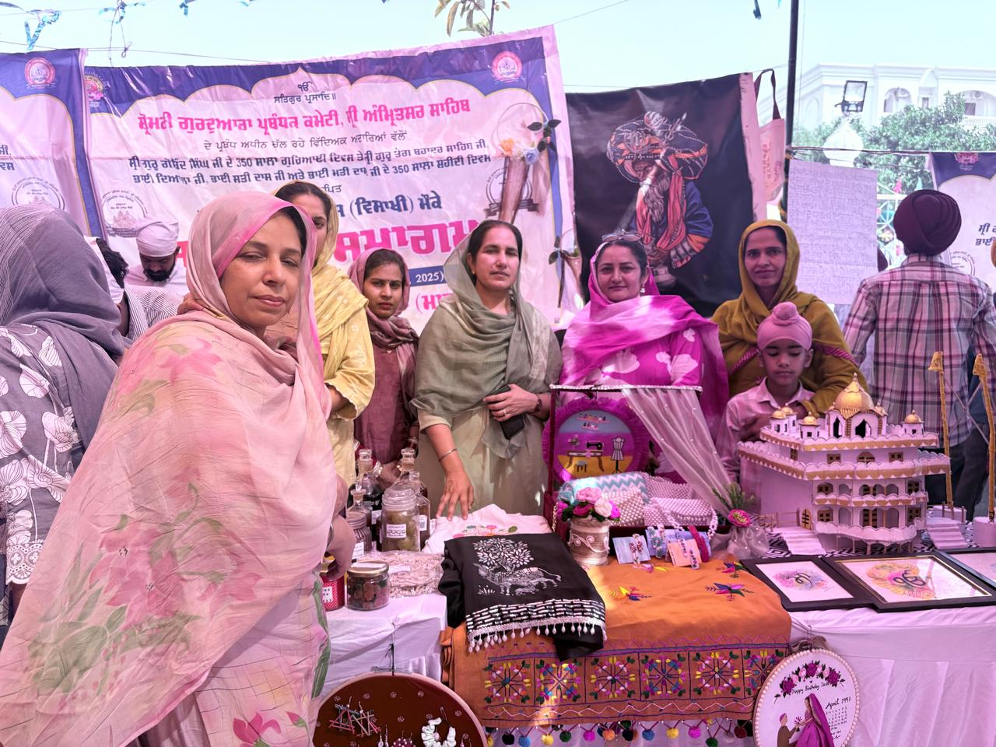
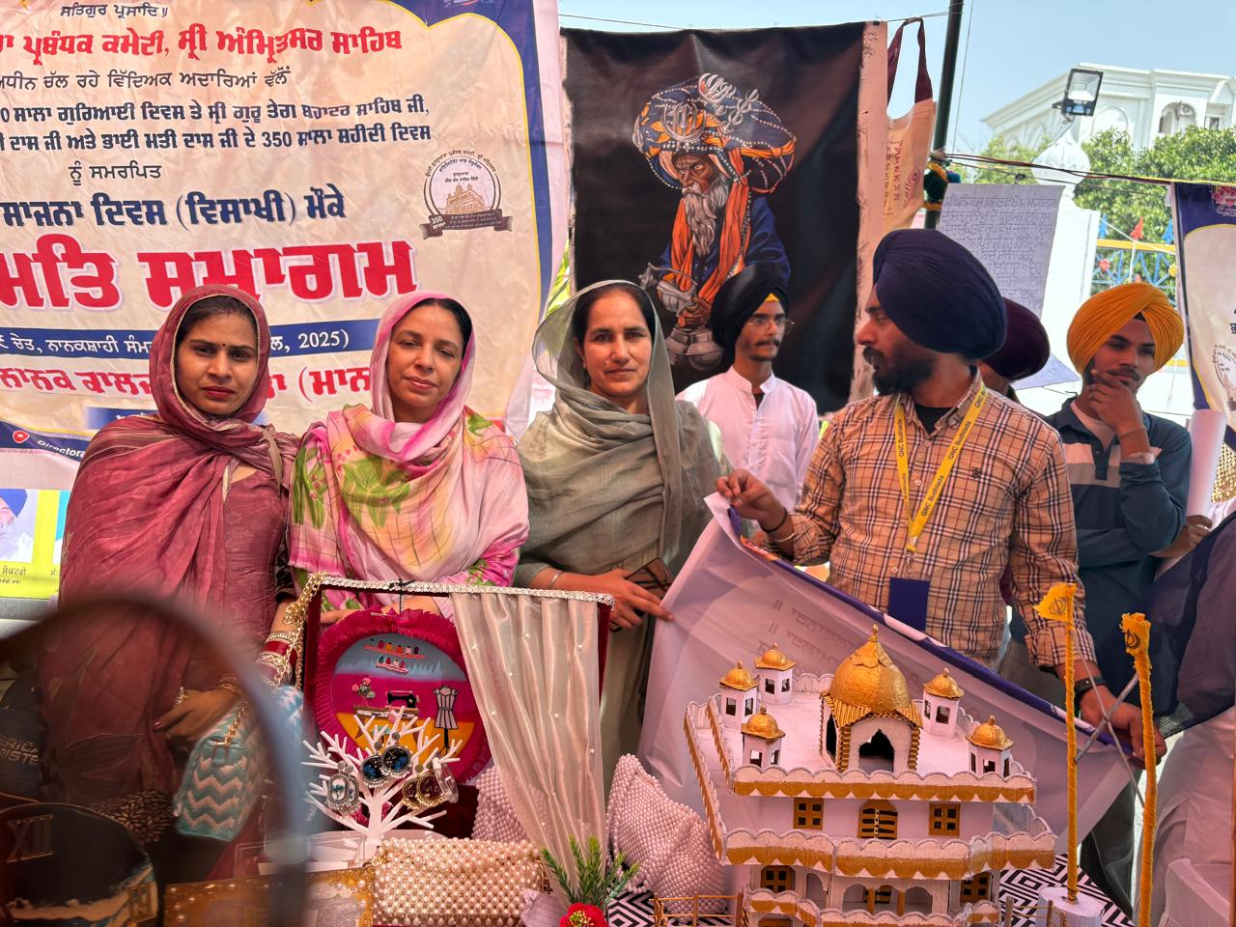
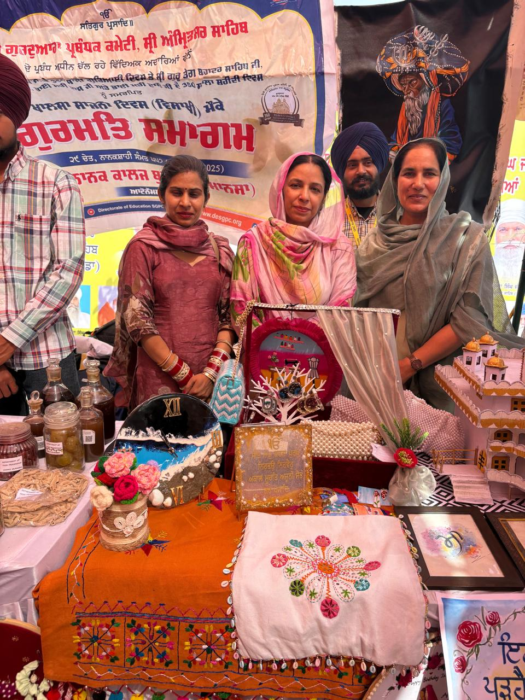
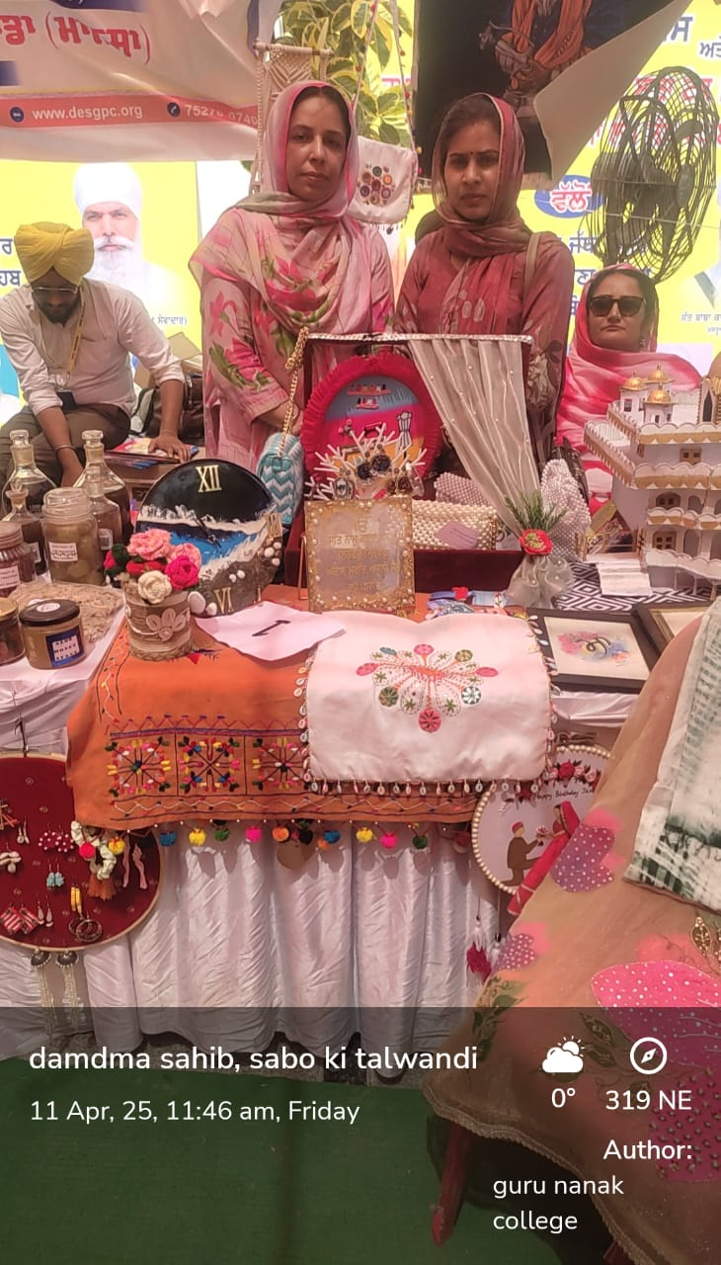

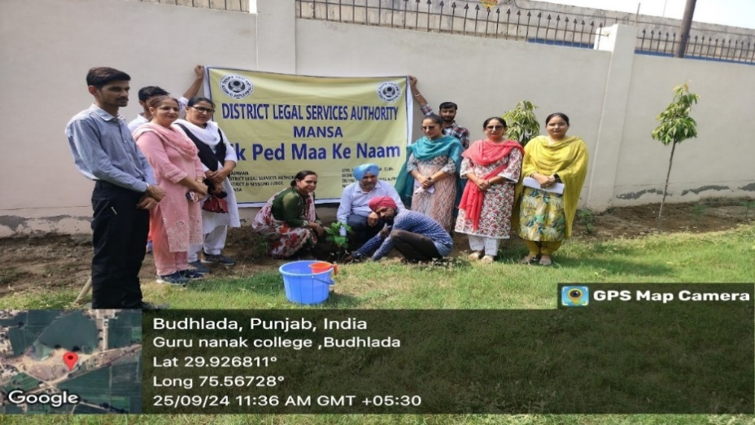
A SpecialLecture on Drug Addiction- Damage to Mankind as well as a Plantation Drive was organised by Department of English on September 25, 2024. Ms.Rajinder Kaur,Civil Judge Mansa participated as a special speaker.
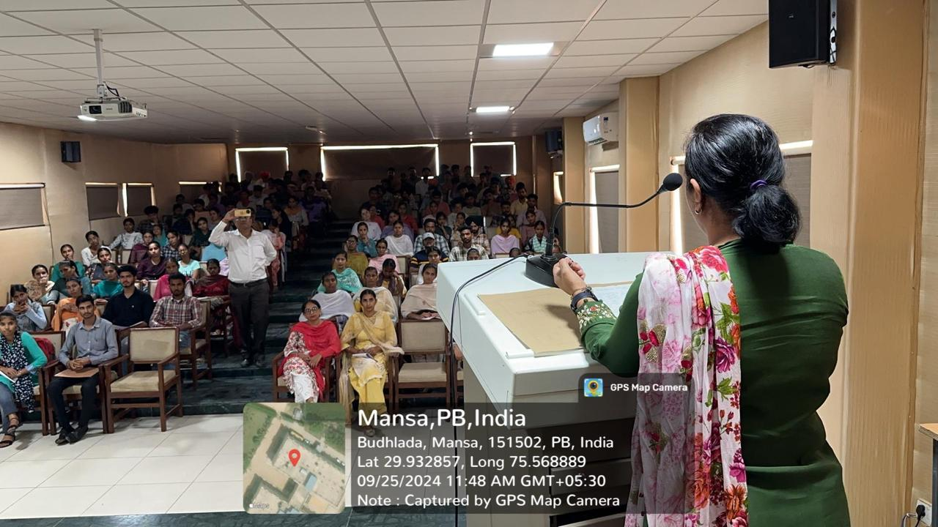
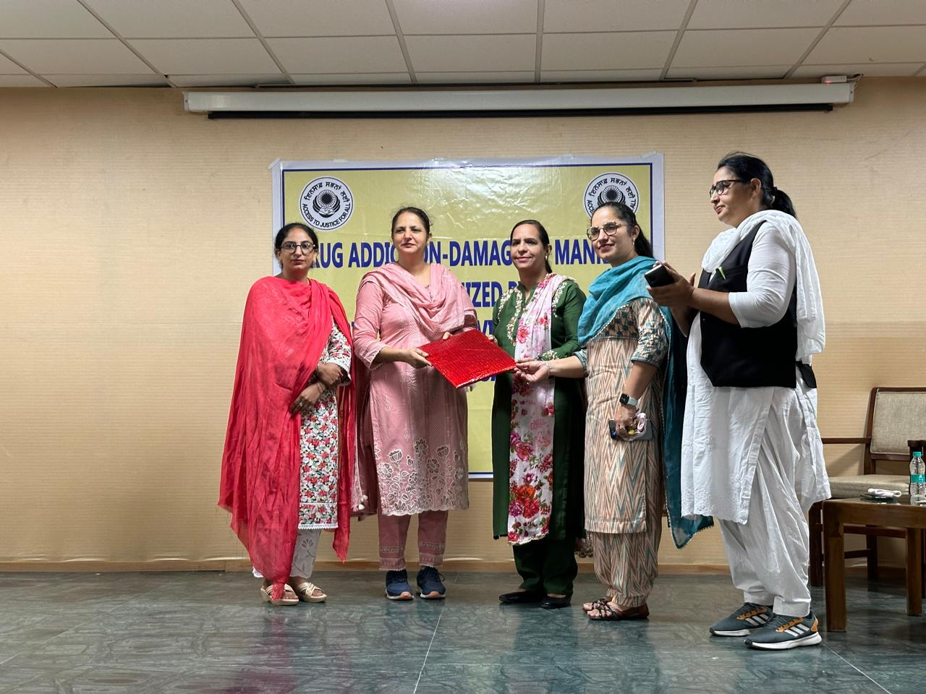
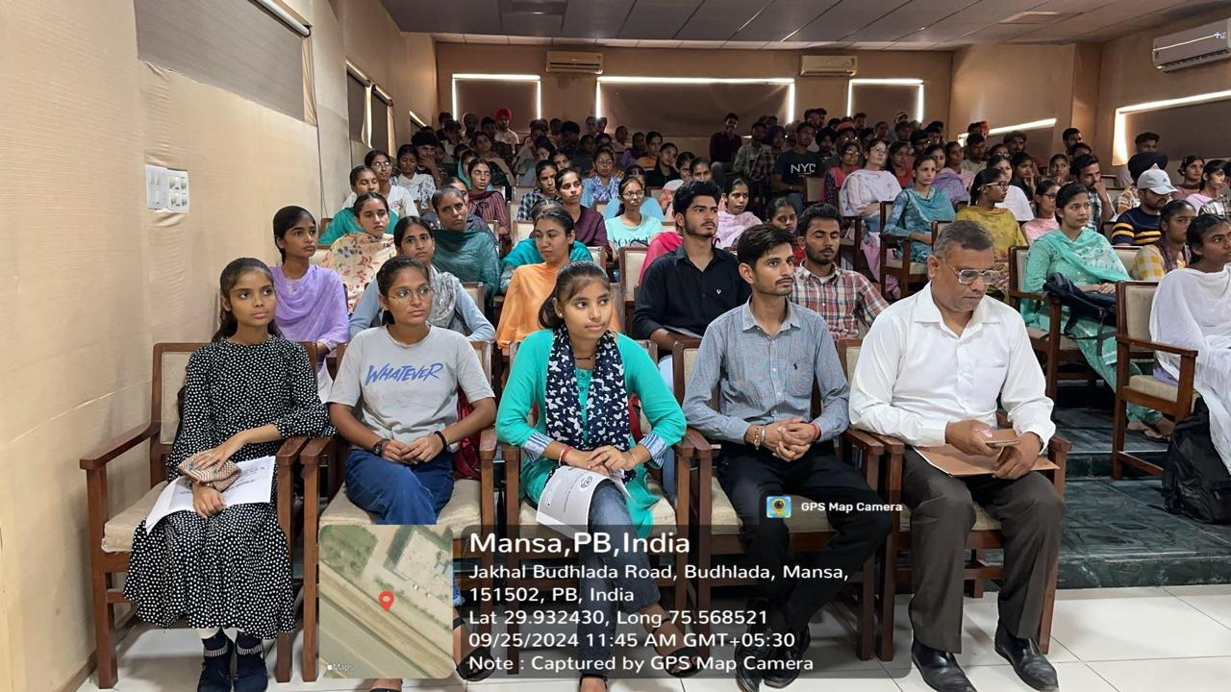
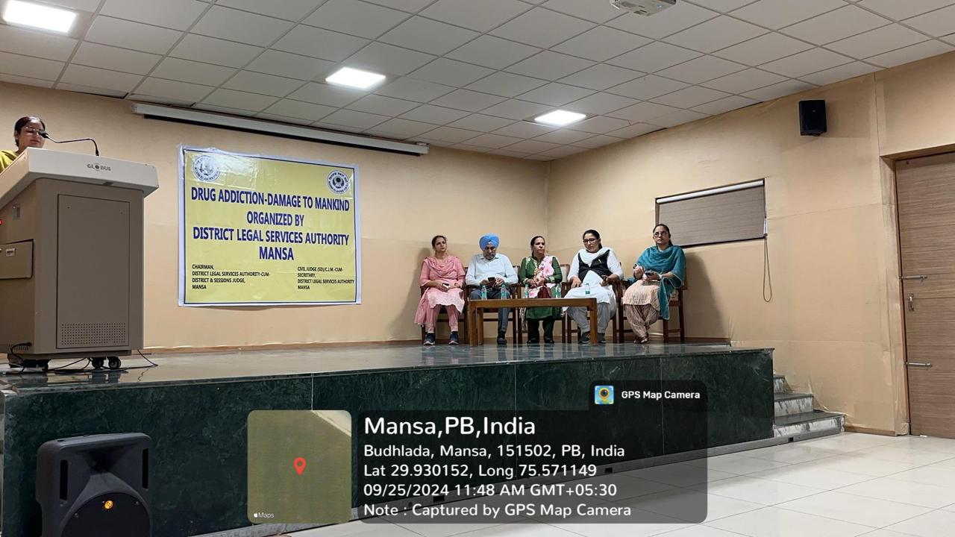

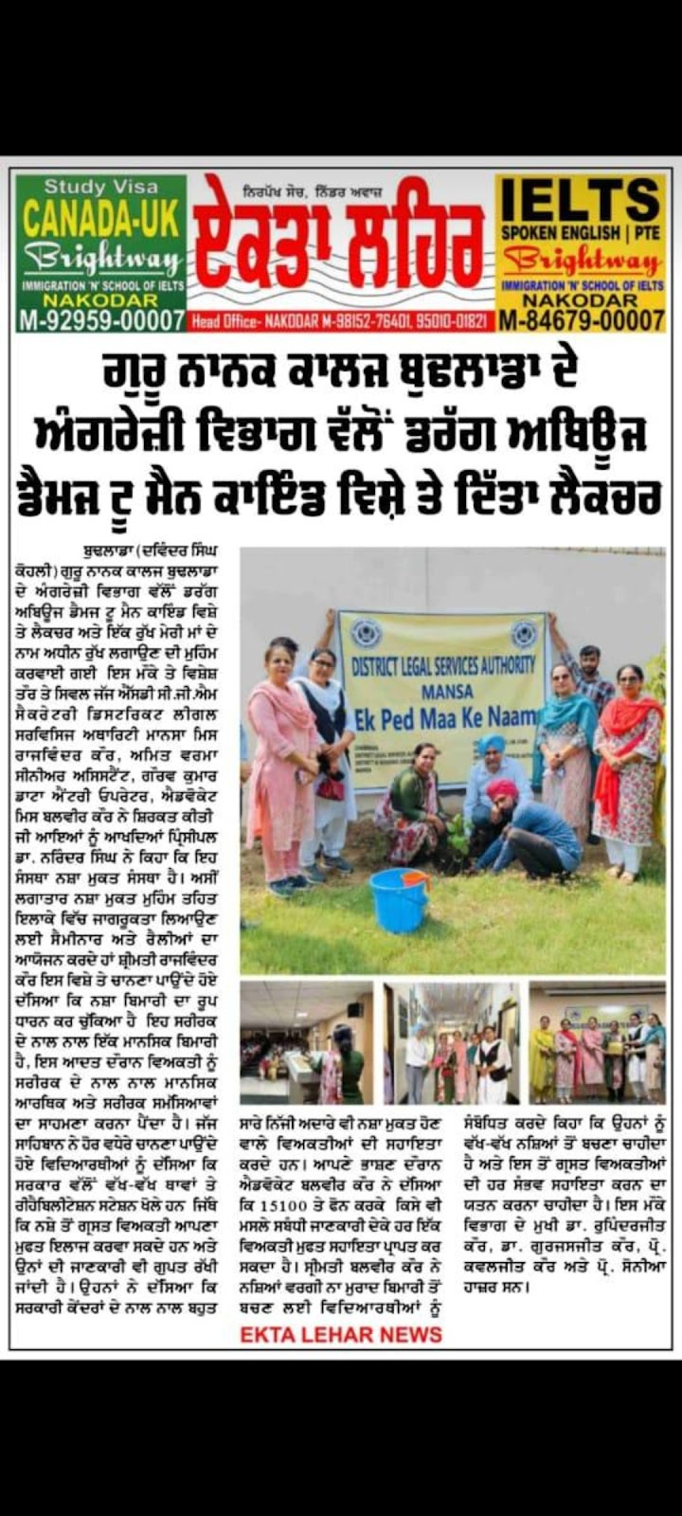
Department Of Fashion Technology & Home Science organised Visit for Pingalwara and Gaushala as Social Work on 14 january 2025

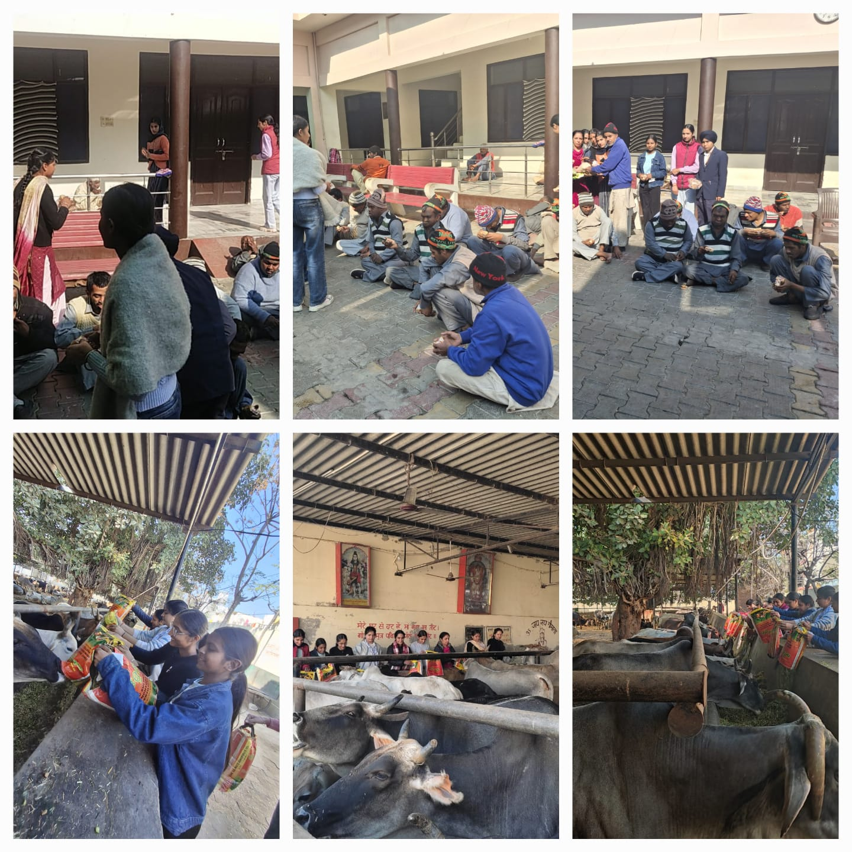
Department of Commerce and Management celebrated Global Ethics Day on 16-10-2024.
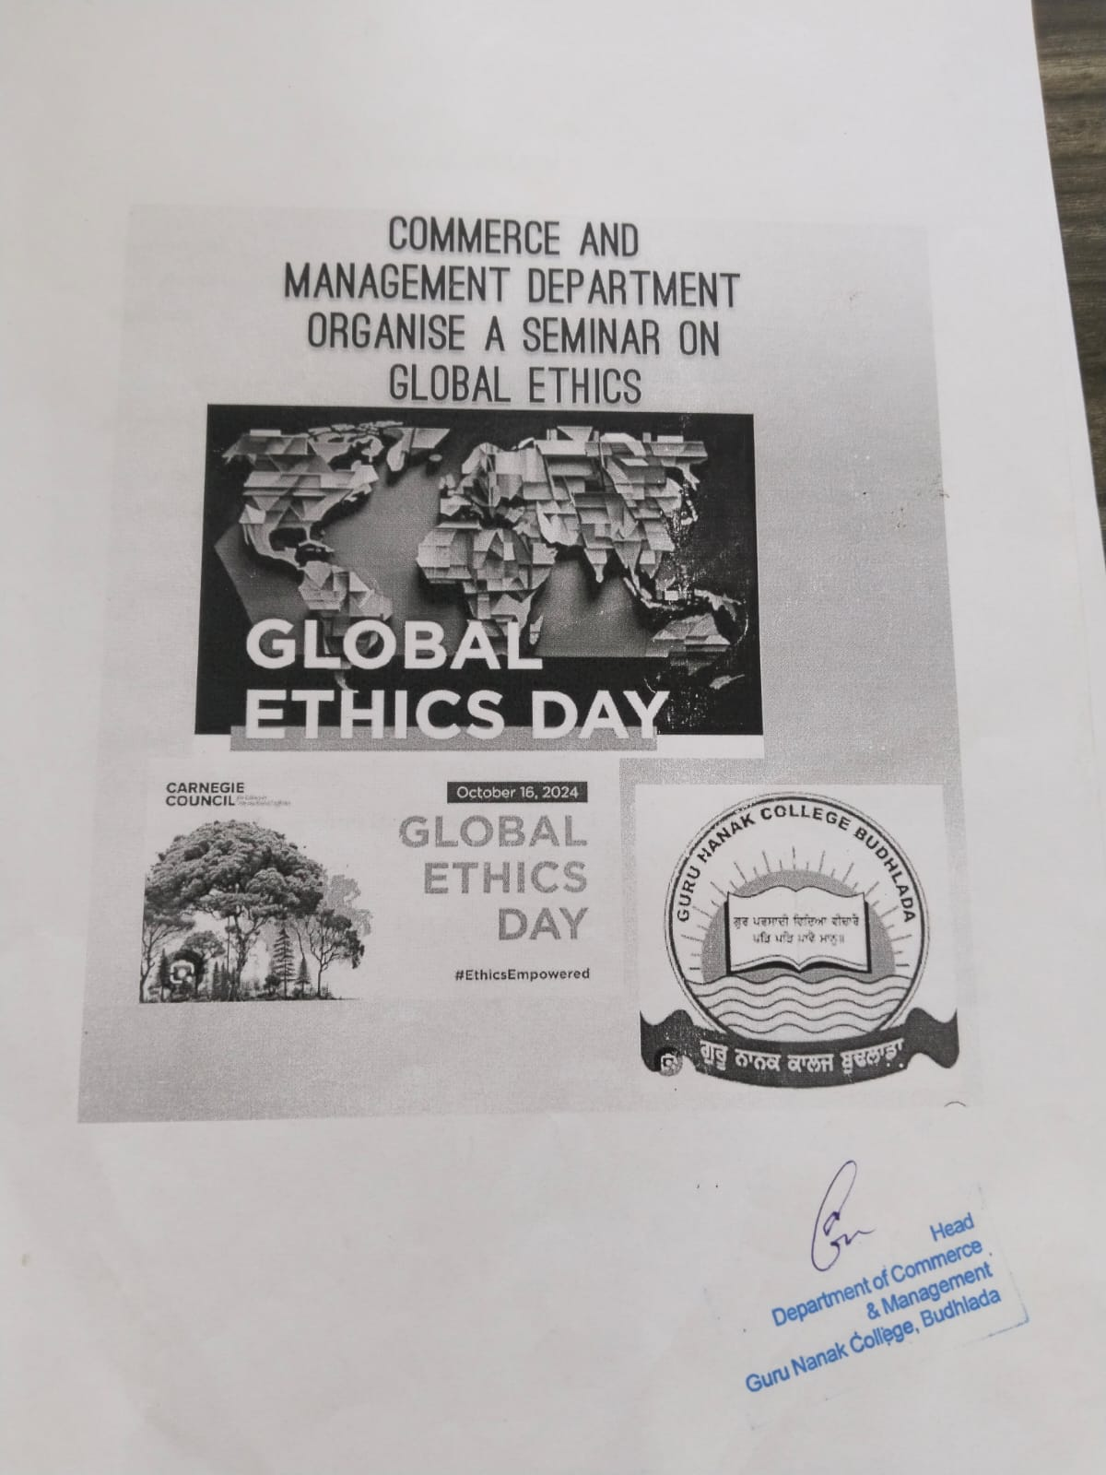
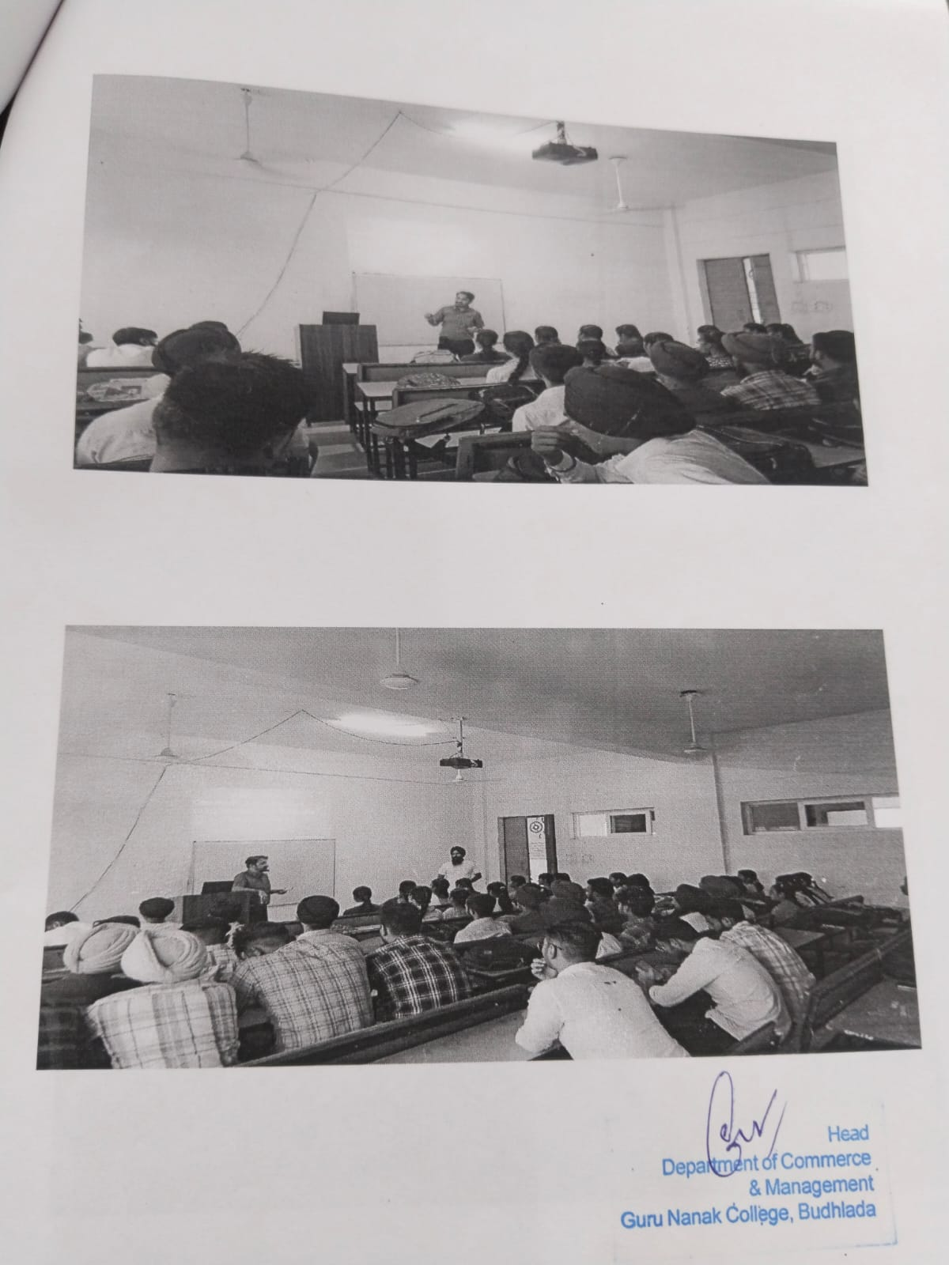
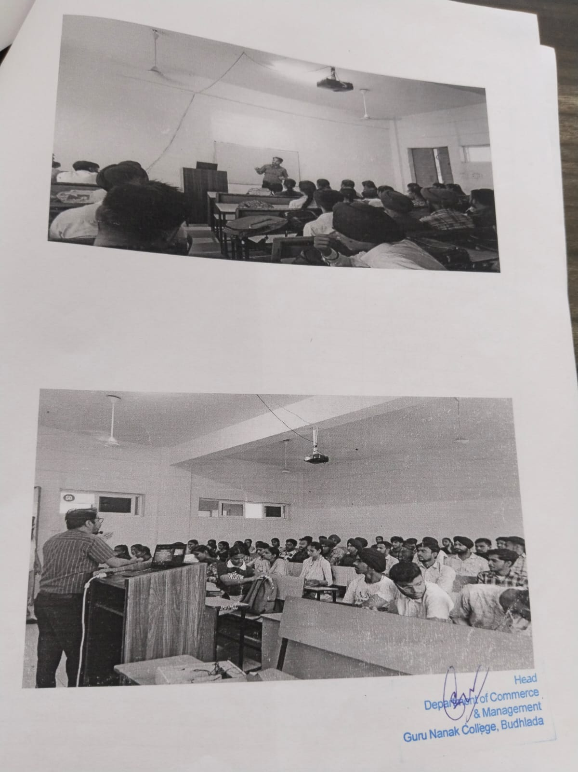
Department of Hindi organised a one day educational tour of Gurdwara Sahib Pahin Sahib Sachi Manji of Saidewala on 26-09-2024.
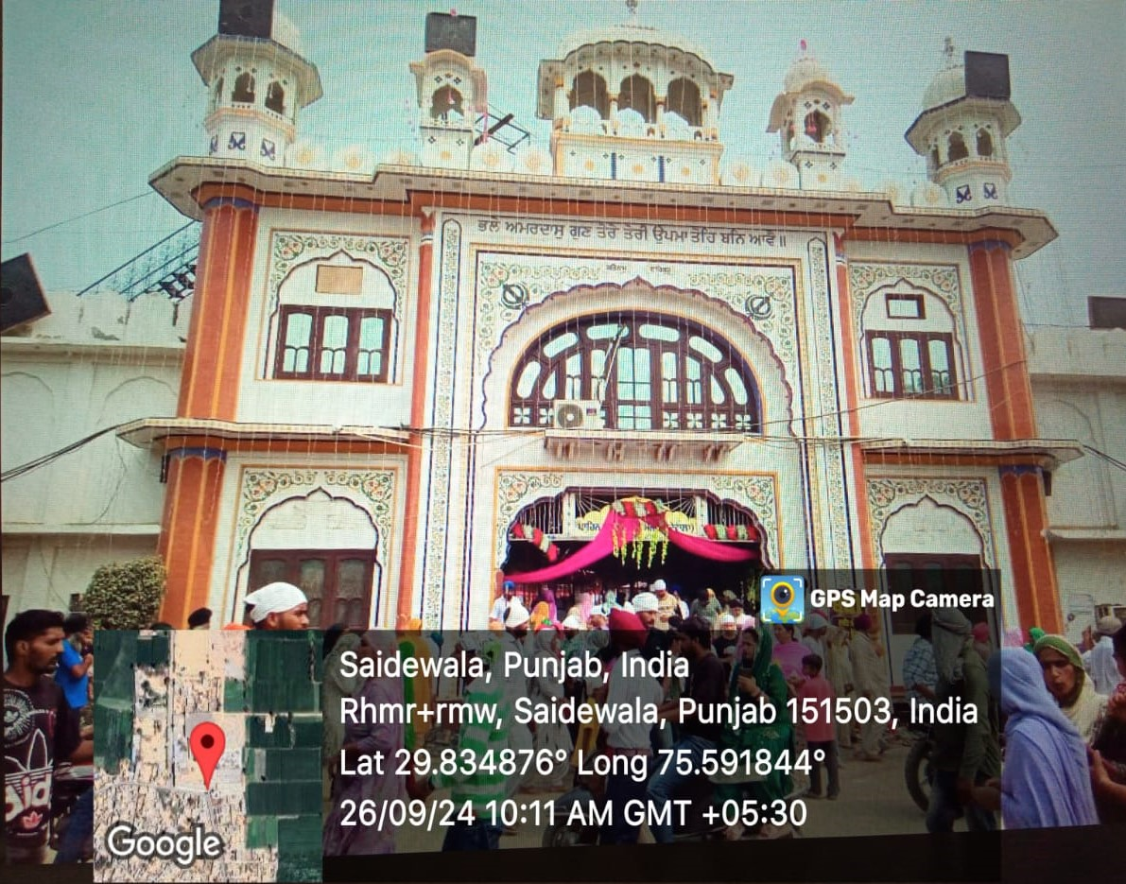
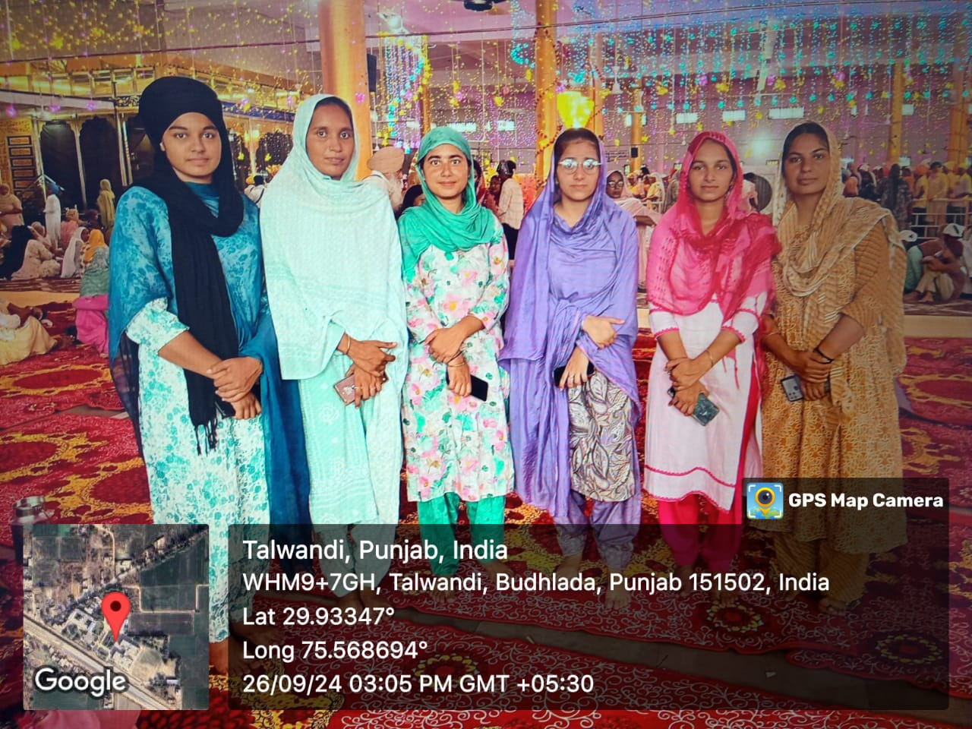
On 28th September 2024, the students of the Mathematics Department visited Pingalwara as part of a social outreach initiative. The visit aimed to instill values of compassion, empathy, and community service among the students.The visit was a heart-touching experience that left a lasting impact on the students, inspiring them to contribute positively to society beyond academics.
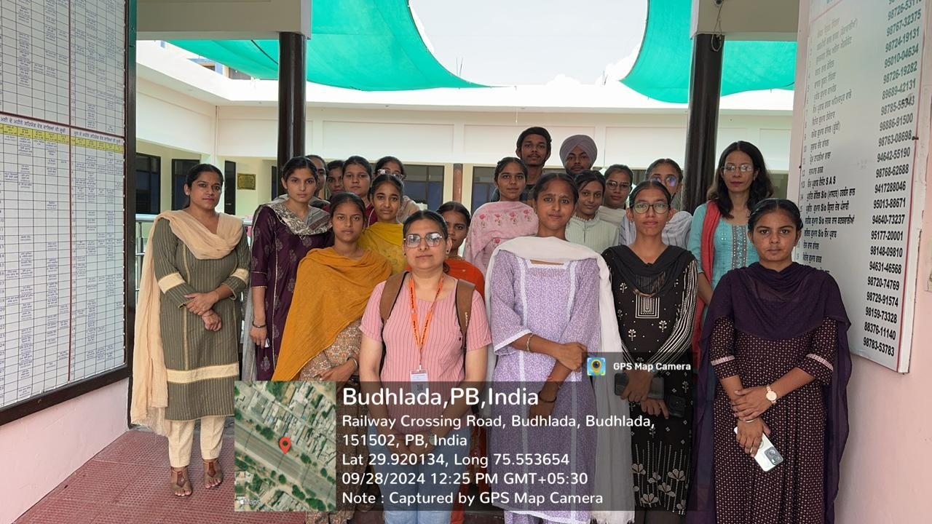
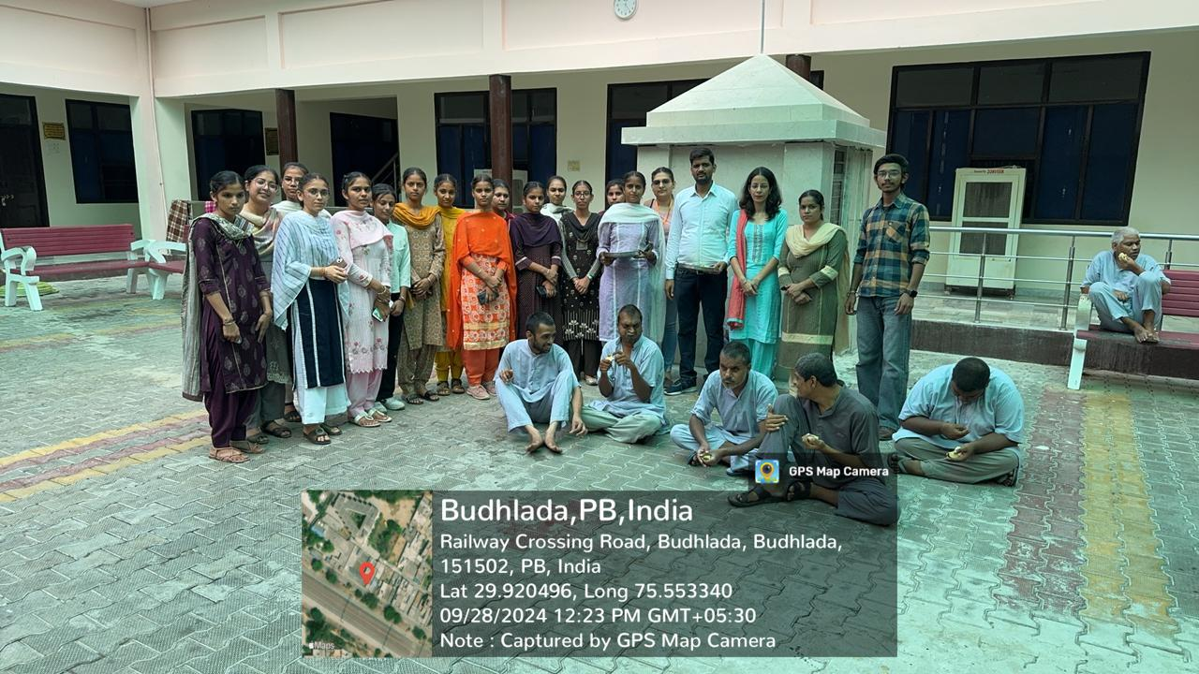
On 3rd March, 2025, a special activity was conducted by Dept of Maths centered around the Guru Granth Sahib to promote spiritual awareness and understanding among the participants. Participants engaged in discussions about the teachings of Guru Granth Sahib, focusing on values such as equality, humility, and compassion. The activity concluded with Ardas (prayer) creating an atmosphere of devotion and unity.
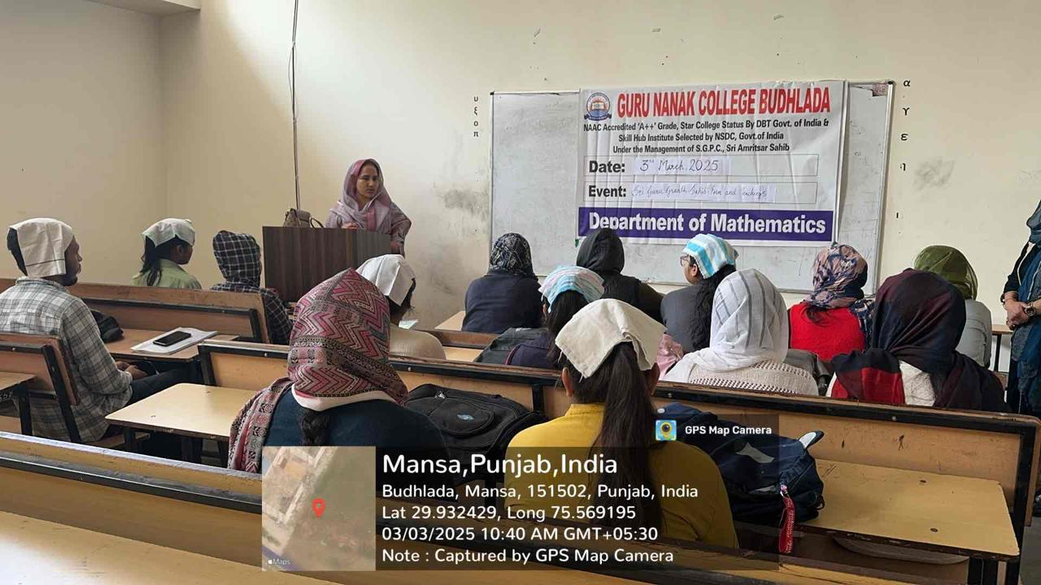

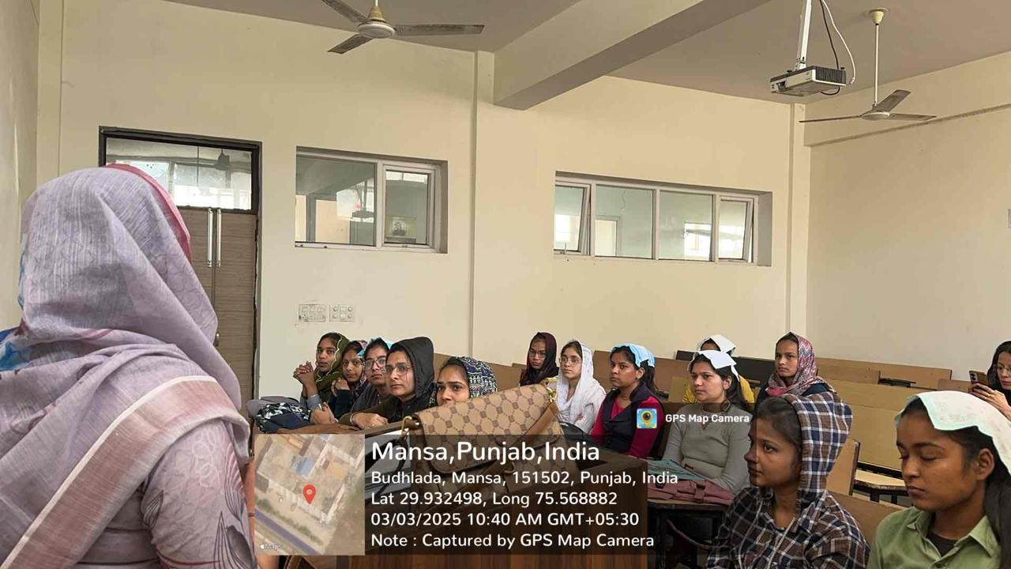
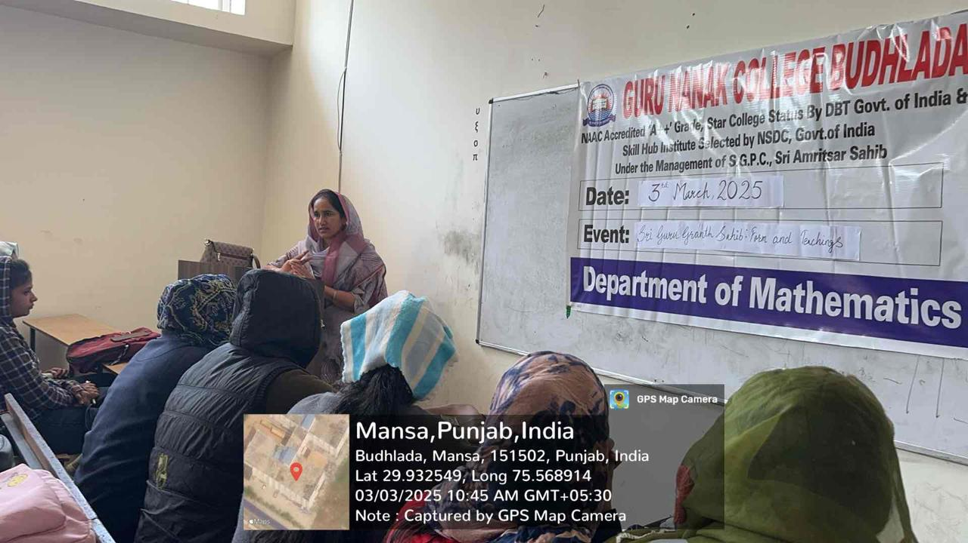
On the occasion of completing 450 years of Joti Jot Diwas of Sri Guru Amar Das Ji and Guriyai Diwas of Sri Guru Ramdas Ji,Guru Nanak Collegeon 7 September 2024 organised GurmatSamagam, kirtan, poetry recitations, and lectures. Additionally, competitions such as quizzes, essay writing, poetry, and speech contests were also organised.
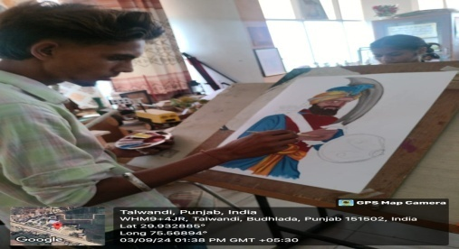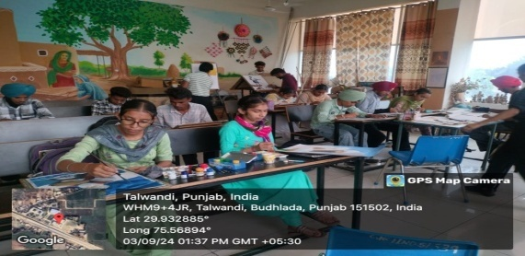
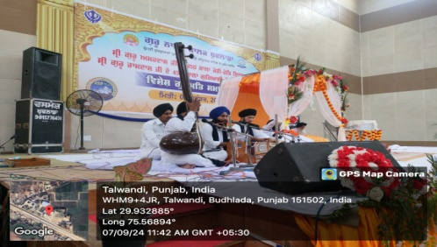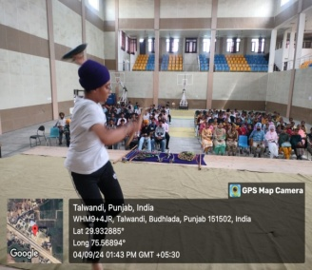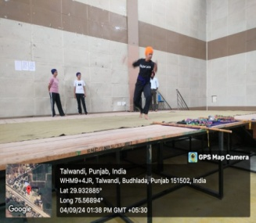
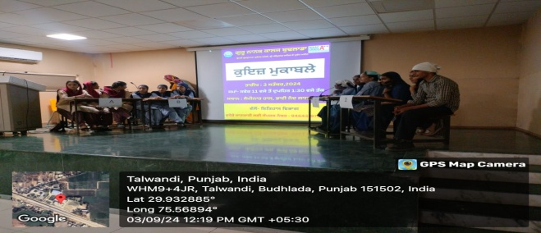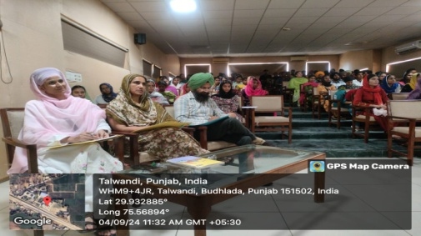
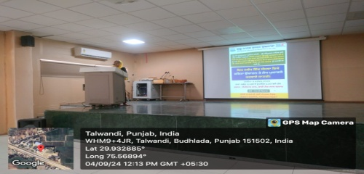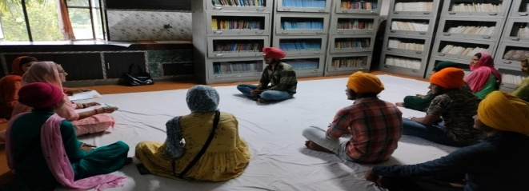
On the occasion of completing 450 years of Joti Jot Diwas of Sri Guru Amar Das Ji and Guriyai Diwas of Sri Guru Ramdas Ji, Guru Nanak College on 12 September 2024 organised a GurmatSamagam.
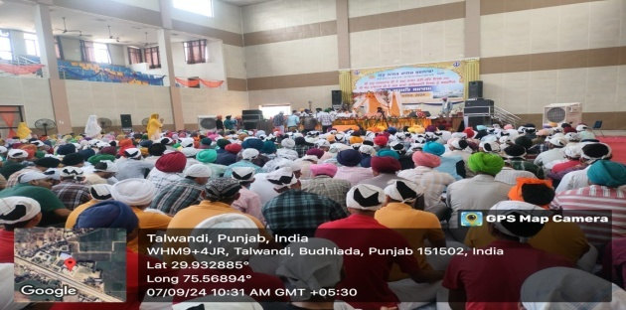
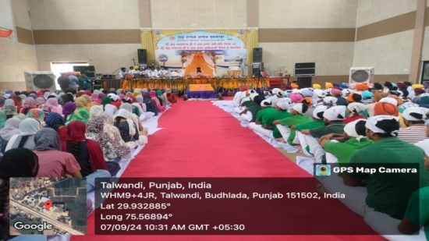
In commemoration of the martyrdom of the ChhoteSahibzade and Mata Gujri Ji, a religious program was held on 23/12/2024.
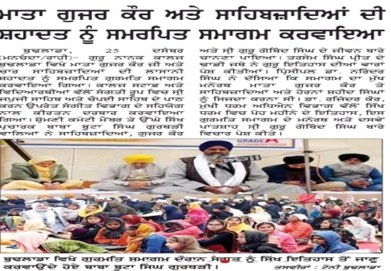
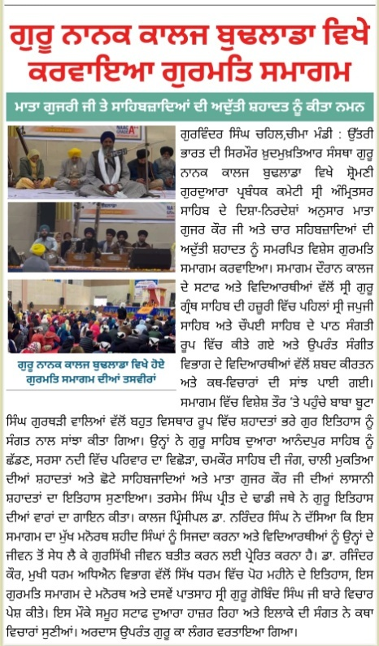
Under the leadership of Baba Buta Singh Ji, member of the Shiromani Gurdwara Parbandhak Committee, a religious programme was organized at village Kube (Barnala) on 26 January 2025. Students of Music Department performed shabad kirtan (devotional singing) at the event.
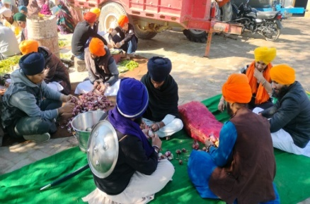
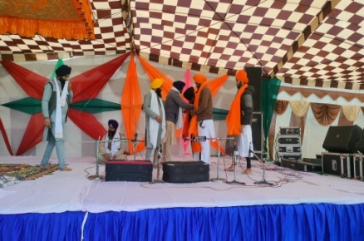
On 7 February 2025, at Guru Nanak College, Budhlada, under the guidance of Principal Dr. Narinder Singh Kalra, the Department of Music organized a ghazal singing programme and a special lecture on the topic “Analysis of Ghazal Gayaki: Traditional and Modern Fusion.”On this occasion, Shri Saleem Kumar participated as the chief speaker. He spoke in detail about the history and evolution of ghazal singing and explained the comparative study of ghazal styles in Indian light classical music. Along with this, he presented ghazals of legendary maestros such as Ghulam Ali and Jagjit Singh, and also discussed the works of contemporary singers, captivating the students and audience alike.
On 5 March 2025, the Department of Music at Guru Nanak College, Budhlada, under the leadership of Principal Dr. Narinder Singh, organized a special musical programme dedicated to the loving memory of Vidushi Gangubai Hangal.During the programme, students of the Music Department presented renowned classical compositions of Gangubai Hangal in a graceful and melodious manner. On this occasion, Dr. Manpreet Singh, Head of the Department, acquainted the students with the life of Gangubai Hangal and her valuable contribution to Indian classical music.Addressing the gathering, Principal Dr. Narinder Singh appreciated such initiatives by the Music Department and encouraged students to listen to and practice good music, so that the rich tradition and heritage of Indian music may always remain alive and vibrant.
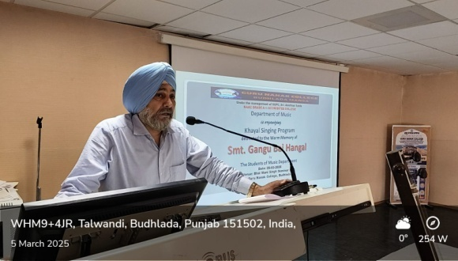
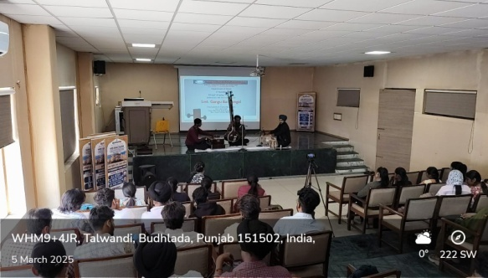
On 5 March 2025, the Department of Music at Guru Nanak College, Budhlada, under the leadership of Principal Dr. Narinder Singh, organized a special musical programme dedicated to the loving memory of Vidushi Gangubai Hangal.During the programme, students of the Music Department presented renowned classical compositions of Gangubai Hangal in a graceful and melodious manner. On this occasion, Dr. Manpreet Singh, Head of the Department, acquainted the students with the life of Gangubai Hangal and her valuable contribution to Indian classical music.
